Section IV: Returnable Bidding Forms
Note to Bidders: Instructions to complete each Form are highlighted in blue in each Form. Please complete the Returnable Biding Forms as instructed and return them as part of your quotation.

The following returnable forms are part of this RFQ and must be completed and returned by bidders as part of their Quotation.

Form A: Quotation submission form
Bidders are requested to complete this form, sign it and return it as part of their bid submission. The bidder shall fill in this form in accordance with the instructions indicated. No alterations to its format shall be permitted and no substitutions shall be accepted.
Date: [Insert submission date]____________________________

Subject: Quotation for the supply of [Insert a brief description of goods/services] __________________________________in ________________________________[Name of country/city], RFQ Case No.[insert RFQ ref number]_______________________________, dated [insert date]_____________________.

We, the undersigned, declare that:
  - We offer to supply in conformity with the bidding documents, including the UNOPS General Conditions of Contract.
  - Our quotation shall be valid for the period of time of [insert number of days which shall not be less than the specified in Section I: Bid Particulars, Period of Validity of Bids] _________________from the date fixed for the bid submission deadline as set out in the RFQ, and it shall remain binding upon us and may be accepted at any time before the expiration of that period;
  - We have no conflict of interest in any activity that would put it, if selected for this assignment, in a conflict of interest with UNOPS;
  - Our firm confirms that the offeror and sub-contractors have not been associated, or had been involved in any way, directly or indirectly, with the preparation of the design, terms of references and/or other documents used as a part of this solicitation;
  - Our firm, its affiliates or subsidiaries—including any subcontractors or suppliers for any part of the Contract—has not been declared ineligible by UNOPS, nor is included in the suspended/ineligibility list of the UN/PD, other UN Agencies, the UN Security Council, and the World Bank, in accordance with Instructions to Bidders Article 3, Eligibility;
  - We embrace the UN Supplier Code of Conduct and adhere to the principles of the UN Global Compact
  - We have not declared bankruptcy, are not involved in bankruptcy or receivership proceedings, and there is no judgment or pending legal action against them that could impair their operations in the foreseeable future.
  - We have not offered and will not offer fees, gifts and/or favours of kind in exchange for this RFQ and will not engage in any such activity during the performance of any Contract awarded.
I, the undersigned, certify that I am duly authorized by [insert full name of bidder] ________________________________to sign this quotation and bind [insert full name of bidder] should UNOPS accept this quotation:

Name: [complete]_______________________________________________________
Title: [complete]_________________________________________________________
Signature: _____________________________________________________________

Provide the name and contact information for the primary contact from your company for this quotation:

Name: [complete]________________________________________________________
Title: [complete]__________________________________________________________
Email address: [complete]____________________________________________________
Telephone: [complete]_______________________________________________________

Form B: Price Schedule Form
Bidders shall fill in this Price Schedule Form in accordance with the instructions indicated.

RFQ reference no: [insert RFQ reference No.]
Currency | RSD

Item No | Description of Goods | Quantity | Unit price DAP  VAT excluded  RSD | Total price DAP  VAT excluded  RSD
1. | Spent oil recover | 1
2. | Booster movable | 1
3. | 3/4" SOCKET SET | 1
4. | Digital Multimeter | 3
5. | Tyre filling gauge | 2
6. | Battery Load Tester | 1
7. | Preliminary treatment of system of cooling | 2
8. | Brake Piston Wind-Back Tool Kit | 3
9. | Oil Pressure Gauge Set | 1
10. | LED lamp for vehicle -hand | 10
11. | Antifreeze Tester | 5
12. | Digital compression pressure test for petrol engines | 1
13. | Digital car spotter | 1
14. | Instant heat soldering iron 130W | 5
15. | Express blower for the tires | 1
16. | Cabin hygiene solution device with 5 l of appropriate detergent for disinfection of ventilation system | 1
17. | Cordless Drill-Driver | 2
18. | Gas welding and cutting set | 1
19. | Welding machines inverter portable, with a suitcase and related cables | 1
TOTAL:

NOTES:
- Transportation and offload equipment to the delivery place must be included in the price.
- The offered prices are net of any direct taxes, customs duties and indirect taxes and VAT.
- DAP and supplier to cover the costs of custom clearance agency if needed;

Payment terms 30 days accepted: ☐ Yes

- List of subcontractors or suppliers
Bidder must identify the names of all subcontractors/suppliers who will be providing good/services under this Contract and the type of work being subcontracted, if applicable.
[Full legal name and address of subcontractors]

- _________________________________________________

- _________________________________________________

- _________________________________________________

- List of legal entities associated to the Bidder
Bidder must also identify and disclose any information regarding all associated legal entity/s, if any, by providing full legal name and address of the associated entity/s.
[Full legal name and address of the associated legal entity]

- _________________________________________________

- _________________________________________________

- _________________________________________________

Should there be no related entities, the Bidder must sign the following statement to that effect:
[Delete or cross out if not applicable]:
I, the undersigned, certify that there are no legal entities associated to the [insert full name of Bidder]
____________________________________________________. [

- Authorization to sign quotation
I, the undersigned, certify that I am duly authorized by [insert full name of Bidder]
____________________________________________________ to sign this quotation and bind
____________________________________________________[insert full name of Bidder] should UNOPS accept this quotation:

Name : _____________________________________________________________

Title : _____________________________________________________________

Date : _____________________________________________________________

Signature : _____________________________________________________________

Form C: Technical Quotation Form

RFQ reference no: [insert RFQ reference No.]______________________________________
Name of Bidder: [insert name of Bidder]___________________________________________

Bidders are required to complete the Comparative Data Tables included in Section III: Schedule of Requirements to demonstrate compliance with UNOPS requirements and insert them below. Bidders are NOT allowed to make any change in the “UNOPS requirements” columns of the Comparative Data Tables. Such changes might disqualify your quotation.

Technical specifications for goods – Comparative Data Table

Item No | UNOPS minimum technical requirements | Quantity | Is quotation compliant?  Bidder to complete | Details of goods offered. Bidder to complete  Insert details of goods offered, including specifications and brand/model offered if applicable
1. | Spent oil recover  Technical Characteristics:  Spent oil recovers to drain oil by gravity through the oil funnel and suction drains with vacuum through the probe;  Mobile on wheels;  ﻿Capacity of tray: minimum 18 l  Capacity of tank: 80 l -100 l  With set of minimum 6 pieces of probes.  Garancija: minimum 12 months  _____________________________  Istakalica za staro ulje  Tehnicke karakteristike:  Istaklalica za ulje za odvođenje/ispust ulja gravitaciono kroz levak za ulje i usisavanje vakuumom preko sonde;  Pokretna na tockovima  Kapacitet levka: minimum 18 l  Kapacitet boce: 80l- 100 l  Sa setom od minimalno 6 sondi za izvlacenje ulja  Garancija minimum 12 meseci  Equal or similar to the model Apac 1832.80 and picture/ ISTO ILI SLICNO MODELU SA SLIKE:  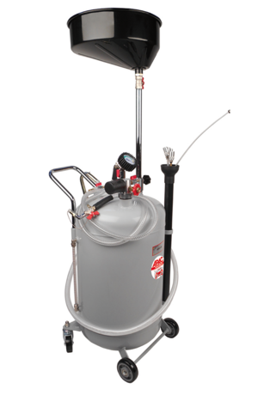 | 1 | ☐ Yes ☐ No
2. | Booster movable  Technical Characteristics:  Electricity starts at 12V - 1600A (max. Current load 6100A).  24V - 800A (max. Current load 3100A)  Predominate projected to run trucks, buses, working vehicles and heavy machinery on the 12V or 24V  Integrated protection for the electrical equipment of the vehicle.  Protection from accidental replacement of poles (reverse binding polarities).  Has an internal battery capacity is extremely high start-up, maintenance-free and liquid electrolyte  The ability to use as secondary power for the duration of the battery replacement on vehicle.  Rechargeable and outside the vehicle on AC power or inside a vehicle on a standard 24V connector.  Integrated digital indicator of the battery level starter.  Equipped with a wide range of the pliers, which are associated with the starter and very flexible, completely insulated copper cable from 35mm2.  Length of connection cables 1,4m.  Warranty minimum 12 months  _____________________________  Buster prenosivi  Tehnicke karakteristike:  Struja startovanja na 12V - 1600A (max. trenutno opterećenje 6200A).  24V - 800A (max. trenutno opterećenje 3100A)  Prvenstevno namenjeno za pokretanje teretnih vozila, autobus, radnih mašina i teške mehanizacije na 12V ili 24V  Ugrađena zaštita za elektro opremu vozila.  Zaštita od slučajne zamene polova(kontra vezivanje polariteta).  Poseduju interne baterije izuzetno visokih kapaciteta pokretanja, bez održavanja i tečnog elektrolita  Mogućnost korišćenja kao pomoćno napajanje dok traje zamena akumulatora na vozilu.  Mogućnost punjenja i van vozila na naizmeničnoj struji ili unutar vozila na standardnom 24V priključku.  Ugrađen DIGITALNI indikator stanja napunjenosti baterije startera.  Opremljeni su klještima širokog zahvata koji su sa starterom povezani vrlo fleksibilnim, potpuno izolovanim bakarnim kablom od 35mm2.  Dužina priključnih kablova 1,4m.  Garancija minimum 12 meseci  Equal or similar to the model Power-Max Buster 12/24V 6200/3100A - PB02 and picture/ ISTO ILI SLICNO MODELU SA SLIKE:  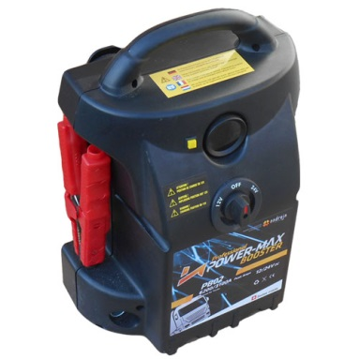 | 1 | ☐ Yes ☐ No
3. | 3/4" SOCKET SET  Technical Characteristics:  - 6 point  - Matt finish  - Chrome vanadium  - In durable plastic or metal storage case  Attribute function: reversible  Parts in the set: minimum 21 pcs  Packaging: plastic or metal storage case,  This products contains the following products  3/4" CHROMEplus Reversible ratchet  3/4" Extensions, approx. 100mm  3/4" Extensions, approx. 200mm  3/4" Extensions, approx. 400mm  3/4" Sliding T-handle, approx. 450mm  3/4" Hexagonal socket, short, 19mm  3/4" Hexagonal socket, short, 21mm  3/4" Hexagonal socket, short, 22mm  3/4" Hexagonal socket, short, 23mm  3/4" Hexagonal socket, short, 24mm  3/4" Hexagonal socket, short, 26mm  3/4" Hexagonal socket, short, 27mm  3/4" Hexagonal socket, short, 29mm  3/4" Hexagonal socket, short, 30mm  3/4" Hexagonal socket, short, 32mm  3/4" Hexagonal socket, short, 35mm  3/4" Hexagonal socket, short, 36mm  3/4" Hexagonal socket, short, 38mm  3/4" Hexagonal socket, short, 41mm  3/4" Hexagonal socket, short, 46mm  3/4" Hexagonal socket, short, 50mm  _____________________________  Komplet gedora 3/4”  Tehnicke karakteristike:  - 6 pozicija  - Mat zavrsnica  - Chrome vanadium  - U plasticnom ili metalnom kucistu za cuvanje  Funkcija cegrtaljke: Dvosmerna  Delova u setu: minimum 21  Pakovanje: plasticno ili metalno kuciste za skadistenje,  Set mora da sadrzi sledece elemente:  3/4" Hromirana cegrtaljka  3/4" Produzetak, otprilike 100mm  3/4" Produzetak, otprilike 200mm  3/4" Produzetak, otprilike. 400mm  3/4" Sliding T-rucica, otprilike 450mm  3/4" setougaoni prikljucak, kratak, 19mm  3/4" setougaoni prikljucak, kratak, 21mm  3/4" setougaoni prikljucak, kratak, 22mm  3/4" setougaoni prikljucak, kratak, 23mm  3/4" setougaoni prikljucak, kratak, 24mm  3/4" setougaoni prikljucak, kratak, 26mm  3/4" setougaoni prikljucak, kratak, 27mm  3/4" setougaoni prikljucak, kratak, 29mm  3/4" setougaoni prikljucak, kratak, 30mm  3/4" setougaoni prikljucak, kratak, 32mm  3/4" setougaoni prikljucak, kratak, 35mm  3/4" setougaoni prikljucak, kratak, 36mm  3/4" setougaoni prikljucak, kratak, 38mm  3/4" setougaoni prikljucak, kratak, 41mm  3/4" setougaoni prikljucak, kratak, 46mm  3/4" CLASSIC setougaoni prikljucak, kratak, 50mm  Equal or similar to the model KS Tools 911.0721 and picture/ ISTO ILI SLICNO MODELU SA SLIKE:  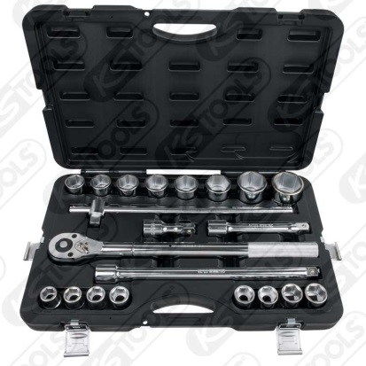 | 1 | ☐ Yes ☐ No
4. | Digital Multimeter  Technical Characteristics:  General purpose multimeter with clear and easy-to-read LCD display.  Features data  Housed in rugged rubber boot with integral stand.  Battery (Supplied)-included  Supplied with full set of leads and probes.  Measures:  - AC and DC Voltage  - DC Current  - Resistance  - Diode/Transistor Verification Mode  _____________________________  Digitalni multimer  Tehnicke karakteristike:  Multimeter opste namene sa jasnim i lako citljivim LCD ekranom.  Zadrzava podatke, U gumenom kucistu sa integrisanim stalkom  Na baterije-baterije ukljucene  Obezbedjen pun set ispitivaca za merenje:  - AC i DC napon  - DC struja  - Otpor  -- IspitvanjeDiode/ Merenje tranzistora  Equal or similar to the model SEALEY MM20 and picture/ ISTO ILI SLICNO MODELU SA SLIKE:  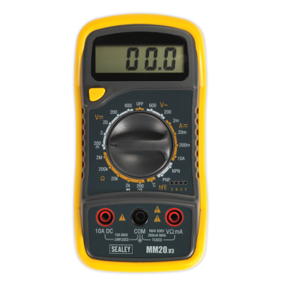 | 3 | ☐ Yes ☐ No
5. | TYRE FILLING GAUGE  Technical Characteristics:  For one hand operation  Rubber coated manometer  Manometer with bar and psi scale  Pressure release button  Tube with integrated locking of valves  Robust rubber coated housing  Technical Data  connection thread: 1/4"  readout: analog  operating pressure in bar : max 6,3 bar (90 psi)  weight in g: 450- 600g  working range bar: 0 - 11bar  tube length in mm: minimum 490mm  _____________________________  Pistolj sa manomentrom za gume  Tehnicke karakteristike:  Za rad jednom rukom  Gumom presvucen manometar  Manometar sa barom i psi skalom  Dugme za oslobađanje pritiska  Cev sa integrisanom sistemom za zaključavanje ventila  Tehnički podaci  priključak navoj: 1/4 "  merač: analogni  radni pritisak u bar mak 6,3 bara (90 psi) u  Tezina : 450- 600g  merni opseg bar: 0 - 11bar  dužina creva u mm: minimum 490mm  Equal or similar to the model KS Tools 515.1950 and picture/ ISTO ILI SLICNO MODELU SA SLIKE:  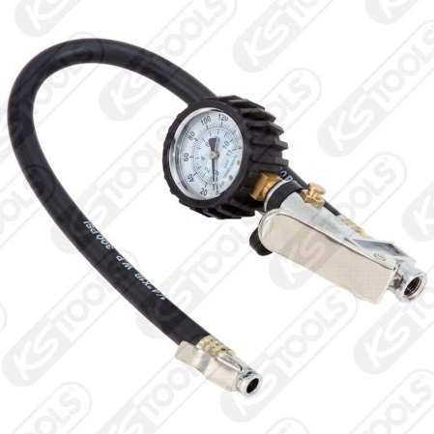 | 2 | ☐ Yes ☐ No
6. | Battery Load Tester  Technical Characteristics:  500 Amp variable load carbon pile tester  Tests batteries up to 1000CCA  Tests 12V batteries, alternators, regulators & starters  Separate voltmeter and ammeter provides easy-to-monitor battery load tests  Metal household  Fully insulated, heavy duty, color coded battery clamps & wire leads  Built-in warning alarm  Minimum 12-Month Warranty  _____________________________  Tester opterećenja akumulatora  Tehnicke karakteristike:  Tester promenljivog opterećenja, max. do 500AMP  Opseg merenja akumulatora do 1000 CCA(EN)  Testira 12 voltne akumulatore, alternatore, regulatore i startere  Ugrađen analogni voltmetar i ampermetar  Metalno kućište  Bez potrebe za dodatnim mrežnim napajanjem.  Ugrađen alarm  Garantni rok minimum 12 meseci  Equal or similar to the model DHC Tester 500A2 and picture/ ISTO ILI SLICNO MODELU SA SLIKE:  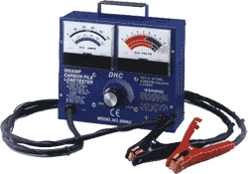 | 1 | ☐ Yes ☐ No
7. | Preliminary treatment of system of cooling  Technical Characteristics:  Set for checking the tightness of the pressure in the cooling system, adapter set in the set.  Minimum 12 adaptors in the plastic carry-case  _____________________________  Uredaj za ispitivanje sistema za hladjenje metodom pritiska  Tehnicke karakteristike:  Set za proveru nepropusnosti pritiska u sistemu hlađenja, set adaptera u skupu  Minimum 12 adaptera u plasticnom pakovanju  Equal or similar to the model PROFITOOL 0XAT1386 and picture/ ISTO ILI SLICNO MODELU SA SLIKE:  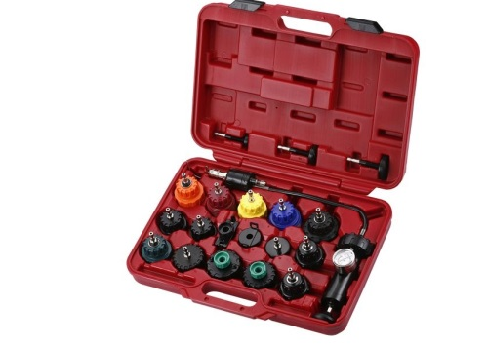 | 2 | ☐ Yes ☐ No
8. | Brake Piston Wind-Back Tool Kit  Technical Characteristics:  Minimum 21 pcs in the set  Suitable for push-back and wind-back brake pistons.  Minimum 16 adaptors  Includes left and right-handed thrust bolt assemblies,  Supplied in carry-case.  _____________________________  Alat za sirenje klipova celjusti visenamenski  Tehnicke karakteristike:  Minimum 21 delova u setu  Pogodan za vracanje I sirenje ​i klipova  Minimum 16 adaptera.  Potisna vretena sa desnim i lijevim navojem  Isporučuje se u koferu.  Equal or similar to the model SEALEY VS0282 and picture/ ISTO ILI SLICNO MODELU SA SLIKE:  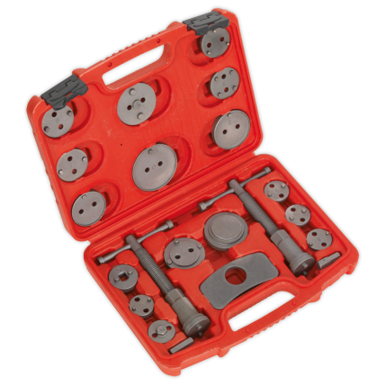 | 3 | ☐ Yes ☐ No
9. | Oil Pressure Gauge Set  Technical Characteristics:  Oil Pressure Gauge Set  Use on diesel and gasoline engines.  Includes standard and metric adaptors for  most popular cars, trucks,  tractors and stationary engines.  Minimum 8 adaptors  Manometer with black protective boot  In plastic or meatal carry- case  _____________________________  Alat za merenje pritiska ulja  Tehnicke karakteristike:  Tester za pritisak ulja sa skupom adaptera za vecinu automobile, kamiona, traktora i stacionarnih motora.  Minimum 8 adaptera  Manometar sa gumenom zastitom.  U plasticnoj ili metalnoj kutiji  Equal or similar to the model PROFITOOL 0XAT1043 and picture/ ISTO ILI SLICNO MODELU SA SLIKE:  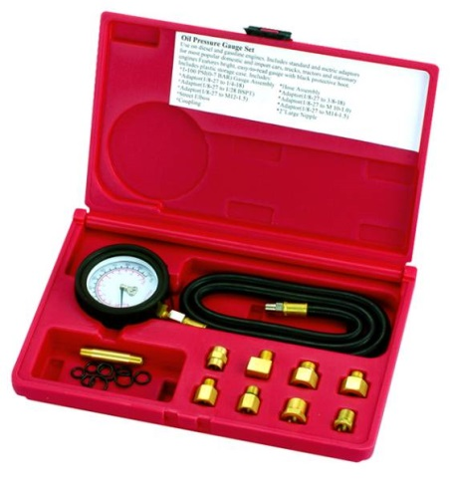 | 1 | ☐ Yes ☐ No
10. | LED lamp for vehicle -hand  Technical Characteristics:  Rechargeable LED lamp with at least 21 LED diode  On the back of the lamp at least one magnet  Plastic hook for use  Must be charged at 220V  Warranty: 6 months  _____________________________  Punjiva Led Lampa -rucna  Tehnicke karakteristike:  Punjiva Led Lampa minimum 21 led dioda  Sa zadnje strane minimum jedan magnet da moze da se lepi na metalne povrsine  Ima plasticnu zakacaljku  Moze da se puni na 220V  Garancija :6 meseci  Equal or similar to the model and picture/ ISTO ILI SLICNO MODELU SA SLIKE  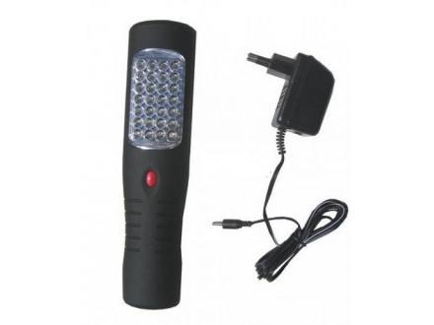 | 10 | ☐ Yes ☐ No
11. | Antifreeze Tester  Technical Characteristics:  To measure the freezing point of antifreeze based on ethylene glycol and a mixture of antifreeze and water in cooling systems of passenger and heavy vehicles.  Hose length [mm]: 200  Material: Plastic  The suction volume [ml]: 45 do 52  Measuring range of [°C]: -40°C – 0°C, -40°C– -5°C  _____________________________  Uredjaj za merenje kvaliteta antifriza  Tehnicke karakteristike:  Za merenje temperature mržnjenja antifriza na bazi etilen glikola i mešavine antifriza i vode u rashladnim sistemima putničkih i teretnih vozila.  Duzina creva [mm]: 200  Materijal: Plastika  Kapacitet usisa [ml]: 45 do 52  Merni opseg [°C]: -40°C – 0°C,  -40°C– -5°C  Equal or similar to the model Elparts and picture/ ISTO ILI SLICNO MODELU SA SLIKE  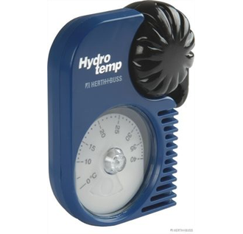 | 5 | ☐ Yes ☐ No
12. | DIGITAL COMPRESSION PRESSURE TEST SET FOR PETROL ENGINES  Technical Characteristics:  For dry and wet compression tests  Compact adaptor pieces with quick couplings  Includes extensive adaptor assortment and digital manometer (psi)  Digital manometer with reading storage up to 12 cylinders  In durable plastic storage case  Technical Data  application in general: petrol  function attribute: digital  manometer: 0,0-20,0 bar  manometer gauge: bar, psi or KPA  parts in the set: minimum 10 pcs  packaging: plastic storage case,  with extensive adaptor assortment  This products contains the following products  Digital gauge  Adaptor M18x1.5  Adaptor M14x1.25 long  Adaptor M14x1.25 short  Adaptor L=64mm M18x1,5  Adaptor L=42mm M12x1,25  Adaptor L=42mm M10x1,0  Coupling f.150.1650, 1/4'' Int.  Fittings f.150.165  _____________________________  Uredjaj za merenje kompresije cilindra benzinskih motora  Za suve I vlažne testove kompresije  Kompaktni set adaptera sa brzim spojnicama  Uključuje širok asortiman adaptera i digitalni manometar (psi)  Digitalni manometar sa prostorom za ocitavanje za 12 cilindara  U adekvanom plastičnom pakovanju/koferu za čuvanje  Tehnički podaci  Opšta namena: benzin  Merac: digitalni  manometar: 0,0-20,0 bara  manometar merac: bar, psi ili kPa  delova u setu: minimum10 kom  ambalaža: plastičnom kućištu za skladištenje,  pribor: sa velikim asortimanom adaptera  Ovaj proizvodi sadrži sledeće proizvode  Digitalni merač  Adapter M18k1,5  Adapter M14k1.25 dugi  Adapter M14k1.25 kratak  Adapter L = 64mm M18k1,5  Adapter L = 42mm M12k1,25  Adapter L = 42mm M10k1,0  Spojnica f.150.1650, 1/4 '' int.  Prikljucak f.150.165  Equal or similar to the model KS Tools 150.1650 and picture/ ISTO ILI SLICNO MODELU SA SLIKE  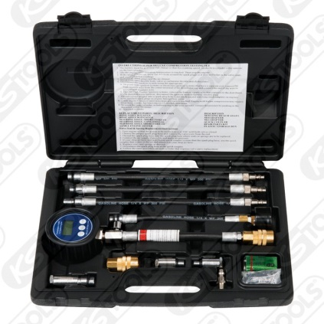 | 1 | ☐ Yes ☐ No
13. | Digital car spotter  Technical Characteristics:  Microprocessor controlled, spot-welding machine fit for applications in car body shops. The LCD digital, multifunction control panel allows the automatic regulation of spot welding parameters according to the chosen tool and sheet thickness.  Complete with the kit for spot welding of screws, washers, rivets and pulling stars, sheet warming and upsetting.  VOLTAGE 400 V MAX  MAX ABSORBED POWER 11 kW  PROTECTION DEGREE IP22  PEAK SPOT-WELDING CURRENT 4200 A  MAX WELD.THICK. ON 2 SHEETS 1,5 + 1,5 mm  DIMENSIONS 39 - 26 - 22.5 cm  WEIGHT 25-29 kg  Warranty: minimum 12 months  ____________________________  Uređaj za tačkasto zavarivanje  Tehnicke karakteristike:  Aparat za elektrootporno zavarivanje za korištenje u autolimariji. Digitalni višefunkcijeki ekran omogućuje automatsku regulaciju parametara zavarivanja prema odabranom alatu i debljini materijala. Isporuka uz komplet nastavaka.  Potrebno je isporuciti u kompletu sa pištoljem, kablom i prihvatom za masu i udarnim izvlakačem,  TEHNIČKE KARAKTERISTIKE  Priključni napon 400 V Max  Max. apsorbirana snaga11 kW  Kuciste zastite IP 22  Max. struja zavarivanja 4200 A  Max. apsorbirana snaga 11 kW  Max. debljina lima1,5 + 1,5 mm  Dimenzije 39 - 26 - 22.5 cm  Težina 25 -29 kg  Garancija minimum 12 meseci  Equal or similar to the model TELWIN DIGITAL CAR SPOTTER 5500 400V and picture/ ISTO ILI SLICNO MODELU SA SLIKE  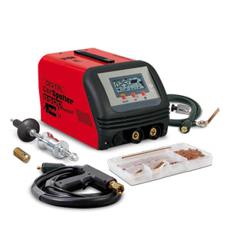 | 1 | ☐ Yes ☐ No
14. | INSTANT HEAT SOLDERING IRON 130W  Soldering iron pistol  Technical Characteristics:  Specifically designed double capacity. is 10 times faster than normal.  Rapid heating  Ceramic heater  The operating voltage of 200 to 240 V  Variable power 30 / 130 W (by pressing the trigger)  Top: N1-1, N1-4  _____________________________  Lemilica 130W  Tehnicke karakteristike:  Pištolj lemilica  Veoma brzo zagrevanje  Keramički grejač  Napon: 220-240V AC  Snaga: 30/130W( kada se pritisne taster)  Vrh: N1-1, N1-4  Equal or similar to the model ZD-80A 130W and picture/ ISTO ILI SLICNO MODELU SA SLIKE  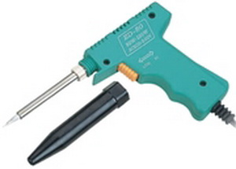 | 5 | ☐ Yes ☐ No
15. | Express blower for the tires  Technical Characteristics:  Horizontal cylindrical hand-portable containers with air at a pressure of 10 bar, which serves to quickly blow tubeless tires up to 25.5 ".  - External diameter of the tank: 255 mm  - Max length: 504 mm  - Width: 600 mm  - Maximum operating pressure: 10 bar  - Operating temperature: AMB.  - Nominal volume: 0,022 m3  - Medium: air  - Weight of the empty container: 13.7 kg  Warranty minimum 12 months  _____________________________  Expres duvač za gume  Tehnicke karakteristike:  Horizontalno cilindrična ručno prenosna posuda sa vazduhom pod pritiskom od 10 bar, koja služi za brzo duvanje tubeless guma do 25,5".  - Spoljni prečnik posude: 255 mm  - Max dužina: 504 mm  - Širina: 600 mm  - Max radni pritisak: 10 bar  - Radna temperatura: AMB.  - Nazivna zapremina: 0,022 m3  - Radni medijum: vazduh  - Masa prazne posude: 13,7 kg  Garancija minimum 12 meseci  Equal or similar to the model PANTER CH-5 and picture/ ISTO ILI SLICNO MODELU SA SLIKE  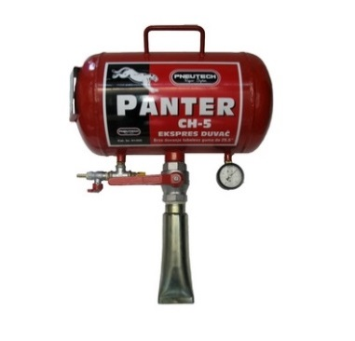 | 1 | ☐ Yes ☐ No
16. | Cabin hygiene solution device with 5 l of appropriate detergent for disinfection of ventilation system  Technical Characteristics:  Device for cleaning and disinfection of the evaporator of the air conditioners, as well as complete vehicle interior.  Fully automatic operation mode  Operated on cigarette lighter on 12V or 220 V power  Appropriate original 5 L ( 5000 ml) Antiseptic liquid detergent must be include in the price  _____________________________  Uredjaj za dezinfekciju ventilacionog sistema vozila sa 5 lit tecnosti za dezinfekciju  Tehnicke karakteristike:  Uređaj za čišćenje i dezinfekciju isparivača klima uređaja, kao i kompletne unutrašnjosti vozila.  Potpuno automatsko upravljanje  Napajanje sa samog vozila na 12V, ili na struju od 220V  Adekvatno orginalno sredstvo za dezinfekciju ventilacionog sistema 5L ( 5000ml) mora biti isporuceno I ukljuceno u cenu  Equal or similar to the model Texa Air+ and picture/ ISTO ILI SLICNO MODELU SA SLIKE  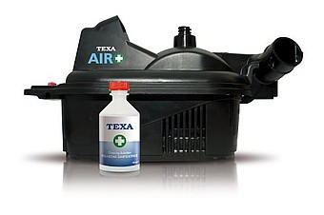 | 1 | ☐ Yes ☐ No
17. | Cordless Drill-Driver  Technical Characteristics:  Torque, max. (hard) 30 -42 Nm  Torque, max. (soft) 13-24 Nm  No-load speed:  1st gear0 – 400 rpm  2nd gear 0 – 1300 rpm or 0 – 1400 rpm  Chuck clamping range 1 - 10 mm or 0.8 – 13 mm  Battery voltage 10,8 – 18 V  Battery capacity 1.3-2 Ah  Drilling diameter  Max. drilling diameter in wood 19 mm -36mm  Max. drilling diameter in steel 10 mm-13 mm  Functions:  More than one gears  Right and left direction of rotation  Soft grip  To be delivered in following set:  2 x 1,3 - 2 Ah Li-Ion battery  Recharger  Plastic carry-case  Warranty 3 years  _____________________________  Akumulatorska bušilica-odvrtač  Tehnicke karakteristike:  Obrtni moment, maks. (tvrdo uvrtanje) 30-42 Nm  Obrtni moment, maks. (meko uvrtanje) 13-24 Nm  Broj obrtaja u praznom hodu:  1 brzina 0-400min-1  2 brzina 0 - 1.300 min-1 ili 0 - 1.400 min-1  Raspon zatezanja stezne glave, min./maks. 1 / 10 mm ili 0.8 – 13 mm  Napon akumulatora 10,8 -18 V  Kapacitet akumulatora 1,3 -2 Ah  Prečnik burgije  Prečnik burgije za drvo, maks. 19 mm- 36 mm  Prečnik bušenja čelika, maks. 10 mm-13 mm  Funkcije:  Više brzina  Desni i levi smer obrtanja  Obim isporuke  2 x 1,3 - 2 Ah Li-Ion akumulatora  Punjač  Plastični kofer za transport  Garancija 3 godine  Equal or similar to the model BOSCH GSR 10,8-2-LI and picture/ ISTO ILI SLICNO MODELU SA SLIKE  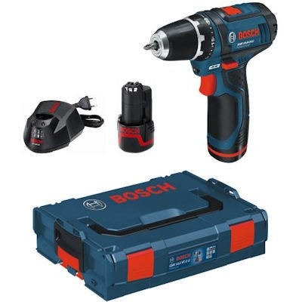 | 2 | ☐ Yes ☐ No
18. | Gas welding and cutting set  Technical Characteristics:  Cutting steel tins up to 300 mm  Welding steel tins up to 30 mm  The work principle: Injector-under high pressure  - Burning gas: Acetylene  - Performance to SRPS K.M6.020.  - Weight sets: 12.5 kg  Integral parts of the set:  - Oxygen regulation valve type 311  - The scale of input manometer, scale range (Bar) from 0-300  - The scale of the output pressure gauge scale range (Bar) 0-16  - cylinder valve connection: nut V21.8 to 1/14 "  - The exit port: nut thread R1 / 4 ", hose connection opening (mm) Ø 6  - Acetylene regulation valve type 436.6  - The scale of input manometer, scale range (Bar) from 0-40  - The scale of the output pressure gauge scale range (Bar) 0-2.5  - cylinder valve connection: stirrup  - The exit port: nut thread R 3/8 "Left, hose connection opening (mm) Ø 8  - Universal handrail burner for welding and cutting torch type 146-1  - Set of 8 welding torches type 147.5(6 burners) plus welding torches 147-7 and 147-8 for welding tins from 0.5 to 30mm  - Burner cutter type 148.2.1  - Kit of 2 external and 6 internal nozzles type 859 for cutting steel material thickness from 3 to 300 mm  - Trolley type 148-4 to run torch cutting  - Pipe key type 308-07  - Combined key type 308-06  - Fork key OK 30  - Metal brush for cleaning  - Flashback arrestor R-1 for acetylene  - Flashback arrestor R-2 for oxygen  - Radius bar for circular cuts type 308-1  _____________________________  Garnitura za gasno zavarivanje i rezanje  Tehnicke karakteristike:  - Rezanje čeličnih limova debljine do 300 mm  - zavarivanje čeličnih limova debljine do 30 mm  - princip rada: injektorski – pod visokim pritiskom  - gorivi gas: acetilen  - izvedba prema SRPS K.M6.020  - masa garniture: 12 kg  Sastavni delovi garniture:  - Regulacioni ventil za kiseonik tip 311  - Skala ulaznog manometra, opseg skale(bar) od 0-300  - Skala Izlaznog manometra,oseg skale (bar)  od 0-16  - Prikljucak za ventil boce: Navrtka W21.8 x 1/14"  - lzlazni prikljucak: Navrtka navoj R1/4”, Prikljucak za crevo otvora (mm) Ø 6  - Regulacioni ventil za acetilen tip 436.6  - Skala ulaznog manometra, opseg skale(bar) od 0-40  - Skala Izlaznog manometra,oseg skale (bar)  od 0-2,5  - Prikljucak za ventil boce: Uzengija  - lzlazni prikljucak: Navrtka navoj R3/8” levi, Prikljucak za crevo otvora (mm) Ø 8  - Univerzalni rukohvat plamenika za zavarivanje i gorionika za rezanje tip 146-1  - Komplet od 8 plamenika tip 147.5. (6 plamenika) plus plamenici 147-7 i 147-8 za zavarivanje čeličnih materijala debljine od 0,5 do 30 mm.  - Gorionik za rezanje tip 148.2  - Komplet od 2 spoljnje i 6 unutrašnjih mlaznica tip 859 za rezanje čeličnih materilala debljine od 3 do 300 mm  - Kolica tip 148-4 za vođenje gorionika za rezanje  - Cevasti ključ tip 308-07  - Kombinovani ključ tip 308-06  - Viljuškasti ključ OK 30  - Metalna četka za čišćenje  - Suvi protivplameni osigurač R-1 za acetilen  - Suvi protivplameni osigurač R-2 za kiseonik  - Šestar za kružno rezanje tip 308-1  Equal or similar to the model TELEOPTIK GZV-35.1 and picture/ ISTO ILI SLICNO MODELU SA SLIKE  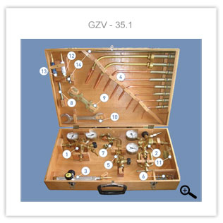 | 1 | ☐ Yes ☐ No
19. | Welding machines inverter portable, with a suitcase and related cables  Technical Characteristics:  Portable IGBT inverter stick welder  Power indicator  Thermal protection  Stepless current setting  Hot start  Anti-sticking  Arc force  Digital display  Generator friendly  Power supply : 230 V/50Hz  Input current:35  Input power :8.1 KVA  No load voltage : 69  Output current range:20-180A  Duty cycle at rated current: 20% at 180A  Electrode diameter 1.5- 3.2 mm or 1.6-4.0mm  Delivered with following accessories:  Case  Welding cable with electrode holder-1 piece  Earth cable with earth clamp- 1 piece  Warranty 24 months  _____________________________  Aparat za zavarivanje invertorski prenosivi, sa koferom i pripadajucim kablovima  Prenosni IGBT inverter  Poseduje funkcije ARC FORCE HOT START (povećana struja zavarivanja na startu)  Indikator napajanja  Termalna zaštita  Minimalna potrošnja električne energije.  Visoka efikasnost.  Hot start  Anti-sticking automatsko isključenje struje nakon zalepljivanja elektrode).  Arc force  Digitalni prikaz amperaže  Tehničke karakteristike  Priključni napon 230V / 50Hz  Max. priključna moć 8,1 kVa  Područje zavarivanja: 20 - 180 A  Intermitenca 20°C na 180A  Vrsta elektrode rutilna, bazična  Prečnik elektrode: 1.5 - 3.25 mm ili 1.6-4.0mm  Obim isporuke  Kofer  Držač elektrode sa kablom  Klešta za masu sa kablom  Garancija 24 meseca  Equal or similar to the model Hugong POWERARC 180 digit PROFI and picture/ ISTO ILI SLICNO MODELU SA SLIKE  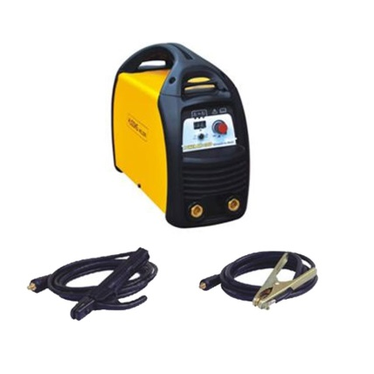 | 1 | ☐ Yes ☐ No

Delivery requirements –– Comparative Data Table

UNOPS Requirements |  | Is quotation compliant? Bidder to complete | Details  Bidder to complete  Insert details
Delivery time | Bidder shall deliver the goods and complete the services as soon as possible but latest within 20 (twenty) calendar days after Contract signature. | ☐ Yes ☐ No
Delivery place and Incoterms rules | DAP (Delivery at Place), offload included, as per Incoterms 2010, net of any direct taxes, customs duties and indirect taxes and VAT.  Delivery of equipment in one place in Belgrade. | ☐ Yes ☐ No
Consignee details | The equipment should be delivered and offloaded in the Belgrade. | ☐ Yes ☐ No
UNOPS Right to vary requirements | At the time the Contract is awarded, UNOPS reserves the right to vary the quantity of the goods and associated services specified above, provided this does not exceed +/- 30%, without any change in the unit prices or other terms and conditions of the RFQ. | ☐ Yes ☐ No

The offered goods and related services (if applicable) are in accordance with the required specifications and requirements specified in Section III: Schedule of Requirements.

☐ Yes ☐ No
ANY DEVIATION MUST BE LISTED BELOW:
_________________________________________________________________________________________________________________________________________________________________________________________________________________________________________________________________________________________________________________________________________________________________________________________________________________________________________

Name : _____________________________________________________________

Title : _____________________________________________________________

Date : _____________________________________________________________

Signature : _____________________________________________________________
Form D: Previous experience form
RFQ reference no: [insert RFQ reference No.]_________________________________
Name of Bidder: [insert name of Bidder]______________________________________

Description of services/goods | Country | Total amount of Contract | Contract Identification and Title and  Contact details of Client:  (Name, Address, telephone, email, fax) | Year project was undertaken

Name : _____________________________________________________________

Title : _____________________________________________________________

Date : _____________________________________________________________

Signature : _____________________________________________________________75 00ax: +45 45 33 75 01

