RETURNABLE BIDDING FORMS
Request for Quotation (RFQ) for Goods
Purchase of office accessories for UNOPS RSOC premises
RFQ No: UNOPS-RSOC-2017-G-005

Version: v2016.1.1

Section IV: Returnable Bidding Forms
Note to Bidders: Instructions to complete each Form are highlighted in blue in each Form. Please complete the Returnable Biding Forms as instructed and return them as part of your quotation.

The following returnable forms are part of this RFQ and must be completed and returned by bidders as part of their Quotation.

Form A: Quotation submission form
Bidders are requested to complete this form, sign it and return it as part of their bid submission. The bidder shall fill in this form in accordance with the instructions indicated. No alterations to its format shall be permitted and no substitutions shall be accepted.

Date: [Insert submission date]

Subject: Quotation for the supply of [Insert a brief description of goods/services] in [Name of country/city], RFQ Case No. [Insert RFQ ref. Number], dated [insert date]

We, the undersigned, declare that:
  - We offer to supply in conformity with the bidding documents, including the UNOPS General Conditions of Contract;
  - Our quotation shall be valid for the period of time of [insert number of days which shall not be less than the specified in Section I: RFQ Particulars, Period of Validity of Quotations] from the date fixed for the submission deadline as set out in the RFQ, and it shall remain binding upon us and may be accepted at any time before the expiration of that period;
  - We have no conflict of interest in any activity that would put it, if selected for this assignment, in a conflict of interest with UNOPS;
  - Our firm confirms that the offeror and sub-contractors have not been associated, or had been involved in any way, directly or indirectly, with the preparation of the design, terms of references and/or other documents used as a part of this solicitation;
  - Our firm, its affiliates or subsidiaries—including any subcontractors or suppliers for any part of the Contract—has not been declared ineligible by UNOPS, nor is included in the suspended/ineligibility list of the UN/PD, other UN Agencies, the UN Security Council, and the World Bank, in accordance with Instructions to Bidders Article 3, Eligibility;
  - We embrace the UN Supplier Code of Conduct and adhere to the principles of the UN Global Compact;
  - We have not declared bankruptcy, are not involved in bankruptcy or receivership proceedings, and there is no judgment or pending legal action against them that could impair their operations in the foreseeable future;
  - We have not offered and will not offer fees, gifts and/or favours of kind in exchange for this RFQ and will not engage in any such activity during the performance of any Contract awarded.
I, the undersigned, certify that I am duly authorized by [insert full name of bidder] to sign this quotation and bind [insert full name of bidder] should UNOPS accept this quotation:

Name: [complete]
Title: [complete]
Date: [complete]
Signature: _____________________________________________________________

Provide the name and contact information for the primary contact from your company for this quotation:

Name: [complete]
Title: [complete]
Email address: [complete]
Telephone: [complete]

Form B: Price Schedule Form
Bidders shall fill in this Price Schedule Form in accordance with the instructions indicated.

RFQ reference no: [insert RFQ reference No.]

Currency | RSD

Lot 1
Item No | Description | Qty | Unit price DAP  (VAT excluded)  insert | Total price DAP  (VAT excluded)  insert
1. | Writing and magnet white board Height 450 x Width 600 mm | 2
2. | Writing and magnet glass board Height 600 x Width 900 mm | 8
3. | Writing and magnet glass board Height 900 x Width 1200 mm | 1
4. | Writing and magnet white board Height 1200 x Width 2000 mm | 1
5. | Frameless writing and magnet optic glass board Height 500 x Width 500 mm | 2
6. | Writing and magnet glass board, double-sided; with stand and wheels | 2
Total Price

Lot 2
Item No | Description | Qty | Unit price DAP  (VAT excluded)  insert | Total price DAP  (VAT excluded)  insert
1. | set of 10 magnets for white board | 4
2. | set of 10 extra strong magnets for glass board | 12
3. | set of 6 dry-erase markers for white & glass boards | 16
4. | eraser for dry-erase of white & glass boards | 16
5. | spray cleaner for white & glass board | 16
6. | Vertical brochures holder | 2
Total Price

Lot 3
Item No | Description | Qty | Unit price DAP  (VAT excluded)  insert | Total price DAP  (VAT excluded)  insert
1. | Desk document holder, book type | 16
2. | Panels for desk document holder | 12
Total Price

Lot 4
Item No | Description | Qty | Unit price DAP  (VAT excluded)  insert | Total price DAP  (VAT excluded)  insert
1. | Self-standing sound absorbing floor divider | 1
2. | Feet for floor self standing dividers | 1
Total Price

NOTES:
- Transportation and offload of the equipment on the beneficiaries’ premises must be included in the price.
- The offered prices are net of any direct taxes, customs duties and indirect taxes and VAT.
- List of subcontractors or suppliers
Bidder must identify the names of all subcontractors/suppliers who will be providing good/services under this Contract and the type of work being subcontracted, if applicable.
[Full legal name and address of subcontractors]

- _________________________________________________

- _________________________________________________

- _________________________________________________

- List of legal entities associated to the Bidder
Bidder must also identify and disclose any information regarding all legal entity/s associated to it, by providing their full legal name and address:
[Full legal name and address of the associated legal entity]

- _________________________________________________

- _________________________________________________

- _________________________________________________

In case of no related entities, the Bidder must sign the following statement to that effect:
[Delete or cross out if not applicable]:
I, the undersigned, certify that there are no legal entities associated to the [insert full name of Bidder]
____________________________________________________. [

- Authorization to sign quotation
I, the undersigned, certify that I am duly authorized by [insert full name of Bidder]
____________________________________________________ to sign this quotation and bind
____________________________________________________[insert full name of Bidder] should UNOPS accept this quotation:

Name : _____________________________________________________________

Title : _____________________________________________________________

Date : _____________________________________________________________

Signature : _____________________________________________________________

Form C: Technical Quotation Form

RFQ reference no: [insert RFQ reference No.]
Name of Bidder: [insert name of Bidder]

Bidders are required to complete the Comparative Data Tables included in Section III: Schedule of Requirements to demonstrate compliance with UNOPS requirements and insert them below. Bidders are NOT allowed to make any change in the “UNOPS requirements” columns of the Comparative Data Tables. Such changes might disqualify your quotation.

Technical specifications for goods – Comparative Data Table

LOT 1
Item No | Description | Equal or similar to below illustration | Qty | Is  Bid compliant? Bidder to complete | Details of goods offered.  (model, brand, description, catalogue reference)  Bidder to complete
1. | Writing and magnet white board  - Height 450 x Width 600 mm;  - Writing and magnet function;  - Made of glass-enamel, scratch-free; white colour;  - Complete with a pen shelf and fixings for wall mounting;  - Minimum Warranty: 3 (three) years. | 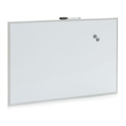 | 2 | ☐ Yes  ☐ No
2. | Writing and magnet glass board  - Height 600 x Width 900 mm  - Writing and magnet function  - Made of tempered glass, minimum 4 mm thick, scratch-free; rounded corners; no visible mountings; white colour;  - Complete with a pen shelf and fixings for wall mounting (no visible);  - Minimum Warranty: 3 (three) years | 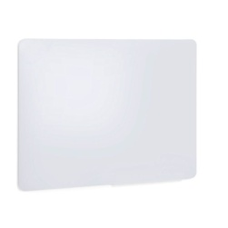 | 8 | ☐ Yes  ☐ No
3. | Writing and magnet glass board  - Height 900 x Width 1200 mm  - Writing and magnet function  - Made of tempered glass, minimum 4 mm thick, scratch-free; rounded corners; no visible mountings; white colour;  - Complete with a pen shelf and fixings for wall mounting (no visible);  - Minimum Warranty: 3 (three) years |  | 1 | ☐ Yes  ☐ No
4. | Writing and magnet white board  - Height 1200 x Width 2000 mm  - Writing and magnet function  - Made of high quality, durable glass-enamel, scratch-free; white colour;  - Complete with a pen shelf and fixings for wall mounting;  - Made of at least 30% recycled materials.  - Minimum Warranty: 20 (twenty) years | 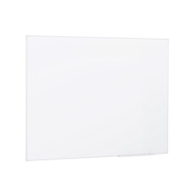 | 1 | ☐ Yes  ☐ No
5. | Frameless writing and magnet optic glass board  - Height 500 x Width 500 mm  - Writing and magnet function  - Made of optic tempered glass, 4-6 mm thick, high-gloss; scratch-free; no visible mountings; various colours;  - Complete with a pen shelf and fixings for wall mounting;  - Minimum Warranty: 3 (three) years | 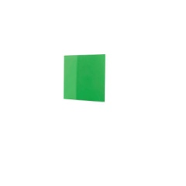 | 2 | ☐ Yes  ☐ No
6. | Writing and magnet glass board, double-sided; with stand and wheels  - Board Height 900 x Width 1200 mm  - Total Height min. 1800 mm  - Writing and magnet function  - Board made of laminated glass, minimum 8 mm thick; metal-framed; scratch-free; white colour;  - Construction made of robust metal, allowing horizontal rotation; with lockable wheels;  - Complete with a pen shelf;  - Minimum Warranty: 3 (three) years | 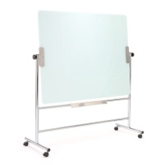 | 2 | ☐ Yes  ☐ No

LOT 2
Item No | Description | Equal or similar to below illustration | Qty | Is  Bid compliant? Bidder to complete | Details of goods offered.  (model, brand, description, catalogue reference)  Bidder to complete
1. | set of 10 magnets for white board  - standard |  | 4 | ☐ Yes  ☐ No
2. | set of 10 magnets for glass board magnets  - extra strong |  | 12 | ☐ Yes  ☐ No
3. | set of 6 dry-erase markers for white & glass boards  - low-odor, non-permanent, non-toxic | 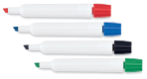 | 16 | ☐ Yes  ☐ No
4. | eraser for dry-erase of white & glass boards,  - dry-erase  - ergonomically designed plastic with fabric pads  - magnetic function | 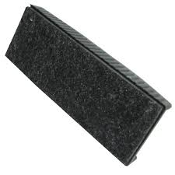 | 16 | ☐ Yes  ☐ No
5. | Spray cleaner for white & glass board  - removes permanent markers, ink, ghosting and residues  - non-toxic, biodegradable, low odour  - min. 250 ml, pump spray | 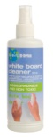 | 16 | ☐ Yes  ☐ No
6. | Vertical brochures holder  - for portrait layout, A4 documents  - 4 levels  - plastic | 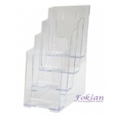 | 2 | ☐ Yes  ☐ No

LOT 3
Item No | Description | Equal or similar to below illustration | Qty | Is  Bid compliant? Bidder to complete | Details of goods offered.  (model, brand, description, catalogue reference)  Bidder to complete
1. | Desk document holder  - With solid heavy stand, A4 portrait, folding type, minimum 10 panels, made of sheet steel;  - Minimum Warranty: 3 years | 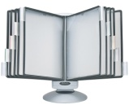 | 16 | ☐ Yes  ☐ No
2. | Panels for desk document holder  - packs of 10, assorted colours  - double sided opening for each panel, allowing two documents in each frame.  - Made of 100% transparent polypropylene  - The frames are flexible and bendable | 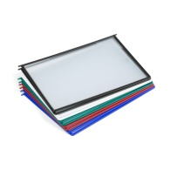 | 12 | ☐ Yes  ☐ No

LOT 4
Item No | Description | Equal or similar to below illustration | Qty | Is  Bid compliant? Bidder to complete | Details of goods offered.  (model, brand, description, catalogue reference)  Bidder to complete
1. | Self-standing sound absorbing floor divider  - filling that is certified for sound absorption by a renowned research institute.  - solid frame upholstered in fabric.  - Widtht 800 x Height 1700 mm  - Thickness: min. 5 cm  - Minimum Warranty: 3 years | 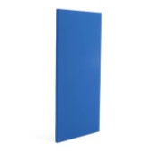 | 1 | ☐ Yes  ☐ No
2. | Feet for floor self standing dividers  - One pair (2 pcs) of compatible feet for floor standing office divider.  - Height Min. 4 cm | 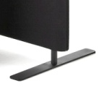 | 1 | ☐ Yes  ☐ No

Delivery requirements –– Comparative Data Table

- Quotations shall remain valid for acceptance by UNOPS for 90 days from the Deadline for Quotation Submission. ☐ Yes
- Payment terms 30 days accepted: ☐ Yes

UNOPS Requirements |  | Is quotation compliant? Bidder to complete | Details  Bidder to complete  Insert details
Delivery time | Bidder shall deliver the goods latest 60 (sixty) calendar days after the signature of Purchase Order | ☐ Yes ☐ No
Delivery place and Incoterms rules | Net of any direct taxes, customs duties, indirect taxes and VAT.  DAP (Delivered at Place)  Transportation and offload of the equipment must be included in the price. | ☐ Yes ☐ No
Consignee details | UNOPS RSOC  Skerlićeva 4  11000 Belgrade  Serbia | ☐ Yes ☐ No
UNOPS Right to vary requirements | At the time the Contract is awarded, UNOPS reserves the right to vary the quantity of the goods and associated services specified above, provided this does not exceed +/- 300%, without any change in the unit prices or other terms and conditions of the RFQ. | ☐ Yes ☐ No

The offered goods and related services (if applicable) are in accordance with the required specifications and requirements specified in Section III: Schedule of Requirements.

☐ Yes ☐ No

ANY DEVIATION MUST BE LISTED BELOW:
_________________________________________________________________________________________________________________________________________________________________________________________________________________________________________________________________________________________________________________________________________________________________________________________________________________________________________

Name : _____________________________________________________________

Title : _____________________________________________________________

Date : _____________________________________________________________

Signature : _____________________________________________________________

Form D: Previous experience form

RFQ reference no: [insert RFQ reference No.]
Name of Bidder: [insert name of Bidder]

Description of services/goods | Country | Total amount of Contract | Contract Identification and Title and  Contact details of Client  (Name, Address, telephone, email, fax) | Year project was undertaken

Name : _____________________________________________________________

Title : _____________________________________________________________

Date : _____________________________________________________________

Signature : _____________________________________________________________

75 00ax: +45 45 33 75 01

