Version: v2016.1
Returnable Bidding Forms
Purchase of Office furniture in support to Youth Self-employment
RFQ Ref No: UNOPS-EP-2016-G-114

Section IV: Returnable Bidding Forms
Note to Bidders: Instructions to complete each Form are highlighted in blue in each Form. Please complete the Returnable Biding Forms as instructed and return them as part of your quotation.

The following returnable forms are part of this RFQ and must be completed and returned by bidders as part of their Quotation.

Form A: Quotation submission form
Bidders are requested to complete this form, sign it and return it as part of their bid submission. The bidder shall fill in this form in accordance with the instructions indicated. No alterations to its format shall be permitted and no substitutions shall be accepted.
Date: [Insert submission date]____________________________

Subject: Quotation for the supply of [Insert a brief description of goods/services] __________________________________in ________________________________[Name of country/city], RFQ Case No.[insert RFQ ref number]_______________________________, dated [insert date]_____________________.

We, the undersigned, declare that:
  - We offer to supply in conformity with the bidding documents, including the UNOPS General Conditions of Contract.
  - Our quotation shall be valid for the period of time of [insert number of days which shall not be less than the specified in Section I: Bid Particulars, Period of Validity of Bids] _________________from the date fixed for the bid submission deadline as set out in the RFQ, and it shall remain binding upon us and may be accepted at any time before the expiration of that period;
  - We have no conflict of interest in any activity that would put it, if selected for this assignment, in a conflict of interest with UNOPS;
  - Our firm confirms that the offeror and sub-contractors have not been associated, or had been involved in any way, directly or indirectly, with the preparation of the design, terms of references and/or other documents used as a part of this solicitation;
  - Our firm, its affiliates or subsidiaries—including any subcontractors or suppliers for any part of the Contract—has not been declared ineligible by UNOPS, nor is included in the suspended/ineligibility list of the UN/PD, other UN Agencies, the UN Security Council, and the World Bank, in accordance with Instructions to Bidders Article 3, Eligibility;
  - We embrace the UN Supplier Code of Conduct and adhere to the principles of the UN Global Compact
  - We have not declared bankruptcy, are not involved in bankruptcy or receivership proceedings, and there is no judgment or pending legal action against them that could impair their operations in the foreseeable future.
  - We have not offered and will not offer fees, gifts and/or favours of kind in exchange for this RFQ and will not engage in any such activity during the performance of any Contract awarded.
I, the undersigned, certify that I am duly authorized by [insert full name of bidder] ________________________________to sign this quotation and bind [insert full name of bidder] should UNOPS accept this quotation:
Name: [complete]_______________________________________________________
Title: [complete]_________________________________________________________
Signature: _____________________________________________________________

Provide the name and contact information for the primary contact from your company for this quotation:

Name: [complete]________________________________________________________
Title: [complete]__________________________________________________________
Email address: [complete]___________________________________________________
Telephone: [complete]______________________________________________________

Form B: Price Schedule Form
Bidders shall fill in this Price Schedule Form in accordance with the instructions indicated.

RFQ reference no: [insert RFQ reference No.]

Currency | RSD

Item No | Description | Qty | Unit price DAP  (VAT exempted) | Total price DAP (VAT exempted)
LOT 1 Office furniture and equipment
1.1 | Office desk 1 | 6
1.2 | Office chair 1 | 6
1.3 | Office desk 2 | 4
1.4 | Club table | 1
1.5 | Open cabinet | 3
1.6 | Drawer cabinet | 2
1.7 | Magnetic white board | 1
1.8 | Office desk 3 | 3
1.9 | Office chair 2 | 2
1.10 | Conference chair | 15
1.11 | Office cabinet | 1
1.12 | Office desk 4/A | 4
1.13 | Office desk 4/B | 1
1.14 | Office chair 3 | 5
1.15 | Desk lamp | 5
Total Price for Lot 1 VAT exempted
LOT 2 Office chairs and desks
2.1 | Chair A | 10
2.2 | Chair B | 2
2.3 | Office armchair | 4
2.4 | Office desk 2/A | 2
Total Price for Lot 2 VAT exempted

NOTES:
- Transportation, offload, assembly and installation of the equipment on the beneficiaries’ premises must be included in the price.
- The offered prices are net of any direct taxes, customs duties and indirect taxes and VAT.

Payment terms 30 days accepted: ☐ Yes

- List of subcontractors or suppliers
Bidder must identify the names of all subcontractors/suppliers who will be providing good/services under this Contract and the type of work being subcontracted, if applicable.
[Full legal name and address of subcontractors]

- _________________________________________________

- _________________________________________________

- _________________________________________________

- List of legal entities associated to the Bidder
Bidder must also identify and disclose any information regarding all legal entity/s associated to it, by providing their full legal name and address:
[Full legal name and address of the associated legal entity]

- _________________________________________________

- _________________________________________________

- _________________________________________________

In case of no related entities, the Bidder must sign the following statement to that effect:
[Delete or cross out if not applicable]:
I, the undersigned, certify that there are no legal entities associated to the [insert full name of Bidder]
____________________________________________________. [

- Authorization to sign quotation
I, the undersigned, certify that I am duly authorized by [insert full name of Bidder]
____________________________________________________ to sign this quotation and bind
____________________________________________________[insert full name of Bidder] should UNOPS accept this quotation:

Name : _____________________________________________________________

Title : _____________________________________________________________

Date : _____________________________________________________________

Signature : _____________________________________________________________

Form C: Technical Quotation Form

RFQ reference no: [insert RFQ reference No.]______________________________________
Name of Bidder: [insert name of Bidder]___________________________________________

Bidders are required to complete the Comparative Data Tables included in Section III: Schedule of Requirements to demonstrate compliance with UNOPS requirements and insert them below. Bidders are NOT allowed to make any change in the “UNOPS requirements” columns of the Comparative Data Tables. Such changes might disqualify your quotation.

Technical specifications for goods – Comparative Data Table

Item No | UNOPS minimum technical requirements | Quantity | Is Bid compliant? Bidder to complete | Details of goods offered. Bidder to complete
LOT 1 Office furniture and equipment
1.1 | Office desk 1  Material: 18 mm univer, edging 2mm ABS  Design: sonoma oak or beech nature  1 drawer, connecting panel between side panels  Table top opening for cables management  Minimum dimensions:  width 100 cm  depth 50 cm  height 74 cm  _____________________________________  Kancelarijski sto 1  Materijal izrade: 18 mm univer, kantovanje 2mm ABS trakom  Dezen: sonoma hrast ili bukva natur  1 fijoka, vezivna ploča izmedju bočnih strana  Otvor za kablove na radnoj ploči stola  Dimenzije minimalno:  širina 100 cm  dubina 50 cm  visina 74 cm  _____________________________________  Equal or similar to the model/picture below:  Jednako ili slično modelu / slici ispod:  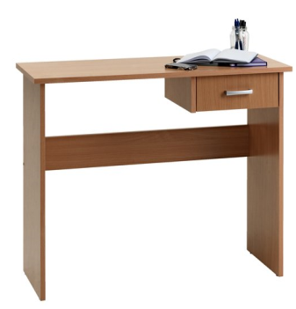  Note: Colours as requested in technical description/Boje kao sto je trazeno u tehnickom opisu | 6
1.2 | Office chair 1  Seat and backrest: eco leather, black colour  Armrests  Height adjusting function  Plastic base with plastic wheels  _____________________________________________  Kancelarijska stolica 1  Sedište i naslon: eko koža, boja crna  Rukonasloni  Funkcija podešavanja visine  Plastična baza sa plastičnim točkićima  ______________________________________________  Equal or similar to the model/picture below:/  Jednako ili slično modelu /slici ispod:  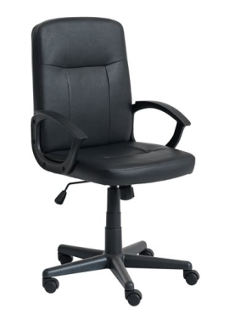  Note: Colours as requested in technical description/Boje kao sto je trazeno u tehnickom opisu | 6
1.3 | Office desk 2  Office desk with metal construction and legs  Worktop: 25mm univer, beech colour, edging 2mm ABS  Worktop laid and fixed on metal construction (no distance between worktop and metal construction)  Metal construction and legs: metal pipes profile 45x45 mm minimum, white colour, legs in quadrate shape, protective pads on desk legs  Table top openings for cable management  Dimensions : height 70, width 60cm , length 145  _________________________________________  Kancelarijski sto 2  Kancelarijski sto sa metalnom konstrikcijom i nogama  Radna ploča: 25mm univer, boja bukva, kantovanje 2mm ABS  Radna ploča položena I fiksirana na metalnu konstrukciju (ploča nije distancirana od metalne konstrukcije)  Metalna konstrukcija i noge stola: metalne cevi profila 45x45 mm minimalno, boja bela, noge u obliku kvadrata, zaštitne gumice na nogama stola  Otvori za sprovođenje kablova kroz ploču stola  Dimenzije : visina 70, širina 60cm , dužina 145 cm  ____________________________________________  Equal or similar to the model / picture below:  Jednako ili slično modelu/ slici ispod:  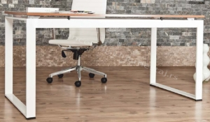  Note: Colours as requested in technical description/Boje kao sto je trazeno u tehnickom opisu | 4
1.4 | Club table  Office desk with metal construction and legs  Worktop: 25mm univer, beech colour, edging 2mm ABS  Metal construction and legs: metal pipes profile 45x45 mm minimum, white colour, legs in quadrate shape, protective pads on desk legs  Dimensions : height 70, width 60cm , length 145  ________________________________________  Klub sto  Klub sto sa metalnom konstrikcijom i nogama  Radna ploča: 25mm univer, boja bukva, kantovanje 2mm ABS  Metalna konstrukcija i noge stola: metalne cevi profila 45x45 mm minimalno, boja bela, noge u obliku kvadrata, zaštitne gumice na nogama stola  Dimenzije : visina 50 cm, širina 50cm , dužina 80 cm  ________________________________________  Equal or similar to the model / picture below:  Jednako ili slično modelu/ slici ispod:  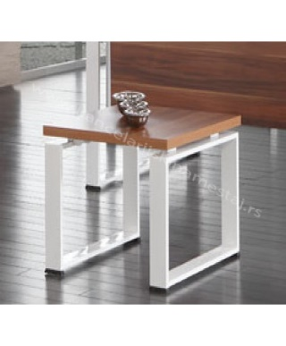  Note: Colours as requested in technical description/Boje kao sto je trazeno u tehnickom opisu | 1
1.5 | Open cabinet  Open cabinet vertical  Minimum 4 height adjustable shelves  Dimensions: width 95cm x height 191.8cm x depth 35cm  Cabinet made of 18 mm univer tops, with upper and sides univer tops of 25 mm  All tops and construction: white colour with 2 mm ABS edging  Backside: HDF, 3.2 mm depth  ________________________________________  Orman otvoren  Vertikalni orman otvoren  Minimalno 4 police podesive po visini  Dimenzije: sirina 95cm x visina 191.8cm x dubina 35cm  Orman izradjen od univer ploča debljine 18mm sa gornjom pločom i bocnim stranicama debljine 25mm.  Sve stranice I konstrukcija bele boje I kantovane ABS trakom- 2mm.  Poleđina: HDF ploča debljine 3.2mm.  ______________________________________  Equal or similar to the model/picture below:/  Jednako ili slicno modelu/ slici ispod:  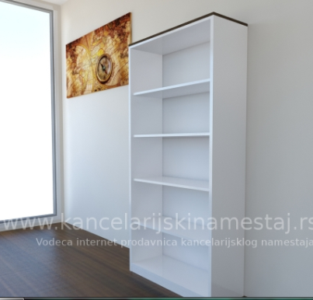  Note: Colours as requested in technical description/Boje kao sto je trazeno u tehnickom opisu | 3
1.6 | Drawer cabinet  Dimensions: width 42cm x height 63cm x depth 60cm  3 drawers  Drawer cabinet made of 18 mm univer tops, with upper and sides univer top of 25 mm  All tops and construction: white colour with 2 mm ABS edging  First drawer locking with “Solido” lock  _________________________________  Fijokar  Dimenzije: širina 42cm x visina 63cm x dubina 60cm  3 fijoke  Fijokar izradjen od univer ploča debljine 18mm sa gornjom pločom debljine 25mm.  Sve strane i konstrukcija fijokara bele boje i kantovane ABS trakom 2mm.  Zaključavanje prve fioke sa "Solido" bravicom  _______________________________________  Equal or similar to the model/picture below:/  Jednako ili slicno modelu/ slici ispod:  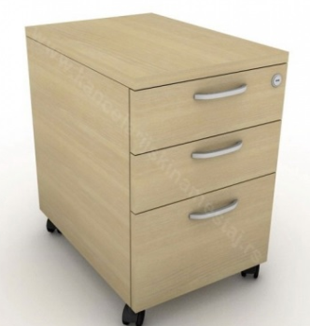  Note: Colours as requested in technical description/Boje kao sto je trazeno u tehnickom opisu | 2
1.7 | Magnetic white board  Mobile board on stand with wheels  Rotating white magnetic board, with built-in mechanism for fixing the position or peg which enable table fixing in start position  Board usable on both sides  Board dimensions: 120x180 cm  ________________________________________  Magnetna bela tabla  Tabla na postolju sa točkovima, pokretna  Bela magnetna tabla okretna/ rotirajuća, sa ugrađenim mehanizmom za fiksiranje položaja ili zubom kojim se tabla prilikom rotiranja može zakočiti u početnom položaju  Tabla iskoristiva sa obe strane  Površina table: 120x180 cm  ________________________________________  Equal or similar to the model/picture below:/  Jednako ili slicno modelu/ slici ispod:  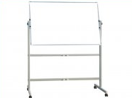 | 1
1.8 | Office desk 3  Worktop: 25mm univer, colour black, edging 2mm ABS  Construction and desk legs: metal pipes profile 45x45 mm minimum, colour white, legs in“П” shape, protective pads on desk legs  Dimensions: 140x80x74 (h)  _________________________________  Kancelarijski sto 3  Radna ploča: 25mm univer, boja crna, kantovanje 2mm ABS  Konstrukcija i noge stola: metalne cevi profila 45x45 mm minimalno, boja bela, noge u obliku slova “П”, zaštitne gumice na nogama stola  Dimenzije: 140x80x74 (h)  _________________________________  Equal or similar to the model/picture below:/  Jednako ili slično modelu/ slici ispod:  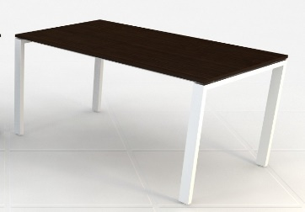  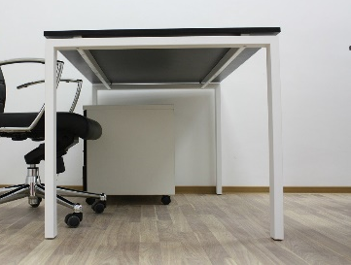  Note: Colours as requested in technical description/Boje kao sto je trazeno u tehnickom opisu | 3
1.9 | Office chair 2  Lumbar support  Mesh backrest, colour black  Adjustable armrests  Headrest, fabric or microfiber, colour black  Seat upholstered in fabric or microfiber, colour black  Synchro mechanism  Adjustable height  Liftomat  Metal base with rubber or plastic rollers  ____________________________________  Kancelarijska stolica 2  Lumbalni podupirač  Mrežni naslon, boja crna  Podesivi rukonasloni  Naslon za glavu, štof ili microfiber, boja crna  Sedište tapacirano u štofu ili mikrofiber, boja crna  Sinhro mehanizam  Podesiva po visini  Liftomat  Metalna baza sa gumenim ili plastičnim točkićima  _____________________________________  Equal or similar to the model/picture below:/  Jednako ili slicno modelu/ slici ispod:  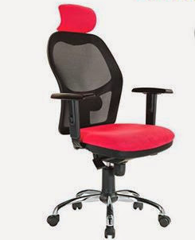  Note: Colours as requested in technical description/Boje kao sto je trazeno u tehnickom opisu | 2
1.10 | Conference chair  Seat and back upholstered, fabric, colour black  Metal frame, colour black  Legs with protective pads  _________________________________  Konferencijska stolica  Sedište i naslon tapacirani u štofu, boja crna  Metalna konstrukcija, boja crna  Zaštitne gumice na nogama stolice  _______________________________________  Equal or similar to the model/picture below:/  Jednako ili slicno modelu/ slici ispod:  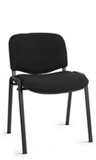  Note: Colours as requested in technical description/Boje kao sto je trazeno u tehnickom opisu | 15
1.11 | Office cabinet  File cabinet vertical  2 doors  Minimum 4 height adjustable shelves  Dimensions: 80x35x195 cm (width x depth x height)  Frame: 25 mm univer, black colour, 2 mm ABS edging  Doors: 25 mm univer, white colour, 2 mm ABS edging  Backside: 10 mm refined chipboard (univer),  Hinges with integrated “soft close” mechanism  Handles on doors, lock, two keys  Optional: Plinth 5- 10 cm  ______________________________________  Kancelarijski orman  Vertikalni orman za registratore  2 vrata  Minimum 4 police podesive po visini  Dimenzije: 80x35x195 cm (širina x dubina x visina)  Konstrukcija: 25 mm univer, boja crna, kantovanje 2mm ABS trakom  Vrata: 25 mm univer, boja bela, kantovanje 2mm ABS trakom  Poleđina: 10 mm univer  Šarke sa integrisanim “soft close” mehanizmom  Ručice na vratima, brava sa dva ključa  Opciono: cokla 5-10 cm  __________________________________________  Equal or similar to the model/picture below:/  Jednako ili slicno modelu/ slici ispod:  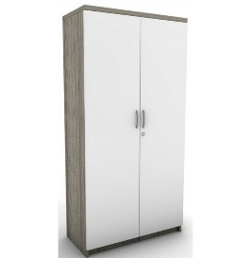  Note: Colours as requested in technical description/Boje kao sto je trazeno u tehnickom opisu | 1
1.12 | Office desk 4/A  Worktop: 25 mm univer black colour, 2 mm ABS edging  Construction and legs: metal pipes profile 45x45 mm minimum, colour grey, legs in " П " shape ,protective pads on legs  Openings for the cables on worktop  Dimensions: 160x80x74 (h)  _________________________________________  Kancelarijski sto 4/A  Radna ploča: 25mm univer, boja crna, kantovanje 2mm ABS  Konstrukcija i noge stola: metalne cevi profila 45x45 mm minimalno, boja siva, noge u obliku slova “П”, zaštitne gumice na nogama stola  Otvori za kablove na radnoj ploči stola  Dimenzije: 160x80x74 (h)  _________________________________________  Equal or similar to the model/picture below:/  Jednako ili slicno modelu/ slici ispod:  Note: Colours as requested in technical description/Boje kao sto je trazeno u tehnickom opisu | 4
1.13 | Office desk 4/B  Worktop: univer, white colour, 2 mm ABS edging  Construction and legs: metal tube profile 45x45 mm minimum, colour white, legs in the shape of the letter " П ", protective pads on legs  Openings for the cables on worktop  Dimensions: 160x80x74 (h)  ________________________________________  Kancelarijski sto 4/B  Radna ploča: 25mm univer, boja bela, kantovanje 2mm ABS  Konstrukcija i noge stola: metalne cevi profila 45x45 mm minimalno, boja bela, noge u obliku slova “П”, zaštitne gumice na nogama stola  Otvori za kablove na radnoj ploči stola  Dimenzije: 160x80x74 (h)  ________________________________________  Equal or similar to the model: see the model for item No12  Jednako ili slicno modelu: videti model za artikal broj 12  Note: Colours as requested in technical description/Boje kao sto je trazeno u tehnickom opisu | 1
1.14 | Office chair 3  Seat: fabric, color black.  Backrest: tekstilen/mesh, colour black or grey  Adjustable headrest, fabric, colour black  Armrests  Function of height adjusting  Adjusting backrests  Metal base with plastic or rubber wheels  ______________________________________  Kancelarijska stolica 3  Sedište: štof, boja crna.  Naslon: tekstilen/mreža, boja crna ili siva.  Podesivi naslon za glavu, štof, boja crna  Rukonasloni  Funkcija podešavanja visine  Podešavanje naslona za leđa  Metalno postolje sa plastičnim ili gumenim točkićima  ___________________________________________  Equal or similar to the model/picture below:/  Jednako ili slicno modelu/ slici ispod:  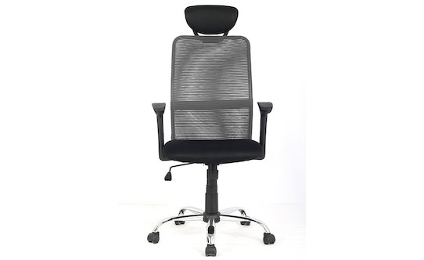  Note: Colours as requested in technical description/Boje kao sto je trazeno u tehnickom opisu | 5
1.15 | Desk lamp  Metal lamp  White color  Adjustable height and position  ___________________________________  Lampa za radni sto  Metalna lampa  Boja bela  Podesiva po visini i položaju  ____________________________________  Equal or similar to the model (picture below):/  Jednako ili slično modelu Firmo ( slika ispod): Firmo  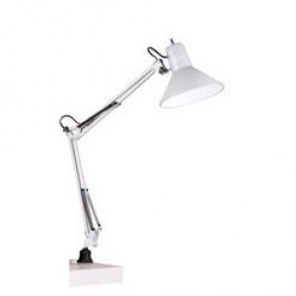 | 5
LOT 2 Office chairs and desks
2.1 | Chair A  Material: ABS plastic, wood, metal  Seat: ABS plastic, white colour  Chair legs: beech wood connected with metal rods  __________________________________________  Stolica A  Materijal: ABS plastika, drvo, metal  Sedište: ABS plastika, boja bela  Noge: od bukovog drveta povezane metalnim šipkama  __________________________________________  Equal or similar to the model/picture below:/  Jednako ili slično modelu /slici ispod:  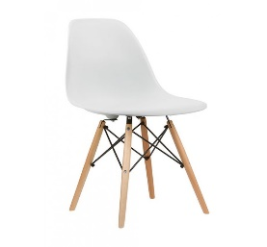 | 10
2.2 | Chair B  Material: ABS plastic, wood, metal  Chair legs: beech wood connected with metal rods  Seat: ABS plastic, white colour  Dimensions: width 60cm ; depth 70cm; height 70c  _________________________________________  Stolica B  Materijal: ABS plastika, drvo, metal  Noge: od bukovog drveta povezane metalnim šipkama  Sedište: ABS plastika, boja bela  Dimenzije: širina 60cm ; dubina 70cm; visina 70cm  _________________________________________  Equal or similar to the model/picture below:/  Jednako ili slično modelu /slici ispod:  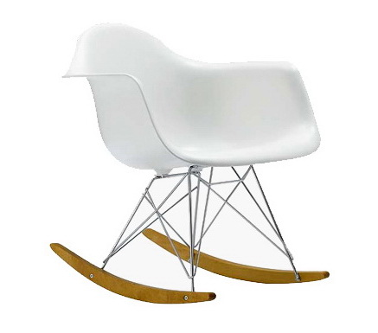 | 2
2.3 | Office armchair  Material: ABS plastic, wood, metal, textile  Colour: fabric with design or patchwork  Chair legs: beech wood connected with metal rods  Seat: ABS plastic, fabric with design or patchwork  ___________________________________  Kancelarijska fotelja  Materijal: ABS plastika, drvo, metal, tekstil  Boja: štof sa dezenom ili pačvork  Noge: od bukovog drveta povezane metalnim šipkama  Sedište: ABS plastika, štof sa dezenom ili pačvork  ____________________________________  Equal or similar to the model/picture below:/  Jednako ili slično modelu /slici ispod:  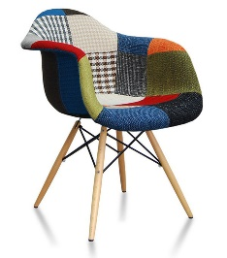 | 4
2.4 | Office desk 2/A  Office desk, white colour  Worktop: farbani medijapan  Legs: beech wood  Dimensions : width 80cm, height 76, length 120 cm  __________________________________  Kancelarijski sto 2/A  Kancelarijski sto bele boje  Radna ploča: medijapan farbani, boja bela,  Noge od bukovog drveta  Dimenzije: širina 80cm, visina 76 cm, dužina 120 cm  __________________________________  Equal or similar to the model / picture below:  Jednako ili slično modelu/ slici ispod:  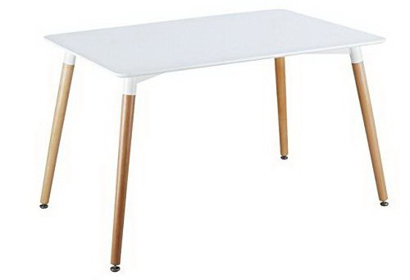 | 2

Delivery requirements –– Comparative Data Table

UNOPS Requirements |  | Is quotation compliant? Bidder to complete | Details  Bidder to complete  Insert details
Delivery time | Bidder shall deliver the goods 20 (Twenty) calendar days after the Contract signature. | ☐ Yes ☐ No
Delivery place and Incoterms rules | Net of any direct taxes, customs duties, indirect taxes and VAT.  DAP (Delivered at Place, as per Incoterms 2010):  Beneficiaries in Raska, Novi Pazar, Leskovac and Bujanovac, as per the distribution list shown below.  Transportation, offload, assembly and installation of the equipment on the beneficiary’s premises are included in the price | ☐ Yes ☐ No
Consignee details | The exact address the goods shall be delivered and offloaded to, as well as all other relevant details, will be available upon contract signature. | ☐ Yes ☐ No
UNOPS Right to vary requirements | At the time the Contract is awarded, UNOPS reserves the right to vary the quantity of the goods and associated services specified above, provided this does not exceed +/- 20%, without any change in the unit prices or other terms and conditions of the RFQ. | ☐ Yes ☐ No

Distribution list
The exact addresses of beneficiaries and contact details will be part of the contract.

No. / Br. | Item | Raška | Novi Pazar | Leskovac | Bujanovac
LOT 1 Office furniture and equipment
1,1 | Office desk 1 | 6
1,2 | Office chair 1 | 6
1,3 | Office desk 2 |  | 4
1,4 | Club table |  | 1
1,5 | Open cabinet |  | 3
1,6 | Drawer cabinet |  | 2
1,7 | Magnetic white board |  | 1
1,8 | Office desk 3 |  |  | 3
1,9 | Office chair 2 |  |  | 2
1.1 0 | Conference chair |  |  | 15
1,11 | Office cabinet |  |  | 1
1,12 | Office desk 4/A |  |  |  | 4
1,13 | Office desk 4/B |  |  |  | 1
1,14 | Office chair 3 |  |  |  | 5
1,15 | Desk lamp |  |  |  | 5
LOT 2 Conference chairs
2,1 | Chair A |  | 10
2,2 | Chair B |  | 2
2,3 | Office armchair |  | 4
2,4 | Office desk |  | 2

The offered goods and related services (if applicable) are in accordance with the required specifications and requirements specified in Section III: Schedule of Requirements.

☐ Yes ☐ No
ANY DEVIATION MUST BE LISTED BELOW:
___________________________________________________________________________________________________________________________________________________________________________________________________________________________________________________________________________________________________________________________________________________________________________________________________________________________________________________

Name : _____________________________________________________________

Title : _____________________________________________________________

Date : _____________________________________________________________

Signature : _____________________________________________________________

Form D: Previous experience form
RFQ reference no: [insert RFQ reference No.] ______________________________________
Name of Bidder: [insert name of Bidder] ______________________________________

Description of services/goods | Country | Total amount of Contract | Contract Identification and Title and  Contact details of Client:  (Name, Address, telephone, email, fax) | Year project was undertaken

Name : _____________________________________________________________

Title : _____________________________________________________________

Date : _____________________________________________________________

Signature : _____________________________________________________________75 00ax: +45 45 33 75 01

