Version: v2016.1
Returnable Bidding Forms
Purchase of automatic line for production of beehives Wax foundations in support to Youth self-employment
RFQ Ref No: UNOPS-EP-2016-G-096

Section IV: Returnable Bidding Forms
Note to Bidders: Instructions to complete each Form are highlighted in blue in each Form. Please complete the Returnable Biding Forms as instructed and return them as part of your quotation.

The following returnable forms are part of this RFQ and must be completed and returned by bidders as part of their Quotation.

Form A: Quotation submission form
Bidders are requested to complete this form, sign it and return it as part of their bid submission. The bidder shall fill in this form in accordance with the instructions indicated. No alterations to its format shall be permitted and no substitutions shall be accepted.
Date: [Insert submission date]____________________________

Subject: Quotation for the supply of [Insert a brief description of goods/services] __________________________________in ________________________________[Name of country/city], RFQ Case No.[insert RFQ ref number]_______________________________, dated [insert date]_____________________.

We, the undersigned, declare that:
  - We offer to supply in conformity with the bidding documents, including the UNOPS General Conditions of Contract.
  - Our quotation shall be valid for the period of time of [insert number of days which shall not be less than the specified in Section I: Bid Particulars, Period of Validity of Bids] _________________from the date fixed for the bid submission deadline as set out in the RFQ, and it shall remain binding upon us and may be accepted at any time before the expiration of that period;
  - We have no conflict of interest in any activity that would put it, if selected for this assignment, in a conflict of interest with UNOPS;
  - Our firm confirms that the offeror and sub-contractors have not been associated, or had been involved in any way, directly or indirectly, with the preparation of the design, terms of references and/or other documents used as a part of this solicitation;
  - Our firm, its affiliates or subsidiaries—including any subcontractors or suppliers for any part of the Contract—has not been declared ineligible by UNOPS, nor is included in the suspended/ineligibility list of the UN/PD, other UN Agencies, the UN Security Council, and the World Bank, in accordance with Instructions to Bidders Article 3, Eligibility;
  - We embrace the UN Supplier Code of Conduct and adhere to the principles of the UN Global Compact
  - We have not declared bankruptcy, are not involved in bankruptcy or receivership proceedings, and there is no judgment or pending legal action against them that could impair their operations in the foreseeable future.
  - We have not offered and will not offer fees, gifts and/or favours of kind in exchange for this RFQ and will not engage in any such activity during the performance of any Contract awarded.
I, the undersigned, certify that I am duly authorized by [insert full name of bidder] ________________________________to sign this quotation and bind [insert full name of bidder] should UNOPS accept this quotation:
Name: [complete]_______________________________________________________
Title: [complete]_________________________________________________________
Signature: _____________________________________________________________

Provide the name and contact information for the primary contact from your company for this quotation:

Name: [complete]________________________________________________________
Title: [complete]__________________________________________________________
Email address: [complete]___________________________________________________
Telephone: [complete]______________________________________________________

Form B: Price Schedule Form
Bidders shall fill in this Price Schedule Form in accordance with the instructions indicated.

RFQ reference no: [insert RFQ reference No.]

Currency | RSD

Item No | Description | Qty | Unit price DAP  (VAT exempted) | Total price DAP (VAT exempted)
1 | Dryer (combined) | 1
Total Price VAT exempted

NOTES:
- Transportation, offload, assembly and installation of the equipment on the beneficiaries’ premises must be included in the price, as well as the short instruction training.
- The offered prices are net of any direct taxes, customs duties and indirect taxes and VAT.
Payment terms 30 days accepted: ☐ Yes

- List of subcontractors or suppliers
Bidder must identify the names of all subcontractors/suppliers who will be providing good/services under this Contract and the type of work being subcontracted, if applicable.
[Full legal name and address of subcontractors]

- _________________________________________________

- _________________________________________________

- _________________________________________________

- List of legal entities associated to the Bidder
Bidder must also identify and disclose any information regarding all legal entity/s associated to it, by providing their full legal name and address:
[Full legal name and address of the associated legal entity]

- _________________________________________________

- _________________________________________________

- _________________________________________________

In case of no related entities, the Bidder must sign the following statement to that effect:
[Delete or cross out if not applicable]:
I, the undersigned, certify that there are no legal entities associated to the [insert full name of Bidder]
____________________________________________________. [

- Authorization to sign quotation
I, the undersigned, certify that I am duly authorized by [insert full name of Bidder]
____________________________________________________ to sign this quotation and bind
____________________________________________________[insert full name of Bidder] should UNOPS accept this quotation:

Name : _____________________________________________________________

Title : _____________________________________________________________

Date : _____________________________________________________________

Signature : _____________________________________________________________

Form C: Technical Quotation Form

RFQ reference no: [insert RFQ reference No.]______________________________________
Name of Bidder: [insert name of Bidder]___________________________________________

Bidders are required to complete the Comparative Data Tables included in Section III: Schedule of Requirements to demonstrate compliance with UNOPS requirements and insert them below. Bidders are NOT allowed to make any change in the “UNOPS requirements” columns of the Comparative Data Tables. Such changes might disqualify your quotation.

Technical specifications for goods – Comparative Data Table

Item No | UNOPS minimum technical requirements | Quantity | Is Bid compliant? Bidder to complete | Details of goods offered. Bidder to complete
1 | Automatic line for production of wax foundations  Technical characteristics:  The method of wax foundations making: cold rolling  Equipment/elements of line for wax foundations is composed of stand on which following elements are installed:  - Container volume of 30 liters (vessels with double bottom, heaters and temperature control)  - Drum for making endless wax strips  - Container for water for preparation of wax strip rolling  - Rollers for engraving the base of cells  - Control panel in the control box  - Knives for formatting the width of wax strips  - Knives for cross-cutting of wax strips (formatting the length of wax strips)  Automatic line with motors of 0.37kW power which via engine reductor provides starting-up of drum for wax strip and rollers for engraving  Speed control of rollers for engraving via frequency converter  Capacy: 20-30kg of honeycomb foundations per hour  Honeycomb cells dimensions: 5.37mm  Dimensions of rollers for engraving : 280mm (diameter 70mm)  Device dimensions: approximately 3.000mm x 1000mm X 1800mm (h)  __________________________________  Automatska linija za proizvodnju satnih osnova  Tehničke karakteristike:  Metoda izrade satnih osnova: hladno valjanje  Oprema/ delovi linije za izradu satnih osnova sastoji se od postolja na kome su ugrađeni sledeći elementi:  - Posuda za vosak zapremine 30 litara (posuda sa duplim dnom, grejačima i regulacijom temperature)  - Doboš za izradu beskonačne voštane trake  - Posuda za vodu za pripremu voštane trake za valjanje  - Valjake za graviranje osnova ćelije  - Upravljački pult u komandnoj kutiji  - Noževi za širinsko formiranje trake izvučenih osnova  - Noževi za dužinsko/ poprečno sečenje voštane trake u gotove satne osnove  Automatska linija sa motorima snage 0.37kW koji preko reduktora pokreću doboš za glatku traku i valjake za graviranje  Kontrola brzine valjaka za graviranje preko frekventnog regulatora  Kapacitet: 20-30kg satnih osnova na sat  Dimenzija ćelija saća: 5.37mm  Dimenzija gravirajućih valjaka: 280mm ( prečnik 70mm)  Dimenzije mašine: približno 3.000mm x 1000mm X 1800mm (h)  __________________________________  Equal or similar to the picture below: /  Jednako ili slično slici ispod:  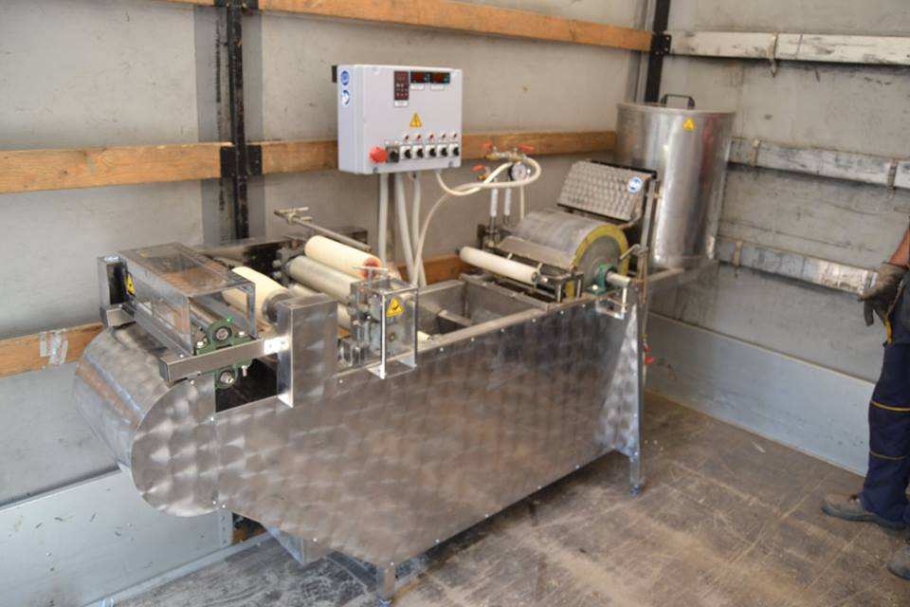  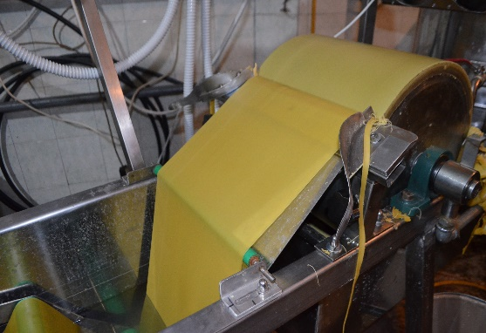  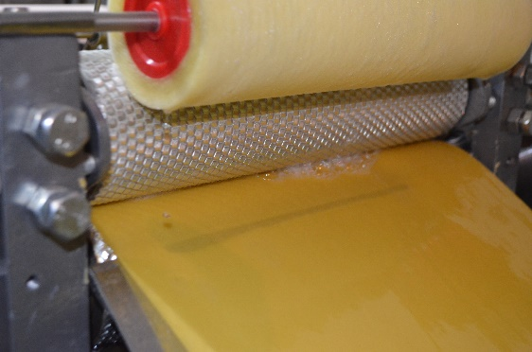 | 1

Delivery requirements –– Comparative Data Table

UNOPS Requirements |  | Is quotation compliant? Bidder to complete | Details  Bidder to complete  Insert details
Delivery time | Bidder shall deliver the goods 60 (Sixty) calendar days after the Contract signature. | ☐ Yes ☐ No
Delivery place and Incoterms rules | Net of any direct taxes, customs duties, indirect taxes and VAT.  DAP (Delivered at Place, as per Incoterms 2010):  Beneficiary in Bujanovac  Transportation, offload, assembly and installation of the equipment on the beneficiary’s premises are included in the price | ☐ Yes ☐ No
Consignee details | The exact address the goods shall be delivered and offloaded to, as well as all other relevant details, will be available upon contract signature. | ☐ Yes ☐ No
UNOPS Right to vary requirements | At the time the Contract is awarded, UNOPS reserves the right to vary the quantity of the goods and associated services specified above, provided this does not exceed +/- 20%, without any change in the unit prices or other terms and conditions of the RFQ. | ☐ Yes ☐ No

The offered goods and related services (if applicable) are in accordance with the required specifications and requirements specified in Section III: Schedule of Requirements.

☐ Yes ☐ No
ANY DEVIATION MUST BE LISTED BELOW:
___________________________________________________________________________________________________________________________________________________________________________________________________________________________________________________________________________________________________________________________________________________________________________________________________________________________________________________

Name : _____________________________________________________________

Title : _____________________________________________________________

Date : _____________________________________________________________

Signature : _____________________________________________________________

Form D: Previous experience form
RFQ reference no: [insert RFQ reference No.] ______________________________________
Name of Bidder: [insert name of Bidder] ______________________________________

Description of services/goods | Country | Total amount of Contract | Contract Identification and Title and  Contact details of Client:  (Name, Address, telephone, email, fax) | Year project was undertaken

Name : _____________________________________________________________

Title : _____________________________________________________________

Date : _____________________________________________________________

Signature : _____________________________________________________________75 00ax: +45 45 33 75 01

