Version: v2016.1
Returnable Bidding Forms
Purchase of Equipment and Furniture for Playrooms in support to Women Entrepreneurship
RFQ Ref No: UNOPS-EP-2016-G-086

Section IV: Returnable Bidding Forms
Note to Bidders: Instructions to complete each Form are highlighted in blue in each Form. Please complete the Returnable Biding Forms as instructed and return them as part of your quotation.

The following returnable forms are part of this RFQ and must be completed and returned by bidders as part of their Quotation.

Form A: Quotation submission form
Bidders are requested to complete this form, sign it and return it as part of their bid submission. The bidder shall fill in this form in accordance with the instructions indicated. No alterations to its format shall be permitted and no substitutions shall be accepted.
Date: [Insert submission date]____________________________

Subject: Quotation for the supply of [Insert a brief description of goods/services] __________________________________in ________________________________[Name of country/city], RFQ Case No.[insert RFQ ref number]_______________________________, dated [insert date]_____________________.

We, the undersigned, declare that:
  - We offer to supply in conformity with the bidding documents, including the UNOPS General Conditions of Contract.
  - Our quotation shall be valid for the period of time of [insert number of days which shall not be less than the specified in Section I: Bid Particulars, Period of Validity of Bids] _________________from the date fixed for the bid submission deadline as set out in the RFQ, and it shall remain binding upon us and may be accepted at any time before the expiration of that period;
  - We have no conflict of interest in any activity that would put it, if selected for this assignment, in a conflict of interest with UNOPS;
  - Our firm confirms that the offeror and sub-contractors have not been associated, or had been involved in any way, directly or indirectly, with the preparation of the design, terms of references and/or other documents used as a part of this solicitation;
  - Our firm, its affiliates or subsidiaries—including any subcontractors or suppliers for any part of the Contract—has not been declared ineligible by UNOPS, nor is included in the suspended/ineligibility list of the UN/PD, other UN Agencies, the UN Security Council, and the World Bank, in accordance with Instructions to Bidders Article 3, Eligibility;
  - We embrace the UN Supplier Code of Conduct and adhere to the principles of the UN Global Compact
  - We have not declared bankruptcy, are not involved in bankruptcy or receivership proceedings, and there is no judgment or pending legal action against them that could impair their operations in the foreseeable future.
  - We have not offered and will not offer fees, gifts and/or favours of kind in exchange for this RFQ and will not engage in any such activity during the performance of any Contract awarded.
I, the undersigned, certify that I am duly authorized by [insert full name of bidder] ________________________________to sign this quotation and bind [insert full name of bidder] should UNOPS accept this quotation:
Name: [complete]_______________________________________________________
Title: [complete]_________________________________________________________
Signature: _____________________________________________________________

Provide the name and contact information for the primary contact from your company for this quotation:

Name: [complete]________________________________________________________
Title: [complete]__________________________________________________________
Email address: [complete]___________________________________________________
Telephone: [complete]______________________________________________________

Form B: Price Schedule Form
Bidders shall fill in this Price Schedule Form in accordance with the instructions indicated.

RFQ reference no: [insert RFQ reference No.]

Currency | RSD

Lot 1: Equipment and furniture for playroom in Sjenica
Item No | Description | Qty | Unit price DAP  (Insert) | Total price DAP  (Insert)
1.1. | Children's playroom labyrinth 1 | 1
1.2. | Baby corner - quartz sand | 1
1.3. | Floor Padding | 1
1.4. | Wall Padding – Strips | 1
1.5. | Padded Lollypop Circles | 8
1.6. | Photo Wallpaper | 1
1.7. | Window Film | 1
1.8. | Carousel | 1
1.9. | CHILDREN'S TABLES 2 | 6
1.10. | Playroom Birthday Chair | 1
1.11. | Children’s Tabourets | 25
1.12. | Shoe Cupboard with Clothes Rack | 1
1.13. | Parents' Booth | 1
1.14. | Parents' Tables 3 | 3
1.15. | Parents' Tables 4 | 1
TOTAL for LOT 1
Lot 2: Equipment and furniture for playroom in Leskovac
Item No | Description | Qty | Unit price DAP  (Insert) | Total price DAP  (Insert)
2.1. | Children's playroom labyrinth 2 | 1
2.2. | Trampoline 1 | 1
2.3. | Baby ball pit 1 | 1
2.4. | Kid’s corner | 1
2.5. | Padded Wall Climber | 1
2.6. | Floor Padding | 1
2.7. | Wall Padding | 1
2.8. | CHILDREN'S TABLES 1 | 6
2.9. | CHILDRENS' BOOTHS | 1
2.10. | Upholstered Children’s Chairs | 17
2.11. | Playroom Birthday Chair | 1
2.12. | Children’s Tabourets | 3
2.13. | Shoe Cupboard with Seat | 1
2.14. | Wall Shelving Unit | 1
2.15. | Parents' Seating Unit | 1
2.16. | Parents' Tables 1 | 3
2.17. | Parents' Chairs | 10
2.18. | Nap Beds with Mattress | 6
TOTAL for LOT 2

Lot 3: Equipment and furniture for playroom in Bujanovac
Item No | Description | Qty | Unit price DAP  (Insert) | Total price DAP  (Insert)
3.1. | Children's playroom labyrinth 3 | 1
3.2. | Baby corner - quartz sand | 1
3.3. | Padded Wall Climber | 1
3.4. | Floor Padding | 1
3.5. | Kids' Corner – Carpenter's Workshop | 1
3.6. | Kids' Corner – Kitchen | 1
3.7. | Soft program | 1
3.8. | CHILDREN'S TABLES 2 | 6
3.9. | Playroom Birthday Chair | 1
3.10. | Children’s Tabourets | 25
3.11. | Shoe Cupboard with Clothes Rack | 1
3.12. | Parents' Tables 2 | 5
3.13. | Parents' Armchairs | 15
TOTAL for LOT 3

Lot 4: Equipment and furniture for playroom in Aleksinac
Item No | Description | Qty | Unit price DAP  (Insert) | Total price DAP  (Insert)
4.1. | Children's playroom labyrinth 4 | 1
4.2. | Trampoline 2 | 1
4.3. | Baby ball pit 2 | 1
4.4. | Padded Wall Climber | 1
4.5. | Floor Padding | 1
4.6. | Wall Padding | 1
4.7. | Kids' Playhouse | 1
4.8. | CHILDREN'S TABLES 1 | 7
4.9. | Children's Wooden Chairs | 30
4.10. | Playroom Birthday Chair | 1
4.11. | Shoe Cupboard with Seat | 2
TOTAL for LOT 4

NOTES:
- Transportation, offload, assembly and installation of the equipment on the beneficiaries’ premises must be included in the price, as well as the short instruction training.
- The offered prices are net of any direct taxes, customs duties and indirect taxes and VAT.
Payment terms 30 days accepted: ☐ Yes

- List of subcontractors or suppliers
Bidder must identify the names of all subcontractors/suppliers who will be providing good/services under this Contract and the type of work being subcontracted, if applicable.
[Full legal name and address of subcontractors]

- _________________________________________________

- _________________________________________________

- _________________________________________________

- List of legal entities associated to the Bidder
Bidder must also identify and disclose any information regarding all legal entity/s associated to it, by providing their full legal name and address:
[Full legal name and address of the associated legal entity]

- _________________________________________________

- _________________________________________________

- _________________________________________________

In case of no related entities, the Bidder must sign the following statement to that effect:
[Delete or cross out if not applicable]:
I, the undersigned, certify that there are no legal entities associated to the [insert full name of Bidder]
____________________________________________________. [

Authorization to sign quotation
I, the undersigned, certify that I am duly authorized by [insert full name of Bidder]
____________________________________________________ to sign this quotation and bind
____________________________________________________[insert full name of Bidder] should UNOPS accept this quotation:

Name : _____________________________________________________________

Title : _____________________________________________________________

Date : _____________________________________________________________

Signature : _____________________________________________________________

Form C: Technical Quotation Form

RFQ reference no: [insert RFQ reference No.]______________________________________
Name of Bidder: [insert name of Bidder]___________________________________________

Bidders are required to complete the Comparative Data Tables included in Section III: Schedule of Requirements to demonstrate compliance with UNOPS requirements and insert them below. Bidders are NOT allowed to make any change in the “UNOPS requirements” columns of the Comparative Data Tables. Such changes might disqualify your quotation.

Technical specifications for goods – Comparative Data Table

Lot 1: Equipment and furniture for playroom in Sjenica
Item No | UNOPS minimum technical requirements | Qty. | Is quotation compliant?  Bidder to complete | Details of goods offered. Bidder to complete  Insert details of goods offered, including specifications and brand/model offered if applicable
1.1. | Children's playroom labyrinth 1  LABYRINTH 1 for a children’s playroom  Surface area 9m2  Dimensions: 3mx3m  Height 2,4m  The labyrinth consists of minimum :  Slide 1 piece, climber 1, pendulum 6 pcs, hammer swing 3 pieces, disc swing 1 piece, trampoline piece, boxing bag 1 piece, ball 1 piece, cascade climber 1 piece, and protective rope net all around the labyrinth.  Labyrinth/Structure:  Steel frame 30x30x1.5 mm made of steel pipes profile 30x30x1,5mm ,wall thickness (W/H/L)  Insulation: min 35/9;  Tarpaulin canvas minimum 580gr/m2 (over insulation)  Floor mats:  High density fibreboard/board minimum 3mm thick;  Sponge minimum 3 cm thick S20kg/m3;  Tarpaulin minimum 580gr/m2;  Mats (upper level);  Chipboard minimum 18mm thick;  Sponge minimum 3cm thick S20kg/m3;  Tarpaulin minimum 580gr/m2  Climber/Slide:  Wooden board consisting of two or more layers glued and pressed together - minimum 19mm;  Padded with sponge;  Insulation: min 35/9;  Tarpaulin minimum 580gr/m2  Rope net: hand-knotted into squares max 6cmx6cm; polyester rope minimum 4mm thick  Certificates of compliance need to be attached for the purpose of issuing fire safety certificates. Manufactured to EN 1176 standard.  Offered model should be equal or similar to the picture below:  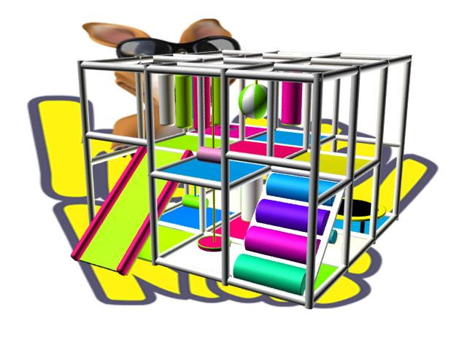 | 1 | ☐ Yes ☐ No
1.2. | Baby corner - quartz sand  Dimensions: 2.25m2 ( 1.5m x 1.5m H-30cm )  Contents: coloured quartz play sand for use in children's playrooms and playgrounds  Material: Chipboard/ Untreated particle board minimum 10mm thick ; Sponge minimum 3cm thick min S20kg/m3; Tarpaulin minimum 580g/m2 Coloured quartz play sand  Offered model should be equal or similar to the picture below:  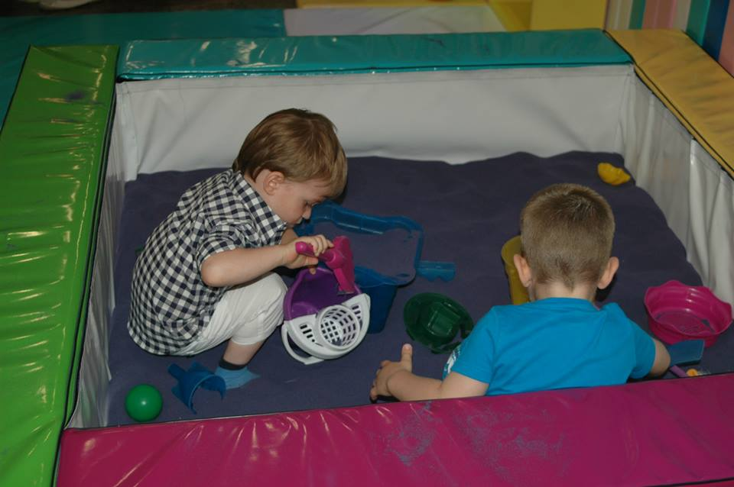 | 2 | ☐ Yes ☐ No
1.3. | Floor Padding  Material: untreated chipboard minimum 18mm thick; minimum 30mm thick sponge; PVC tarpaulin of minimum 690gr/m2 or tarpaulin minimum 580g/m2. Different colours, offered colours minimum 3.  Total surface area :21m2 | 1 | ☐ Yes ☐ No
1.4. | Wall Padding – Strips  Surface area: 13.2m2  Material:  Fibreboard/Untreated particle board minimum 3mm thick  Sponge minimum 2cm thick minimum S20 kg/m3  Tarpaulin minimim 580g/m2  Strips in different dimensions and colours as on the picture.  Offered model should be similar to the picture below:  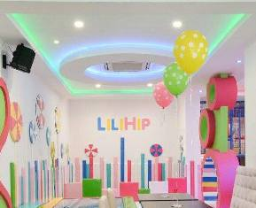 | 1 | ☐ Yes ☐ No
1.5. | Padded Lollypop Circles  Material: Fibreboard/Untreated particle board minimum 3mm thick  Sponge minimum 2cm thick minimum S20 kg/m3  Tarpaulin minimum 580g/m2  Description: wall mounted lollypop-shaped circles.  Lollypop circles in different diameters and colors.  Offered model should be similar to the picture below: | 8 | ☐ Yes ☐ No
1.6. | Photo Wallpaper  Dimensions surface: 4.5 m2  Material: Printed foil with children's motives. Minimum three offered motives.  Purpose: wall decoration | 1 | ☐ Yes ☐ No
1.7. | Window Film  Surface: 14m2  Description: Self-adhesive film with children's motives preventing the view of the interior and allowing a clear view of the outside, with the effect of stained patterned glass. Minimum three offered children's motives. | 1 | ☐ Yes ☐ No
1.8. | CAROUSEL  R-160cm  H-2.4m  With 4 seats  Steel box 30x30x1.8mm  Steel rod f-20mm  Sponge minimum 3cm thick S20kg/m3  Sponge minimum 1cm thick S20kg/m3  Chipboard minimum 18mm thick  High density fibreboard minimum 3mm thick  Rope minimum f-6mm  Tarpaulin 580g/m2  Offered model should be similar to the picture below:  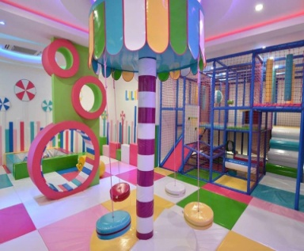 | 1 | ☐ Yes ☐ No
1.9. | Children's tables 2  Dimensions: 50cmx50cm H-50cm  Material: veneered chipboard minimum 18mm thick.  Chamfered edges, edged with ABS strip.  Steel pipe f-40/1.2  Minimum five offered colors of chipboard which will be chosen by beneficiaries | 6
1.10. | Playroom Birthday Chair  Dimensions (h/w/l): 120cm x 45cmx 40cm  Material: Wooden substructure in a given form.  Padded with sponge of minimum 5/25 density and microfiber canvas  Minimum five offered colors of canvas which will be chosen by beneficiaries | 4
1.11. | Children’s Tabourets  Material: Wooden substructure (beech).  Seats shall be made of circle-shaped high density fibreboard and sponge of minimum minimum 3cm thick/density 25.  Upholstered in synthetic leather.  Dimensions ; Height 38cm, seat diameter/width 30cm  Minimum five offered colors of synthetic leather which will be chosen by beneficiaries. | 25
1.12. | She Cupboard with Clothes Rack  Dimensions: 80cmx60cmx25cm  Material: coloured chipboard 18mm  Clothes rack hooks  Minimum five offered colors of chipboard which will be chosen by beneficiaries. | 1
1.13. | Parents' Booth  Dimensions: 80x 60cm, total length 7.2m  Description: composed of three units in 'horseshoe' shape  Material:  Sponge minimum 6cm thick S20kg/m3  Sponge minimum 3cm thick S20kg/m3  Chipboard minimum 18mm thick  Upholstery or Synthetic leather  retex 70g/m2  decorative buttons  Minimum five offered colors of synthetic leather and upholstery fabric which will be chosen by beneficiaries. | 1
1.14. | Parents' Tables 3  Dimensions: 60cmx60cmx75cm  Material: coloured chipboard minimum 18mm thick; 60x60x1.8 steel box; ABS edging strip 2mm;  Minimum five offered colors of chipboard which will be chosen by beneficiaries. | 3
1.15. | Parents' Tables 4  Dimensions surface: 4.5 m2  Material: coloured chipboard minimum 18mm thick; 60x60x1.8 steel box; ABS edging strip 2mm;  Minimum five offered colors of chipboard which will be chosen by beneficiaries. | 1

Lot 2: Equipment and furniture for playroom in Leskovac
Item No | UNOPS minimum technical requirements | Qty. | Is quotation compliant?  Bidder to complete | Details of goods offered. Bidder to complete  Insert details of goods offered, including specifications and brand/model offered if applicable
2.1. | Labyrinth for a children's playroom 2  Surface area: 10m2 - dimension (W/L/H) 5m x 2m x 2.4m  The labyrinth consists of minimum :  1 toboggan, 1 climber, level and floor boards, 4 pieces of crawl-through cylinders, 1 bridge and protective rope net all around the labyrinth.  Labyrinth/structure:  30x 30mm square profile 1.5mm thin pipes;  Insulation min 35/9 (over the pipes), PVC tarpaulin minimum 690gr/m2 (over insulation)  The structure is connected into fields of size 1.2m x 1.3m.  The labyrinth shall be prefabricated and mountable.  Construction is in the white colour.  Level boards:  Material: minimum 21mm thick boards, coated with minimum 3cm/25 thick sponges and PVC tarpaulin minimum 690gr/m2. The underside of the boards shall be coated with minimum 10mm thick sponges. Panels are in various colours.  Floor boards:  Material: untreated particle board minimum 18mm thick, coated with minimum 5cm/20 thick sponges and PVC tarpaulin of min 690gr/m2.  Floor mounted inside the labyrinth.  Prefabricated, mountable. Panel colours are grey or grey metallic.  Rope net: hand-knotted into squares max 6cmx6cm; polyester rope minimum 4mm thick  Rope net needs to be placed wherever there is a possibility of injury.  Climber and slide boards:  Material: Wooden board consisting of two or more layers glued and pressed together - minimum 19mm; padded with minimum 3cm thick sponge and PVC tarpaulin minimum 580gr/m2  Climber and slides are coated on the back side with coloured PVC tarpaulin glued onto the base.  Crawl-through cylinders:  Material: plastic tubes coated with sponges minimum 5cm thick and PVC tarpaulin of 690gr/m2.  Toboggan (manufactured):  Wooden board consisting of two or more layers glued and pressed together - minimum 19mm;  Padded with sponge;  Insulation: min 35/9;  Tarpaulin minimum 580gr/m2 (over insulation)  Hand grips also made of wooden board consisting of two or more layers glued and pressed together coated on both sides.  Certificates of compliance need to be attached for the purpose of issuing fire safety certificates. Manufactured to EN 1176 standard.  Offered model should be equal or similar to the picture below: | 1 | ☐ Yes ☐ No
2.2. | TRAMPOLINE 1  Material: metal pipes minimum 30x 30 x 15mm thick, armaflex insulation 42/13mm or similar, PVC tarpaulin of minimum 690gr/m2. Adhesive bonding. Jumping mat minimum 1200gr/m2 density stitched and mounted to trampoline.  Trampoline surface: 2m2 Dimension (W/L/H); 100cm x 200cm x 220cm. Shape; cube shape. Protective web all around trampoline | 1 | ☐ Yes ☐ No
2.3. | BABY BALL PIT 1  The ball pit is padded on all sides (raw chipboard coated with sponge with 30 density and PVC canvas 690gr/m2) and has sides for sitting up. Filled with plastic balls of various colours, dimensions 8cm.  More than 100 balls to 1 m2.  Pit surface: 2m2 ; Dimension : (W/L/H) first side of baby pit 30x100x30 cm and second side of baby pit 30x200x30cm  Offered model should be equal or similar to the picture below:  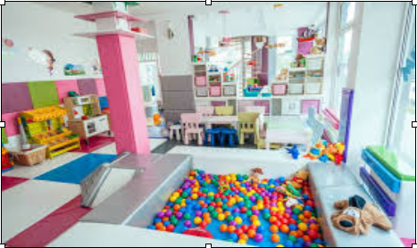 | 1 | ☐ Yes ☐ No
2.4. | KIDS' CORNER  Manufacturing material: Fir wood for the structure and plywood coated chipboard minimum 10mm thick. Processed and with smooth edges. Painted in natural colours.  Kids’ corner kitchen: Kitchen dimension; (W/L/H) 30x100x100cm Minimum equipment; (coffee set 1pcs, 2 small pots, cookware 1pcs, dishcloth 1 pcs, apron 1pcs, tea set 1pcs)  Doctor's corner: Dimensions ; (W/L/H) 30x80x120cm Minimum Doctor's corner equipment ; (chairs 2 pcs, plastic made medical examination set 1pcs, stethoscope 1pcs, medical glows 1 set, blood pressure monitor 1 pcs, examination spatula 1pcs, notebook 1 pcs, doctor's coat 1pcs)  Workshop for boys: Dimension (W/L/H) 30x70x80cm Minimum equipment (tool set - screwdriver 1 pcs, hammer 1pcs, wrench 1 pcs, pliers 1 pcs, 2 sets of smaller and bigger screws, apron 1 pcs, protective helmet 1 pcs)  Market corner: Dimensions (W/L/H) 40x90x120cm Minimum equipment ( plastic crates holding fruits and vegetables made of plastic, 2 sets with 12 pieces of fruits and vegetables )  Hairdresser's and Make-up artist's corner: Dimensions (W/L/H) 30x120x120 cm Minimum equipment (combs and brushes 1 set,hairdressers chair 1pcs, hair dryer toys 2 pcs, hairpins, ribbons and bows - 1 set, hairspray toy 1 pcs, mini shampoo chair 1 pcs)  Offered model should be similar to the picture below:  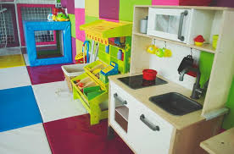 | 1 | ☐ Yes ☐ No
2.5. | Padded Wall Climber  Dimensions: 2.88m2 (W/H) 2,4 x 1,2m  Material: Basic panel phenol coated plywood board minimum 21mm thick or chipboard minimum 18mm thick overlaid with minimum 3cm thick sponge of density 25 and a PVC tarpaulin of minimum 690gr/m2 or 580 g/m2 tarpaulin. Wooden rungs for climbing, minimum 21mm thick overlaid with minimum 3cm thick sponge of density 25 and a PVC tarpaulin of minimum 690gr/m2 or 580 g/m2 tarpaulin. Wooden rungs connected with basic panel with screws, and connected with wall with anchor screws 120 mm. Basic panels in one colour and wooden rungs in various colours. | 1 | ☐ Yes ☐ No
2.6. | Floor Padding  Material: untreated chipboard minimum 18mm thick; minimum 30mm thick sponge; PVC tarpaulin of minimum 690gr/m2 or tarpaulin minimum 580g/m2. Different colours, offered colours minimum 3.  Total surface area :20m2 | 1 | ☐ Yes ☐ No
2.7. | Wall Padding  Material: untreated chipboard minimum 18mm thick; minimum 3cm thick sponge of density 25, upholstered with PVC tarpaulin of minimum 690gr/m2. Glued onto the wall. Different colors, offered colors minimum 3.  Total surface area :20m2 | 1 | ☐ Yes ☐ No
2.8. | Children's tables 1  Dimensions (h/w/l): 60cmx60cm x56cm  Material: veneered chipboard minimum 18mm thick. Chamfered edges, edged with ABS strip.  Table legs shall be made of minimum 8x8cm beech planks.  Minimum five offered colors of chipboard which will be chosen by beneficiaries  Offered model should be equal or similar to the picture below:  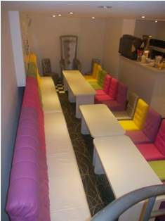 | 6
2.9. | CHILDRENS' BOOTHS  Dimensions: 5m2  Material: wood substructure.  Minimum 18mm thick panels padded with minimum 5/35 density sponge and upholstered in microfiber canvas.  Minimum five offered colors of canvas which will be chosen by beneficiaries  Offered model should be equal or similar to the picture below: | 1
2.10. | Upholstered Children’s Chairs  Dimensions (h x w x l): 60cm x 40cmx 40cm  Material: wood substructure (beech).  Chairs padded with sponge minimum 3cm thick/density 25 and microfiber canvas.  Chairs are completely upholstered.  Minimum five offered colors of canvas which will be chosen by beneficiaries  Offered model should be equal or similar to the picture below: | 17
2.11. | Playroom Birthday Chair  Dimensions (h/w/l): 120cm x 45cmx 40cm  Material: Wooden substructure in a given form.  Padded with sponge of minimum 5/25 density and microfiber canvas  Minimum five offered colors of canvas which will be chosen by beneficiaries | 1
2.12. | Children’s Tabourets  Material: Wooden substructure (beech).  Seats shall be made of circle-shaped high density fibreboard and sponge of minimum minimum 3cm thick/density 25.  Upholstered in synthetic leather.  Dimensions ; Height 38cm, seat diameter/width 30cm  Minimum five offered colors of synthetic leather which will be chosen by beneficiaries. | 3
2.13. | Shoe Cupboard with Seat  Material: chipboard minimum 18mm thick (white)  Dimensions (h/w/l) 40cm x 30cm x 80cm  Seat for changing footwear padded with sponge 3cm thick/density 25 overlaid with PVC tarpaulin 690gr/m2 | 1
2.14. | Wall Shelving Unit  Material: chipboard (white)  Dimensions: 80x200cm | 1
2.15. | Parent’s Seating Unit  Dimensions: 4m2  Material: Wooden substructure. The seat and backrest made of untreated chipboard minimum 18mm thick, padded with sponges minimum 5cm thick/ density 35 and microfiber canvas.  Minimum five offered colors of canvas which will be chosen by beneficiaries | 1
2.16. | Parents' Tables 1  Material: Metal standalone leg made of 10x 10cm metal profile pipes and 30 x 30cm x 6mm panel, green plasticization finish, and 60 x 60cm table board made of 36mm thick chipboard.  Minimum five offered colors of plasticization which will be chosen by beneficiaries. | 3
2.17. | Parents' Chairs  Dimensions: 80cmx45cmx45cm  Material: wooden substructure (beech). Padded with sponges minimum 3cm thick/density 25 and microfiber canvas  Minimum five offered colors of canvas which will be chosen by beneficiaries. | 10
2.18. | Nap Beds with Mattress  Dimensions: 150cmx55cmx25cm  Material: beech substructure  with headrest  with anti-allergy mattress minimum 15cm thick  with option of vertical stacking against the wall | 6

Lot 3: Equipment and furniture for playroom in Bujanovac
Item No | UNOPS minimum technical requirements | Qty. | Is quotation compliant?  Bidder to complete | Details of goods offered. Bidder to complete  Insert details of goods offered, including specifications and brand/model offered if applicable
3.1. | LABYRINTH 3 for a children's playroom  Surface:  16m2 (4m x 4m H-2.4m )  The labyrinth consists of minimum :  Soft slide 1 pcs, pendulum 6pcs, cylindrical climber 1 pcs, hammer swing 6pcs, disc swing 3pcs, trampoline 1 pcs, double basket 1pcs, boxing bag 1 pcs, ball 1 pcs, cascade climbers 1 pcs, fitted trampoline 1pcs  Labyrinth/Structure  Steel frame dimensions 30x30x1.5 mm (W/H/L)  Insulation of pipes: min 35/9,  Tarpaulin canvas minimum 580gr/m2 (over insulation)  Floor mats:  Material: minimum 21mm thick boards, coated with minimum 3cm/20 thick sponges and PVC tarpaulin minimum 580gr/m2.  Mats (upper level)  Chipboard/ untreated particle board minimum 18mm thick, coated with minimum 3cm thick sponges S20kg/m3 and tarpaulin canvas minimum 580gr/m2  Climber and slide boards:  Material: Wooden board consisting of two or more layers glued and pressed together - minimum 19mm; padded with minimum 3cm thick sponge and PVC tarpaulin canvas minimum 580gr/m2  Climber and slides are coated on the back side with coloured PVC tarpaulin glued onto the base.  Rope net: hand-knotted into squares max 6cmx6cm; polyester rope minimum 4mm thick  Rope net needs to be placed wherever there is a possibility of injury.  Certificates of compliance need to be attached for the purpose of issuing fire safety certificates. Manufactured to EN 1176 standard.  Offered model should be equal or similar to the picture below: | 1 | ☐ Yes ☐ No
3.2. | Baby corner - quartz sand  Dimensions: 2.25m2 ( 1.5m x 1.5m H-30cm )  Contents: coloured quartz play sand for use in children's playrooms and playgrounds  Material: Chipboard/ Untreated particle board minimum 10mm thick ; Sponge minimum 3cm thick min S20kg/m3; Tarpaulin minimum 580g/m2 Coloured quartz play sand  Offered model should be equal or similar to the picture below: | 1 | ☐ Yes ☐ No
3.3. | Padded Wall Climber  Dimensions: 2.88m2 (W/H) 2,4 x 1,2m  Material: Basic panel phenol coated plywood board minimum 21mm thick or chipboard minimum 18mm thick overlaid with minimum 3cm thick sponge of density 25 and a PVC tarpaulin of minimum 690gr/m2 or 580 g/m2 tarpaulin. Wooden rungs for climbing, minimum 21mm thick overlaid with minimum 3cm thick sponge of density 25 and a PVC tarpaulin of minimum 690gr/m2 or 580 g/m2 tarpaulin. Wooden rungs connected with basic panel with screws, and connected with wall with anchor screws 120 mm. Basic panels in one colour and wooden rungs in various colours. | 1 | ☐ Yes ☐ No
3.4. | Floor Padding  Material: untreated chipboard minimum 18mm thick; minimum 30mm thick sponge; PVC tarpaulin of minimum 690gr/m2 or tarpaulin minimum 580g/m2. Different colours, offered colours minimum 3.  Total surface area :20m2 | 1 | ☐ Yes ☐ No
3.5. | Kids' Corner – Carpenter's Workshop  Pieces: desk, screw clamp, carpenter-s square  Dimensions: minimum 50cm x minimum 60cm x minimum 35cm  Material: beech profiles, chipboard minimum 18mm thick, high density fibreboard minimum 3 mm thick, MDF minimum 10mm thick; (2mm ABS edging, 1 mm ABS edging) | 1 | ☐ Yes ☐ No
3.6. | Kids' Corner – Kitchen  Pieces minimum: cooker and sink.  Dimensions: minimum 90cm x minimum 60cm x minimum 35cm  Material: coloured chipboard minimum 18mm thick, high density fibreboard minimum 3 mm thick, Plexiglas minimum 1 mm thick, edged (2mm ABS edging, 1 mm ABS edging) | 1 | ☐ Yes ☐ No
3.7. | Soft program  Dimensions: minimum 90cm x minimum 60cm x minimum 35cm  Pieces: steps (minimum 60cm x minimum 50cm x minimum 45cm); tunnel (minimum 50cm x minimum 60cm x minimum 45cm); slide (minimum 50cm x minimum 60cm x minimum 45cm)  Material: chipboard/untreated particle board minimum 10mm thick, sponge minimum S20kg/m3, synthetic leather  Offered model should be similar to the picture below:  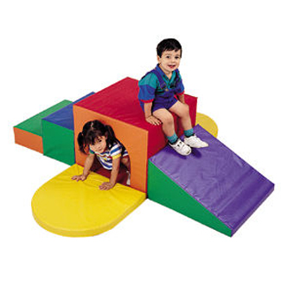 | 1 | ☐ Yes ☐ No
3.8. | Children's tables 2  Dimensions: 50cmx50cm H-50cm  Material: veneered chipboard minimum 18mm thick.  Chamfered edges, edged with ABS strip.  Steel pipe f-40/1.2  Minimum five offered colors of chipboard which will be chosen by beneficiaries | 6
3.9. | Playroom Birthday Chair  Dimensions (h/w/l): 120cm x 45cmx 40cm  Material: Wooden substructure in a given form.  Padded with sponge of minimum 5/25 density and microfiber canvas  Minimum five offered colors of canvas which will be chosen by beneficiaries | 1
3.10. | Children’s Tabourets  Material: Wooden substructure (beech).  Seats shall be made of circle-shaped high density fibreboard and sponge of minimum minimum 3cm thick/density 25.  Upholstered in synthetic leather.  Dimensions ; Height 38cm, seat diameter/width 30cm  Minimum five offered colors of synthetic leather which will be chosen by beneficiaries. | 25
3.11. | She Cupboard with Clothes Rack  Dimensions: 80cmx60cmx25cm  Material: coloured chipboard 18mm  Clothes rack hooks  Minimum five offered colors of chipboard which will be chosen by beneficiaries. | 1
3.12. | Parents' Tables 2  Dimensions: 50cmx80cmx45cm  Material: coloured chipboard minimum 18mm thick; 25x25x1.5 steel box; ABS edging strip 2mm  Minimum five offered colors of chipboard which will be chosen by beneficiaries | 5
3.13. | Parents' Armchairs  Dimensions: 50cmx50cmx45cm  Material: shaped sponge minimum S20kg/m3, chipboard minimum 18mm thick, retex minimum 70g/m2, synthetic leather, upholstery fabric, 40x20x1.5 steel profiles  Minimum five offered colors of synthetic leather or upholstery fabric which will be chosen by beneficiaries | 15

Lot 4: Equipment and furniture for playroom in Aleksinac
Item No | UNOPS minimum technical requirements | Qty. | Is quotation compliant?  Bidder to complete | Details of goods offered. Bidder to complete  Insert details of goods offered, including specifications and brand/model offered if applicable
4. | Labyrinth for a children's playroom 4  Surface: 18.6m2  Labyrinth equipment minimum; (toboggan 1pcs, level boards 1 pcs, level and floor boards, crawl-through cylinders and slides 4 pcs, bridge 1 pcs, protective web all around the labyrinth)  Labyrinth/structure: Steel frame dimensions 30x30x1.5 mm (W/H/L)  Material: 30x 30mm square profile 1.5mm thin pipes;  Wedges to connect steel pipes, diameter 25mm x 25mm; insulation minimum 35/9 and PVC tarpaulin minimum 690gr/m2. The structure is connected into fields of size 1.2m x 1.3m. The labyrinth shall be prefabricated and mountable.  Construction is in the white colour.  Level boards:  Material: minimum 21mm thick boards, coated with minimum 3cm/25 thick sponges and PVC tarpaulin minimum 690gr/m2. The underside of the boards shall be coated with minimum 10mm thick sponges. Panels are in various colours.  Floor boards: Material: untreated particle board minimum 18mm thick, minimum 5cm/20 thick sponges and PVC tarpaulin of 690gr/m2. Floor mounted inside the labyrinth. Prefabricated, mountable. Panel colour is grey or grey metallic.  Obstacles and props:  Made of 3cm thick sponges with density of 20, PVC tarpaulin of 690gr/m2, 0.50mm high density fibreboard, and cardboard impregnated pipes of thickness up to 0.5mm, wear and tear resistant.  Rope net: hand-knotted into squares max 6cmx6cm; polyester rope minimum 4mm thick  Rope net needs to be placed wherever there is a possibility of injury.  Climber and slide boards:  Material: phenol coated plywood minimum 21mm thick, minimum 3cm thick sponge and PVC tarpaulin of 690gr/m2. Climber and slides are coated on the back side with coloured PVC tarpaulin glued onto the base.  Crawl-through cylinders:  Material: plastic tubes coated with sponges minimum 5cm thick and PVC tarpaulin. Made of phenol coated plywood boards minimum 21mm thick and coated with sponges and PVC tarpaulin of 690gr/m2.  Slides (manufactured): Made of phenol coated plywood boards 21mm thick and coated with sponges and PVC tarpaulin of 690gr/m2, slide edges, i.e. Hand grips also made of phenol coated plywood boards coated on both sides.  Floor padding:  Untreated particle board 18mm thick, sponges 30mm thick and PVC tarpaulin of 690gr/m2  Certificates of compliance need to be attached for the purpose of issuing fire safety certificates. Manufactured to EN 1176 standard.  Offered model should be equal or similar to the picture below: | 1 | ☐ Yes ☐ No
6. | TRAMPOLINE 2  Material: metal pipes minimum 30x 30 x 15mm thick, armaflex insulation 42/13mm or similar, PVC tarpaulin of minimum 690gr/m2. Adhesive bonding. Jumping mat minimum 1200gr/m2 density stitched and mounted to trampoline.  Trampoline surface: 2,56m2 Shape; cube shape. Protective web all around trampoline | 1 | ☐ Yes ☐ No
8. | BABY BALL PIT 2  The ball pit is padded on all sides (raw chipboard coated with sponge with 30 density and PVC canvas 690gr/m2) and has sides for sitting up. Filled with plastic balls of various colours, dimensions 8cm.  More than 100 balls to 1 m2.  Pit surface: 2.50-2.60 m2 ; Pit depth : 30cm ; Pit width 30cm  Offered model should be equal or similar to the picture below: | 1 | ☐ Yes ☐ No
11. | Padded Wall Climber  Dimensions: 2.88m2 (W/H) 2,4 x 1,2m  Material: Basic panel phenol coated plywood board minimum 21mm thick or chipboard minimum 18mm thick overlaid with minimum 3cm thick sponge of density 25 and a PVC tarpaulin of minimum 690gr/m2 or 580 g/m2 tarpaulin. Wooden rungs for climbing, minimum 21mm thick overlaid with minimum 3cm thick sponge of density 25 and a PVC tarpaulin of minimum 690gr/m2 or 580 g/m2 tarpaulin. Wooden rungs connected with basic panel with screws, and connected with wall with anchor screws 120 mm. Basic panels in one colour and wooden rungs in various colours. | 3 | ☐ Yes ☐ No
12. | Floor Padding  Material: untreated chipboard minimum 18mm thick; minimum 30mm thick sponge; PVC tarpaulin of minimum 690gr/m2 or tarpaulin minimum 580g/m2. Different colours, offered colours minimum 3.  Total surface area :20m2 | 1 | ☐ Yes ☐ No
14. | Wall Padding  Material: untreated chipboard minimum 18mm thick; minimum 3cm thick sponge of density 25, upholstered with PVC tarpaulin of minimum 690gr/m2. Glued onto the wall. Different colors, offered colors minimum 3.  Total surface area :20m2 | 1 | ☐ Yes ☐ No
18. | Kids' Playhouse  Description:  Made of metal structure with triangle shape (will be mounted under the stairs). Playhouse contains two rows of fields, one field are stairs dimensions W/L 50 x 50cm made for climbing and other field is made tobogganlike, dimension W/L 50x220 cm made for kid's lowering and exiting from the playhouse. Playhouse look like cheese with holes, children will wear mouse- like masks.  The entire structure of the playhouse is padded with armaflex 42/13 insulation or similar and PVC tarpaulin of minimum 690gr/m2.  The house is surrounded by a protective mesh knotted into 5cm x 5cm eyelets.  The front of the playhouse is covered with boards padded with sponges and PVC tarpaulin with a printed image.  Playhouse Dimensions:  Length 320 cm, Width 120 cm, highest roof point on 270 cm | 1 | ☐ Yes ☐ No
 | Children's tables 1  Dimensions (h/w/l): 60cmx60cm x56cm  Material: veneered chipboard minimum 18mm thick. Chamfered edges, edged with ABS strip.  Table legs shall be made of minimum 8x8cm beech planks.  Minimum five offered colors of chipboard which will be chosen by beneficiaries  Offered model should be equal or similar to the picture below: | 7
 | Children’s Wooden Chairs  dimensions: 38cmx38cmx60cm  Made of painted medium density fibreboard, 18mm thick and with chamfered edges.  Chair structure shall be made of 5x 5 cm wood planks painted in natural-based colours.  Minimum five offered colors of medium density fibreboard which will be chosen by beneficiaries. | 30
 | Playroom Birthday Chair  Dimensions (h/w/l): 120cm x 45cmx 40cm  Material: Wooden substructure in a given form.  Padded with sponge of minimum 5/25 density and microfiber canvas  Minimum five offered colors of canvas which will be chosen by beneficiaries | 1
 | Shoe Cupboard with Seat  Material: chipboard minimum 18mm thick (white)  Dimensions (h/w/l) 40cm x 30cm x 80cm  Seat for changing footwear padded with sponge 3cm thick/density 25 overlaid with PVC tarpaulin 690gr/m2 | 3

Delivery requirements –– Comparative Data Table

UNOPS Requirements |  | Is quotation compliant? Bidder to complete | Details  Bidder to complete  Insert details
Delivery time | Bidder shall deliver the goods 90 (Ninety) calendar days after the Contract signature. | ☐ Yes ☐ No
Delivery place and Incoterms rules | Net of any direct taxes, customs duties, indirect taxes and VAT.  DAP (Delivered at Place, as per Incoterms 2010):  Beneficiary in Leskovac, Sjenica, Aleksinac and Bujanovac  Transportation, offload, assembly and installation of the equipment on the beneficiary’s premises are included in the price. | ☐ Yes ☐ No
Consignee details | The exact address the goods shall be delivered and offloaded to, as well as all other relevant details, will be available upon contract signature. | ☐ Yes ☐ No
UNOPS Right to vary requirements | At the time the Contract is awarded, UNOPS reserves the right to vary the quantity of the goods and associated services specified above, provided this does not exceed +/- 20%, without any change in the unit prices or other terms and conditions of the RFQ. | ☐ Yes ☐ No

The offered goods and related services (if applicable) are in accordance with the required specifications and requirements specified in Section III: Schedule of Requirements.

☐ Yes ☐ No
ANY DEVIATION MUST BE LISTED BELOW:
___________________________________________________________________________________________________________________________________________________________________________________________________________________________________________________________________________________________________________________________________________________________________________________________________________________________________________________

Name : _____________________________________________________________

Title : _____________________________________________________________

Date : _____________________________________________________________

Signature : _____________________________________________________________

Form D: Previous experience form
RFQ reference no: [insert RFQ reference No.] ______________________________________
Name of Bidder: [insert name of Bidder] ______________________________________

Description of services/goods | Country | Total amount of Contract | Contract Identification and Title and  Contact details of Client:  (Name, Address, telephone, email, fax) | Year project was undertaken

Name : _____________________________________________________________

Title : _____________________________________________________________

Date : _____________________________________________________________

Signature : _____________________________________________________________75 00ax: +45 45 33 75 01

