Version: v2016.1
Returnable Bidding Forms
Purchase of Wood and Fruit Dryers in support to Youth and SMEs
RFQ Ref No: UNOPS-EP-2016-G-084

Section IV: Returnable Bidding Forms
Note to Bidders: Instructions to complete each Form are highlighted in blue in each Form. Please complete the Returnable Biding Forms as instructed and return them as part of your quotation.

The following returnable forms are part of this RFQ and must be completed and returned by bidders as part of their Quotation.

Form A: Quotation submission form
Bidders are requested to complete this form, sign it and return it as part of their bid submission. The bidder shall fill in this form in accordance with the instructions indicated. No alterations to its format shall be permitted and no substitutions shall be accepted.
Date: [Insert submission date]____________________________

Subject: Quotation for the supply of [Insert a brief description of goods/services] __________________________________in ________________________________[Name of country/city], RFQ Case No.[insert RFQ ref number]_______________________________, dated [insert date]_____________________.

We, the undersigned, declare that:
  - We offer to supply in conformity with the bidding documents, including the UNOPS General Conditions of Contract.
  - Our quotation shall be valid for the period of time of [insert number of days which shall not be less than the specified in Section I: Bid Particulars, Period of Validity of Bids] _________________from the date fixed for the bid submission deadline as set out in the RFQ, and it shall remain binding upon us and may be accepted at any time before the expiration of that period;
  - We have no conflict of interest in any activity that would put it, if selected for this assignment, in a conflict of interest with UNOPS;
  - Our firm confirms that the offeror and sub-contractors have not been associated, or had been involved in any way, directly or indirectly, with the preparation of the design, terms of references and/or other documents used as a part of this solicitation;
  - Our firm, its affiliates or subsidiaries—including any subcontractors or suppliers for any part of the Contract—has not been declared ineligible by UNOPS, nor is included in the suspended/ineligibility list of the UN/PD, other UN Agencies, the UN Security Council, and the World Bank, in accordance with Instructions to Bidders Article 3, Eligibility;
  - We embrace the UN Supplier Code of Conduct and adhere to the principles of the UN Global Compact
  - We have not declared bankruptcy, are not involved in bankruptcy or receivership proceedings, and there is no judgment or pending legal action against them that could impair their operations in the foreseeable future.
  - We have not offered and will not offer fees, gifts and/or favours of kind in exchange for this RFQ and will not engage in any such activity during the performance of any Contract awarded.
I, the undersigned, certify that I am duly authorized by [insert full name of bidder] ________________________________to sign this quotation and bind [insert full name of bidder] should UNOPS accept this quotation:
Name: [complete]_______________________________________________________
Title: [complete]_________________________________________________________
Signature: _____________________________________________________________

Provide the name and contact information for the primary contact from your company for this quotation:

Name: [complete]________________________________________________________
Title: [complete]__________________________________________________________
Email address: [complete]___________________________________________________
Telephone: [complete]______________________________________________________

Form B: Price Schedule Form
Bidders shall fill in this Price Schedule Form in accordance with the instructions indicated.

RFQ reference no: [insert RFQ reference No.]

Currency | RSD

Lot 1: Equipment for wood dryer
Item No | Description | Qty | Unit price DAP  (VAT exempted) | Total price DAP (VAT exempted)
1.1 | Equipment for wood dryer | 1
Total Price for Lot 1 VAT exempted

Lot 2: Fruit Dryers
Item No | Description | Qty | Unit price DAP  (VAT exempted) | Total price DAP (VAT exempted)
2.1 | Dryer (combined) | 1
2.2 | Tunnel dryer for fruits, vegetables and herbs | 1
2.3 | The dryer with a closed drying system | 1
Total Price for Lot 2 VAT exempted

NOTES:
- Transportation, offload, assembly and installation of the equipment on the beneficiaries’ premises must be included in the price, as well as the short instruction training.
- The offered prices are net of any direct taxes, customs duties and indirect taxes and VAT.
Payment terms 30 days accepted: ☐ Yes

- List of subcontractors or suppliers
Bidder must identify the names of all subcontractors/suppliers who will be providing good/services under this Contract and the type of work being subcontracted, if applicable.
[Full legal name and address of subcontractors]

- _________________________________________________

- _________________________________________________

- _________________________________________________

- List of legal entities associated to the Bidder
Bidder must also identify and disclose any information regarding all legal entity/s associated to it, by providing their full legal name and address:
[Full legal name and address of the associated legal entity]

- _________________________________________________

- _________________________________________________

- _________________________________________________

In case of no related entities, the Bidder must sign the following statement to that effect:
[Delete or cross out if not applicable]:
I, the undersigned, certify that there are no legal entities associated to the [insert full name of Bidder]
____________________________________________________. [

- Authorization to sign quotation
I, the undersigned, certify that I am duly authorized by [insert full name of Bidder]
____________________________________________________ to sign this quotation and bind
____________________________________________________[insert full name of Bidder] should UNOPS accept this quotation:

Name : _____________________________________________________________

Title : _____________________________________________________________

Date : _____________________________________________________________

Signature : _____________________________________________________________

Form C: Technical Quotation Form

RFQ reference no: [insert RFQ reference No.]______________________________________
Name of Bidder: [insert name of Bidder]___________________________________________

Bidders are required to complete the Comparative Data Tables included in Section III: Schedule of Requirements to demonstrate compliance with UNOPS requirements and insert them below. Bidders are NOT allowed to make any change in the “UNOPS requirements” columns of the Comparative Data Tables. Such changes might disqualify your quotation.

Technical specifications for goods – Comparative Data Table

Lot 1: Equipment for wood dryer
Item No | UNOPS minimum technical requirements | Quantity | Is Bid compliant? Bidder to complete | Details of goods offered. Bidder to complete
1.1 | Equipment for wood dryer / Oprema za sušaru za drva  The equipment should be installed in the existing chamber (6.30 x 4.80 x 4.0 m (H)) and the price should include the cost of equipment and installation of the same.  Sušara se oprema u već postojećem sazidanom objektu (6.30 x 4.80 x 4.0 m (H)) i cena mora da uključi i cenu opreme i instalaciju iste.  Dryer shold be similar like model NKS-20./Sušara se pravi slična modelu NKS-20.  Dryer scheme (picture below): /Šema sušare (slika ispod):  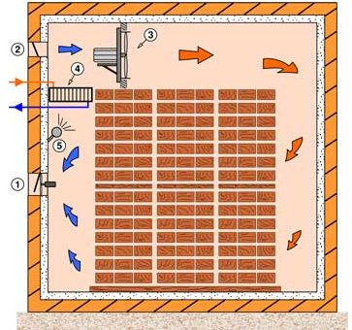  1-Exhaust flaps  2-Intake flaps  3-Circulation fans  4-Heaters  5-Atomizers  1-Izduvne klapne  2-Isisne klapne  3-Ventilator za cirkulaciju  4-Grejaci  5-Sistem za vlaženje  Timber Volume/ Kapacitet drvene građe koja u jednom trenutku može da se smesti u sušaru: 15-25 m3  Dryer equipments: Oprema za sušaru:  1. Heat exchanger /Izmenjivač toplote 60kW (12 cevi) L=2120mm/680mm - 2 pieces /komada  2. Heat exchanger /Izmenjivač toplote 60kW (12 cevi) L=1500mm/680mm - 1 piece / komad  3. Supply and return line/ Napojni i povratni vod – 1 piece /komad  4. Dihting /Dihtung 40/6 – 6 pieces /komada  5. Stainless steel screw M12 with nut/ Inox vijak M12 sa navrtkom – 24 pieces /komada  6. Three-way valve, similar to or the same as the model / Trokraki ventil , sličan ili isti kao model ESBBE 3MS40 – 1 piece/komad  7. Actuator three-way valve, similar to or the same as the model e / Pogon trokrakog ventila , sličan ili isti kao model ESBE 96 – 1 piece/komad  8. Breather pipe /Odzračni vod – 2 pieces/komada  9. Circulation fans /Ventilatori za cirkulaciju Ø560, 0,75kW – 6 pieces /komada  10. Aluminium fan bracket and exchanger /Aluminijumski nosač ventilatora i izmenjivača – 1 piece/komad  11. Exhaust valve with fan /Izduvna klapna sa ventilatorom Ø560, 0,75kW and router /I usmerivačem – 1piece/ komad  12. Suction flap /Usisna klapna 450x250 mm – 3 pieces/komada  13. Humidification system with low pressure/ Sistem za vlaženje sa niskim pritiskom – 1 piece/ komad  14. Electrical command and control box for the dryer with 6 fans /Elektro komandno razvodni ormar za sušaru sa 6 ventilatora (the same or similar to model /isto ili slicno modelu KRO 6 )-1 komad  15. Automatic control unit, equal or similar with model MC-502R (picture below): /Automat za vođenje procesa sušenja (isto ili slicno modelu MC-502R, slika ispod)  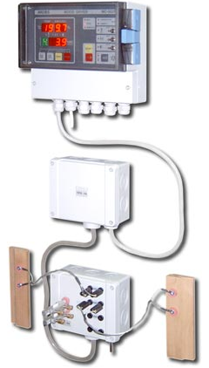  Main automatic control unit characteristics/Karakteristike automata:  Power suply /Napajanje: 220 Vac; 50Hz; 4VA max  Number of inputs /Broj ulaza: 6 (1 Temperature inputs /ulaz za temperaturu, 1 EMC inputs /ulaz za relativnu vlagu i 4 Wood MC inputs /ulaza za vlagu drveta)  Number of outputs/Broj izlaza: 5 (3-o pin/pinski; 8A / 250Vac; 1 output for temperature control (heating valves) /izlaz za regulaciju temperature (ventil grejanja) ON/OFF regulacija; 2 outputs for fans work and direction control (reversion/) izlaza za rad i upravljanje smerom ventilatora; 1 outputs for humidity control (servo-controlled drying flaps) /izlaz za regulaciju vlage (servo klapne za sušenje) ON/OFF regulacija; 1 output for spraying /izlaz za vlaženje)  Communication/Komunikacija: digital/digitalna  Communication line/Komunikacione linije: 1  16. Cable for installation and accessories / Kablovi za instalaciju I pribor | 1

Lot 2: Fruit Dryers
Item No | UNOPS minimum technical requirements | Quantity | Is Bid compliant? Bidder to complete | Details of goods offered. Bidder to complete
2.1 | Dryer (combined)  For drying all kinds of fruits, vegetables and herbs.  The dryer is consisted of a chamber with a closed drying system (condensation dryer with heat pump) / same or similar with model XEROMON50/ and the chamber with open system of drying / same or similar with model EURUS25 /  Combined dryer conducted drying and cooling of raw materials, at the same time, independently.  The total active area of drying: 48.7m2 (+/-10%)  Capacity: 750kg  Number of shelves (trays): 65 - 85  Maximum temperature 70 ° C  Power: 7.5 kW  Dyer dimensions (m): 1x3x2,5(H) (+/-10%)  Automatic control of stability parameters.  Same or similar with model " Optimonia TIP50 + 25"  Sušara (kombinovana)  Za sušenje svih vrsta voća, povrca i bilja  Sušara se sastoji od komore sa zatvorenim sistemom sušenja (kondenzaciona sušara sa toplotnom pumpom) slična ili ista modelu XEROMON50 i komorom sa otvorenim sistemom slična ili ista modelu EURUS25 (u isto vreme, nezavisno se odvija sušenje i hlađenje sirovina).  Ukupna aktivna povrsina sušenja: 48.7m2 (+/-10%)  Kapacitet: 750kg  Broj polica (tacni): 65 - 85  Maksimalna temperatura 70° C  Instalisana elektro snaga 7.5 kW  Dimenzija sušare 1x3x2,5(H) m (+/-10%)  Regulacija stabilnosti parametaraje automatska.  Sušara sa kombinovanim sistemom sušenja je slična ili ista modelu ("TIP50+25" Optimonia) | 1
2.2 | Tunnel dryer for fruits, vegetables and herbs  Dryer is made as a prefabricated building of steel structures, lined with insulating panels. All metal parts inside the dryer were previously galvanized and subsequently painted with electrostatic special paint. Trays are made of stainless steel materials (INOX) intended for use in the food industry.  Air heating is done by thermo generator fuelled by wood, briquettes, dried charcoal (piece), etc. (manual feeding)  Construction of thermo generator was done so as not to allow the mixing of flue gases and combustion products  Air drying, a combustion chamber - exchanger is made of high-quality fire-retardant steel.  Daily drying capacity: 200 kg  Tunelska sušara za voće, povrće i lekovito bilje  Sušare je napravljena kao montažni objekat, od čelične konstrukcije, obložene izolacionim panelima. Svi metalni delovi u unutrašnjosti sušare su prethodno pocinkovani a naknadno obojeni elektrostatičkom specijalnom bojom. Tacne su od prohromskog materijala (INOX-a) namenjenog za upotrebu u prehrambenoj industriji.  Zagrevanje vazduha vrši se termogeneratorom koji kao energent koristi:  - drvo, briket, sušeni drveni ugalj (komad) i sl (ručno loženje)  Konstrukcija termogeneratora urađena je tako, da ne dozvoljava mešanje dimnih gasova i produkata sagorevanja vazduha za sušenje, a ložište – razmenjivač je urađen od visokokvalitetnog vatrootpornog čelika.  Dnevni kapacitet sušenja: 200 kg  Same or similar with model Termoplin SVP-200, (picture below):  Sušara je ista ili slična modelu Termoplin SVP-200, slika ispod:  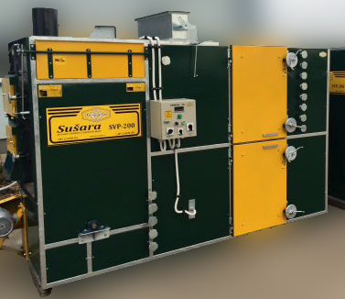  Preview stainless steel drying frames/ Prikaz inox lesa za slaganje materijala sušenja  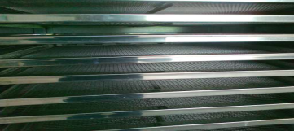 | 1
2.3 | The dryer with a closed drying system  Condensation dryer with heat pump for drying all kinds of fruit vegetables and herbs.  Capacity 400kg  Number of shelves(trays) per trolleys 35-45  Number of trolleys 2  Maximum temperature 70 C.  Material: Aluminium  Installed electrical power unit (power to the electrical connection): 6 kW (AC connection).  The nominal (average) power of 5.5 kW with a power consumption of 5.5 kWh per hour.  The dryer is equipped with a supercharged engine.  Heating of the chamber is performed by heat exchangers (18 kW+/-10%).  Cooling of the condensation chamber is performed by heat exchangers (18 kW+/-10%).  The chamber is equipped with a suitable system for the fan air flowing that provides continuous and uniform drying.  Control of stability parameters is automatic.  Dimensions of dryer:  Base: 2.5m x 2m approximately (+/-10%)  Height: 2.5m approximately (+/-10%)  Same or similar with model OPTIMONIA XEROMON40, (picture below):  Sušara sa zatvorenim sistemom sušenja  Kondenzaciona sušara sa toplotnom pumpom za sušenje svih vrsta voća povrća i bilja.  Kapacitet 400kg  Broj polica (tacni) po kolicima: 35-45  Broj kolica 2  Maksimalna temperature 70 C  Materijal izrade: Aluminijum  Instalisana elektro snaga agregata (snaga na elektro priključku): 6 kW (trofazni priključak).  Nominalna (prosečna) snaga sušare 5.5 kw sa potrošnjom struje od 5.5 kwh na sat.  Sušara je opremljena kompresorskim agregatom.  Zagrevanje komore se obavlja razmenjivačima toplote od 18 kw (+/-10%).  Hlađenje kondenzacione komore obavlja se razmenjivačima toplote od 18 kw (+/-10%).  Komora je opremljena odgovarajućim sistemom ventilatora za opstrujavanje vazduha tako da se  obezbeđuje kontinualno i ravnomerno sušenje.  Regulacija stabilnosti parametara je automatska.  Dimenzije sušare:  Osnova: 2.5m x 2m, približno (+/-10%)  Visina: 2.5, približno (+/-10%)  Sušara je ista ili slična modelu OPTIMONIA XEROMON40, slika ispod:  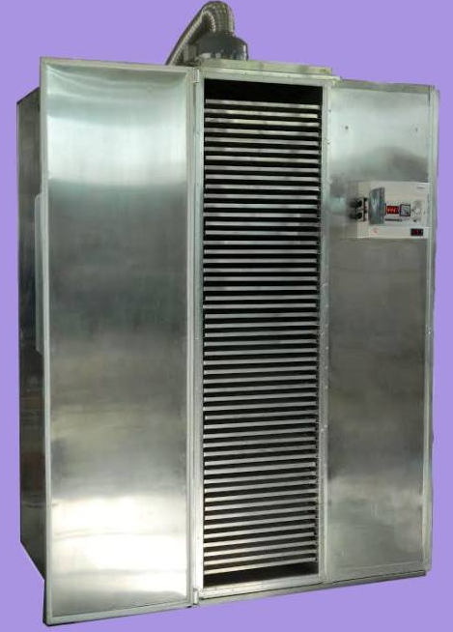 | 1

Delivery requirements –– Comparative Data Table

UNOPS Requirements |  | Is quotation compliant? Bidder to complete | Details  Bidder to complete  Insert details
Delivery time | Bidder shall deliver the goods 45 (Forty Five) calendar days after the Contract signature. | ☐ Yes ☐ No
Delivery place and Incoterms rules | Net of any direct taxes, customs duties, indirect taxes and VAT.  DAP (Delivered at Place, as per Incoterms 2010):  Beneficiary in Ivanjica, Svrljig, Prijepolje and Vranje  Transportation, offload, assembly and installation of the equipment on the beneficiary’s premises are included in the price | ☐ Yes ☐ No
Consignee details | The exact address the goods shall be delivered and offloaded to, as well as all other relevant details, will be available upon contract signature. | ☐ Yes ☐ No
UNOPS Right to vary requirements | At the time the Contract is awarded, UNOPS reserves the right to vary the quantity of the goods and associated services specified above, provided this does not exceed +/- 20%, without any change in the unit prices or other terms and conditions of the RFQ. | ☐ Yes ☐ No

The offered goods and related services (if applicable) are in accordance with the required specifications and requirements specified in Section III: Schedule of Requirements.

☐ Yes ☐ No
ANY DEVIATION MUST BE LISTED BELOW:
___________________________________________________________________________________________________________________________________________________________________________________________________________________________________________________________________________________________________________________________________________________________________________________________________________________________________________________

Name : _____________________________________________________________

Title : _____________________________________________________________

Date : _____________________________________________________________

Signature : _____________________________________________________________

Form D: Previous experience form
RFQ reference no: [insert RFQ reference No.] ______________________________________
Name of Bidder: [insert name of Bidder] ______________________________________

Description of services/goods | Country | Total amount of Contract | Contract Identification and Title and  Contact details of Client:  (Name, Address, telephone, email, fax) | Year project was undertaken

Name : _____________________________________________________________

Title : _____________________________________________________________

Date : _____________________________________________________________

Signature : _____________________________________________________________75 00ax: +45 45 33 75 01

