Section IV: Returnable Bidding Forms
Note to Bidders: Instructions to complete each Form are highlighted in blue in each Form. Please complete the Returnable Biding Forms as instructed and return them as part of your quotation.

The following returnable forms are part of this RFQ and must be completed and returned by bidders as part of their Quotation.

Form A: Quotation submission form
Bidders are requested to complete this form, sign it and return it as part of their bid submission. The bidder shall fill in this form in accordance with the instructions indicated. No alterations to its format shall be permitted and no substitutions shall be accepted.
Date: [Insert submission date]____________________________

Subject: Quotation for the supply of [Insert a brief description of goods/services] __________________________________in ________________________________[Name of country/city], RFQ Case No.[insert RFQ ref number]_______________________________, dated [insert date]_____________________.

We, the undersigned, declare that:
  - We offer to supply in conformity with the bidding documents, including the UNOPS General Conditions of Contract.
  - Our quotation shall be valid for the period of time of [insert number of days which shall not be less than the specified in Section I: Bid Particulars, Period of Validity of Bids] _________________from the date fixed for the bid submission deadline as set out in the RFQ, and it shall remain binding upon us and may be accepted at any time before the expiration of that period;
  - We have no conflict of interest in any activity that would put it, if selected for this assignment, in a conflict of interest with UNOPS;
  - Our firm confirms that the offeror and sub-contractors have not been associated, or had been involved in any way, directly or indirectly, with the preparation of the design, terms of references and/or other documents used as a part of this solicitation;
  - Our firm, its affiliates or subsidiaries—including any subcontractors or suppliers for any part of the Contract—has not been declared ineligible by UNOPS, nor is included in the suspended/ineligibility list of the UN/PD, other UN Agencies, the UN Security Council, and the World Bank, in accordance with Instructions to Bidders Article 3, Eligibility;
  - We embrace the UN Supplier Code of Conduct and adhere to the principles of the UN Global Compact
  - We have not declared bankruptcy, are not involved in bankruptcy or receivership proceedings, and there is no judgment or pending legal action against them that could impair their operations in the foreseeable future.
  - We have not offered and will not offer fees, gifts and/or favours of kind in exchange for this RFQ and will not engage in any such activity during the performance of any Contract awarded.
I, the undersigned, certify that I am duly authorized by [insert full name of bidder] ________________________________to sign this quotation and bind [insert full name of bidder] should UNOPS accept this quotation:
Name: [complete]_______________________________________________________
Title: [complete]_________________________________________________________
Signature: _____________________________________________________________

Provide the name and contact information for the primary contact from your company for this quotation:

Name: [complete]________________________________________________________
Title: [complete]__________________________________________________________
Email address: [complete]___________________________________________________
Telephone: [complete]______________________________________________________

Form B: Price Schedule Form
Bidders shall fill in this Price Schedule Form in accordance with the instructions indicated.

RFQ reference no: [insert RFQ reference No.]

Currency | RSD

Item No | Description | Qty | Unit price DAP  (Insert) | Total price DAP  (Insert)
1. | Children's playroom labyrinth 1 | 1
2. | Children's playroom labyrinth 2 | 1
3. | Children's playroom labyrinth 3 | 1
4. | Children's playroom labyrinth 4 | 1
5. | Trampoline 1 | 1
6. | Trampoline 2 | 1
7. | Baby ball pit 1 | 1
8. | Baby ball pit 2 | 1
9. | Baby corner - quartz sand | 2
10. | Kid’s corner | 1
11. | Padded Wall Climber | 1
12. | Floor Padding | 1
13. | Wall Padding – Strips | 1
14. | Wall Padding | 1
15. | Padded Lollypop Circles | 8
16. | Photo Wallpaper | 1
17. | Window Film | 1
18. | Kids' Playhouse | 1
19. | Kids' Corner – Carpenter's Workshop | 1
20. | Kids' Corner – Kitchen | 1
21. | Soft program | 1
22. | Carousel | 1
TOTAL

NOTES:
- Transportation, offload, assembly and installation of the equipment on the beneficiaries’ premises must be included in the price.
- The offered prices are net of any direct taxes, customs duties and indirect taxes and VAT.

Payment terms 30 days accepted: ☐ Yes

- List of subcontractors or suppliers
Bidder must identify the names of all subcontractors/suppliers who will be providing good/services under this Contract and the type of work being subcontracted, if applicable.
[Full legal name and address of subcontractors]

- _________________________________________________

- _________________________________________________

- _________________________________________________

- List of legal entities associated to the Bidder
Bidder must also identify and disclose any information regarding all legal entity/s associated to it, by providing their full legal name and address:
[Full legal name and address of the associated legal entity]

- _________________________________________________

- _________________________________________________

- _________________________________________________

In case of no related entities, the Bidder must sign the following statement to that effect:
[Delete or cross out if not applicable]:
I, the undersigned, certify that there are no legal entities associated to the [insert full name of Bidder]
____________________________________________________. [

- Authorization to sign quotation
I, the undersigned, certify that I am duly authorized by [insert full name of Bidder]
____________________________________________________ to sign this quotation and bind
____________________________________________________[insert full name of Bidder] should UNOPS accept this quotation:

Name : _____________________________________________________________

Title : _____________________________________________________________

Date : _____________________________________________________________

Signature : _____________________________________________________________

Form C: Technical Quotation Form

RFQ reference no: [insert RFQ reference No.]______________________________________
Name of Bidder: [insert name of Bidder]___________________________________________

Bidders are required to complete the Comparative Data Tables included in Section III: Schedule of Requirements to demonstrate compliance with UNOPS requirements and insert them below. Bidders are NOT allowed to make any change in the “UNOPS requirements” columns of the Comparative Data Tables. Such changes might disqualify your quotation.

Technical specifications for goods – Comparative Data Table

Item No | UNOPS minimum technical requirements | Qty. | Is quotation compliant?  Bidder to complete | Details of goods offered. Bidder to complete  Insert details of goods offered, including specifications and brand/model offered if applicable
1. | Children's playroom labyrinth 1  LABYRINTH 1 for a children’s playroom  Surface area 9m2  Dimensions: 3mx3m  Height 2,4m  Equipment inside the labyrinth Minimum: Slide 1 piece, climber 1, pendulum 6 pcs, hammer swing 3 pieces, disc swing 1 piece, trampoline piece, boxing bag 1 piece, ball 1 piece, cascade climber 1 piece  Labyrinth/Structure:  Steel frame 30x30x1.5 mm made of steel pipes profile 30x30x1,5mm ,wall thickness (W/H/L)  Insulation: Isoflex 35/9 or similar;  Tarpaulin canvas minimum 580gr/m2  Floor mats:  High density fibreboard minimum 3mm thick;  Sponge minimum 3 cm thick S20kg/m3;  Tarpaulin minimum 580gr/m2;  Mats (upper level);  Chipboard minimum 18mm thick;  Sponge minimum 3cm thick S20kg/m3;  Tarpaulin minimum 580gr/m2  Climber/Slide:  Veneered medium density fibreboard minimum 19mm;  Sponge minimum 1cm thick S20kg/m3;  Timber 5cm x 8 cm;  Insulation: Isoflex 35/9 or similar;  Tarpaulin minimum 580gr/m2  Web: minimum 4mm thick polyester rope  Cube 6cmx6cm  Certificates of compliance need to be attached for the purpose of issuing fire safety certificates. Manufactured to EN 1176 standard.  Offered model should be equal or similar to the picture below:  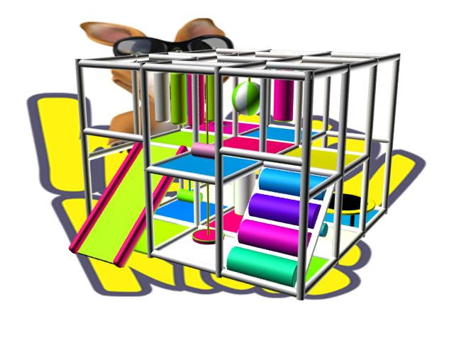 | 1 | ☐ Yes ☐ No
2. | Labyrinth for a children's playroom 2  Surface area: 10m2 - dimension (W/L/H) 5m x 2m x 2.4m  The labyrinth consists of minimum :  1 toboggan, 1 climber, level and floor boards, 4 pieces of crawl-through cylinders, 1 bridge and protective web all around the labyrinth.  Labyrinth/structure:  Steel frame dimensions 30x30x1.5 mm (W/H/L)  Material: 30x 30mm square profile 1.5mm thin pipes;  Wedges to connect steel pipes, diameter 25mm x 25mm; insulation armafleks 35/9 or similar and PVC tarpaulin minimum 690gr/m2.  The structure is connected into fields of size 1.2m x 1.3m.  The labyrinth shall be prefabricated and mountable.  Construction is in the white color.  Level boards:  Material: minimum 21mm thick boards, coated with minimum 3cm/25 thick sponges and PVC tarpaulin minimum 690gr/m2. The underside of the boards shall be coated with minimum 10mm thick sponges. Panels are in various colors.  Floor boards:  Material: untreated particle board minimum 18mm thick, minimum 5cm/20 thick sponges and PVC tarpaulin of 690gr/m2.  Floor mounted inside the labyrinth.  Prefabricated, mountable. Panel colors are grey or grey metallic.  Obstacles and props:  Made of 3cm thick sponges with density of 20, PVC tarpaulin of 690gr/m2, 0.50mm high density fibreboard, and cardboard impregnated pipes of thickness up to 0.5mm, wear and tear resistant.  Web:  Hand knotted into 5cm x 5 cm mesh, made of polyamide string with coloured string core, hardness over 34.  Web shall include all protective mesh around the labyrinth and inside the labyrinth in parts where children's safety is presumed to be under threat.  Climber and slide boards:  Material: phenol coated plywood minimum 21mm thick, minimum 3cm thick sponge and PVC tarpaulin of 690gr/m2.  Climber and slides are coated on the back side with coloured PVC tarpaulin glued onto the base.  Crawl-through cylinders:  Material: plastic tubes coated with sponges minimum 5cm thick and PVC tarpaulin. Made of phenol coated plywood boards minimum 21mm thick and coated with sponges and PVC tarpaulin of 690gr/m2.  Toboggan (manufactured):  Made of phenol coated plywood boards 21mm thick and coated with sponges and PVC tarpaulin of 690gr/m2, slide edges, i.e. Hand grips also made of phenol coated plywood boards coated on both sides.  Floor padding:  Untreated particle board 18mm thick, sponges 30mm thick and PVC tarpaulin of 690gr/m2  Certificates of compliance need to be attached for the purpose of issuing fire safety certificates. Manufactured to EN 1176 standard.  Offered model should be equal or similar to the picture below: | 1 | ☐ Yes ☐ No
3. | LABYRINTH 3 for a children's playroom  Surface:  16m2 (4m x 4m H-2.4m )  Equipment inside the labyrinth minimum: Soft slide 1 pcs, pendulum 6pcs, cylindrical climber 1 pcs, hammer swing 6pcs, disc swing 3pcs, trampoline 1 pcs, double basket 1pcs, boxing bag 1 pcs, ball 1 pcs, cascade climbers 1 pcs, fitted trampoline 1pcs  Labyrinth/Structure  Steel frame dimensions 30x30x1.5 mm (W/H/L)  Material: 30x 30mm square profile 1.5mm thin pipes;  Insulation: Isoflex 35/9 or similar  Tarpaulin canvas minimum 580gr/m2  Floor mats:  High density fibreboard minimum 3mm thick  Sponge minimum 3 cm thick S20kg/m3  Tarpaulin minimum 580gr/m2  Mats (upper level)  Chipboard minimum 18mm thick  Sponge minimum 3cm thick S20kg/m3  Tarpaulin minimum 580gr/m2  Climber/Slide:  Veneered medium density fibreboard minimum 19mm  Sponge minimum 1cm thick S20kg/m3  Timber 5 x 8  Insulation: Isoflex 35/9 or similar  Tarpaulin minimum 580gr/m2  Web: minimum 4mm thick polyester rope  Cube 6cmx6cm  Certificates of compliance need to be attached for the purpose of issuing fire safety certificates. Manufactured to EN 1176 standard.  Offered model should be equal or similar to the picture below: | 1 | ☐ Yes ☐ No
4. | Labyrinth for a children's playroom 4  Surface: 18.6m2  Labyrinth equipment minimum; (toboggan 1pcs, level boards 1 pcs, level and floor boards, crawl-through cylinders and slides 4 pcs, bridge 1 pcs, protective web all around the labyrinth)  Labyrinth/structure: Steel frame dimensions 30x30x1.5 mm (W/H/L)  Material: 30x 30mm square profile 1.5mm thin pipes;  Wedges to connect steel pipes, diameter 25mm x 25mm; insulation armafleks 35/9 or similar and PVC tarpaulin minimum 690gr/m2. The structure is connected into fields of size 1.2m x 1.3m. The labyrinth shall be prefabricated and mountable.  Construction is in the white color.  Level boards:  Material: minimum 21mm thick boards, coated with minimum 3cm/25 thick sponges and PVC tarpaulin minimum 690gr/m2. The underside of the boards shall be coated with minimum 10mm thick sponges. Panels are in various colors.  Floor boards: Material: untreated particle board minimum 18mm thick, minimum 5cm/20 thick sponges and PVC tarpaulin of 690gr/m2. Floor mounted inside the labyrinth. Prefabricated, mountable. Panel colors are grey or grey metallic.  Obstacles and props:  Made of 3cm thick sponges with density of 20, PVC tarpaulin of 690gr/m2, 0.50mm high density fibreboard, and cardboard impregnated pipes of thickness up to 0.5mm, wear and tear resistant.  Web:  Hand knotted into 5cm x 5 cm mesh, made of polyamide string with coloured string core, hardness over 34.  Web shall include all protective mesh around the labyrinth and inside the labyrinth in parts where children's safety is presumed to be under threat.  Climber and slide boards:  Material: phenol coated plywood minimum 21mm thick, minimum 3cm thick sponge and PVC tarpaulin of 690gr/m2. Climber and slides are coated on the back side with coloured PVC tarpaulin glued onto the base.  Crawl-through cylinders:  Material: plastic tubes coated with sponges minimum 5cm thick and PVC tarpaulin. Made of phenol coated plywood boards minimum 21mm thick and coated with sponges and PVC tarpaulin of 690gr/m2.  Slides (manufactured): Made of phenol coated plywood boards 21mm thick and coated with sponges and PVC tarpaulin of 690gr/m2, slide edges, i.e. Hand grips also made of phenol coated plywood boards coated on both sides.  Floor padding:  Untreated particle board 18mm thick, sponges 30mm thick and PVC tarpaulin of 690gr/m2  Certificates of compliance need to be attached for the purpose of issuing fire safety certificates. Manufactured to EN 1176 standard.  Offered model should be equal or similar to the picture below: | 1 | ☐ Yes ☐ No
5. | TRAMPOLINE 1  Material: metal pipes minimum 30x 30 x 15mm thick, armaflex insulation 42/13mm or similar, PVC tarpaulin of minimum 690gr/m2. Adhesive bonding. Jumping mat minimum 1200gr/m2 density stitched and mounted to trampoline.  Trampoline surface: 2m2 Dimension (W/L/H); 100cm x 200cm x 220cm. Shape; cube shape. Protective web all around trampoline | 1 | ☐ Yes ☐ No
6. | TRAMPOLINE 2  Material: metal pipes minimum 30x 30 x 15mm thick, armaflex insulation 42/13mm or similar, PVC tarpaulin of minimum 690gr/m2. Adhesive bonding. Jumping mat minimum 1200gr/m2 density stitched and mounted to trampoline.  Trampoline surface: 2,56m2 Shape; cube shape. Protective web all around trampoline | 1 | ☐ Yes ☐ No
7. | BABY BALL PIT 1  The ball pit is padded on all sides (raw chipboard coated with sponge with 30 density and PVC canvas 690gr/m2) and has sides for sitting up. Filled with plastic balls of various colours, dimensions 8cm.  More than 100 balls to 1 m2.  Pit surface: 2m2 ; Dimension : (W/L/H) first side of baby pit 30x100x30 cm and second side of baby pit 30x200x30cm  Offered model should be equal or similar to the picture below:  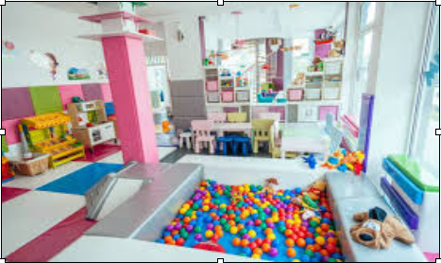 | 1 | ☐ Yes ☐ No
8. | BABY BALL PIT 2  The ball pit is padded on all sides (raw chipboard coated with sponge with 30 density and PVC canvas 690gr/m2) and has sides for sitting up. Filled with plastic balls of various colours, dimensions 8cm.  More than 100 balls to 1 m2.  Pit surface: 2.50-2.60 m2 ; Pit depth : 30cm ; Pit width 30cm  Offered model should be equal or similar to the picture below: | 1 | ☐ Yes ☐ No
9. | Baby corner - quartz sand  Dimensions: 2.25m2 ( 1.5m x 1.5m H-30cm )  Contents: coloured quartz play sand for use in children's playrooms and playgrounds  Material: High density fibreboard minimum 3mm thick; Chipboard minimum 10mm thick ; Sponge minimum 1cm thick S20kg/m3; Sponge minimum 3cm thick S20kg/m3; Tarpaulin minimum 580g/m2 Coloured quartz play sand  Offered model should be equal or similar to the picture below:  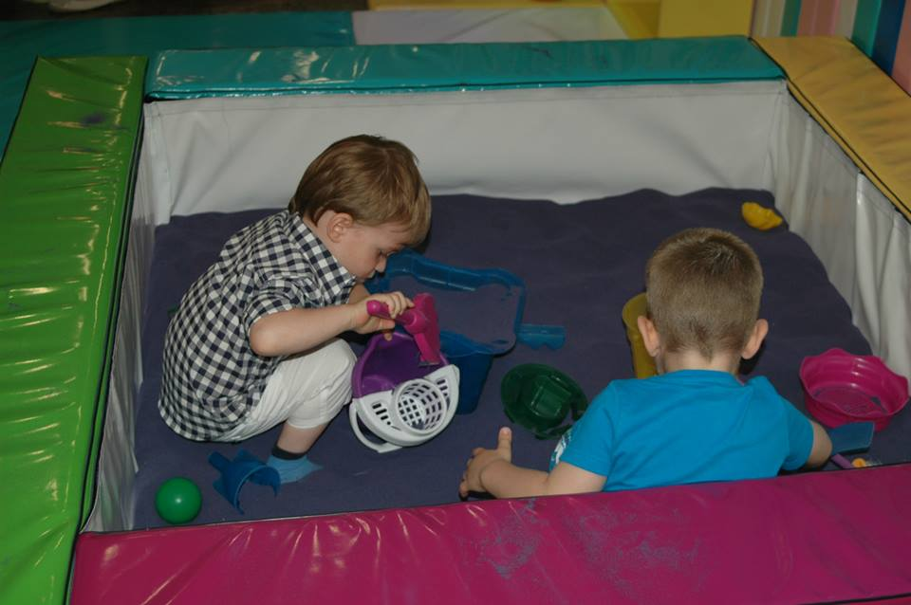 | 2 | ☐ Yes ☐ No
10. | KIDS' CORNER  Manufacturing material: Fir wood for the structure and plywood coated chipboard minimum 10mm thick. Processed and with smooth edges. Painted in natural colours.  Kids’ corner kitchen: Kitchen dimension; (W/L/H) 30x100x100cm Minimum equipment; (coffee set 1pcs, 2 small pots, cookware 1pcs, dishcloth 1 pcs, apron 1pcs, tea set 1pcs)  Doctor's corner: Dimensions ; (W/L/H) 30x80x120cm Minimum Doctor's corner equipment ; (chairs 2 pcs, plastic made medical examination set 1pcs, stethoscope 1pcs, medical glows 1 set, blood pressure monitor 1 pcs, examination spatula 1pcs, notebook 1 pcs, doctor's coat 1pcs)  Workshop for boys: Dimension (W/L/H) 30x70x80cm Minimum equipment (tool set - screwdriver 1 pcs, hammer 1pcs, wrench 1 pcs, pliers 1 pcs, 2 sets of smaller and bigger screws, apron 1 pcs, protective helmet 1 pcs)  Market corner: Dimensions (W/L/H) 40x90x120cm Minimum equipment ( plastic crates holding fruits and vegetables made of plastic, 2 sets with 12 pieces of fruits and vegetables )  Hairdresser's and Make-up artist's corner: Dimensions (W/L/H) 30x120x120 cm Minimum equipment (combs and brushes 1 set, hairdressers chair 1pcs, hair dryer toys 2 pcs, hairpins, ribbons and bows - 1 set, hairspray toy 1 pcs, mini shampoo chair 1 pcs)  Offered model should be similar to the picture below:  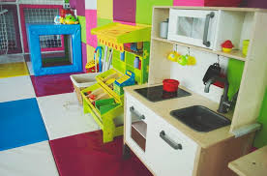 | 1 | ☐ Yes ☐ No
11. | Padded Wall Climber  Dimensions: 2.88m2 (W/H) 2,4 x 1,2m  Material: Basic panel phenol coated plywood board minimum 21mm thick or chipboard minimum 18mm thick overlaid with minimum 3cm thick sponge of density 25 and a PVC tarpaulin of minimum 690gr/m2 or 580 g/m2 tarpaulin. Wooden rungs for climbing, minimum 21mm thick overlaid with minimum 3cm thick sponge of density 25 and a PVC tarpaulin of minimum 690gr/m2 or 580 g/m2 tarpaulin. Wooden rungs connected with basic panel with screws, and connected with wall with anchor screws 120 mm. Basic panels in one color and wooden rungs in various colors. | 3 | ☐ Yes ☐ No
12. | Floor Padding  Material: untreated chipboard minimum 18mm thick; minimum 30mm thick sponge; PVC tarpaulin of minimum 690gr/m2 or tarpaulin minimum 580g/m2. Different colors , offered colors minimum 3.  Total surface area :81m2 | 1 | ☐ Yes ☐ No
  One playroom in LESKOVAC (20m2)
  One playroom in ALEKSINAC ( 20m2)
  One playroom in BUJANOVAC (20m2)
  One playroom in SJENICA(21m2)
13. | Wall Padding – Strips  Surface area: 13.2m2  Material:  High density fibreboard minimum 3mm thick  Sponge minimum 2cm thick S20 kg/m3  Tarpaulin 580g/m2  Strips in different dimensions and colors as on the picture.  Offered model should be similar to the picture below:  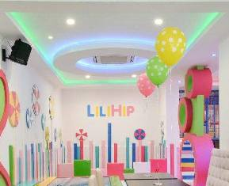 | 1 | ☐ Yes ☐ No
14. | Wall Padding  Material: untreated chipboard minimum 18mm thick; minimum 3cm thick sponge of density 25, upholstered with PVC tarpaulin of minimum 690gr/m2. Glued onto the wall. Different colors, offered colors minimum 3.  Total surface area :40m2 | 1 | ☐ Yes ☐ No
  One playroom in LESKOVAC (20m2)
  One playroom in ALEKSINAC (20m2)
15. | Padded Lollypop Circles  Material: High-density fibreboard minimum 3mm thick  Sponge minimum 2cm thick S20kg/m3  Tarpaulin 580g/m2  Description: wall mounted lollypop-shaped circles.  Lollypop circles in different diameters and colors.  Offered model should be similar to the picture below: | 8 | ☐ Yes ☐ No
16. | Photo Wallpaper  Dimensions surface: 4.5 m2  Material: Printed foil with children's motives. Minimum three offered motives.  Purpose: wall decoration | 1 | ☐ Yes ☐ No
17. | Window Film  Surface: 14m2  Description: Self-adhesive film with children's motives preventing the view of the interior and allowing a clear view of the outside, with the effect of stained patterned glass. Minimum three offered children's motives. | 1 | ☐ Yes ☐ No
18. | Kids' Playhouse  Description:  Made of metal structure with triangle shape (will be mounted under the stairs). Playhouse contains two rows of fields, one field are stairs dimensions W/L 50 x 50cm made for climbing and other field is made toboggan like, dimension W/L 50x220 cm made for kid's lowering and exiting from the playhouse. Playhouse look like cheese with holes, children will wear mouse- like masks.  The entire structure of the playhouse is padded with armaflex 42/13 insulation or similar and PVC tarpaulin of minimum 690gr/m2.  The house is surrounded by a protective mesh knotted into 5cm x 5cm eyelets.  The front of the playhouse is covered with boards padded with sponges and PVC tarpaulin with a printed image.  Playhouse Dimensions:  Length 320 cm, Width 120 cm, highest roof point on 270 cm | 1 | ☐ Yes ☐ No
19. | Kids' Corner – Carpenter's Workshop  Pieces: desk, screw clamp, carpenter-s square  Dimensions: minimum 50cm x minimum 60cm x minimum 35cm  Material: beech profiles, chipboard minimum 18mm thick, high density fibreboard minimum 3 mm thick, MDF minimum 10mm thick; (2mm ABS edging, 1 mm ABS edging) | 1 | ☐ Yes ☐ No
20. | Kids' Corner – Kitchen  Pieces minimum: cooker and sink.  Dimensions: minimum 90cm x minimum 60cm x minimum 35cm  Material: coloured chipboard minimum 18mm thick, high density fibreboard minimum 3 mm thick, Plexiglas minimum 1 mm thick, edged (2mm ABS edging, 1 mm ABS edging) | 1 | ☐ Yes ☐ No
21. | Soft program  Dimensions: minimum 90cm x minimum 60cm x minimum 35cm  Pieces: steps (minimum 60cm x minimum 50cm x minimum 45cm); tunnel (minimum 50cm x minimum 60cm x minimum 45cm); slide (minimum 50cm x minimum 60cm x minimum 45cm)  Material: chipboard minimum 10mm thick, sponge S20kg/m3. retex70g/m2, synthetic leather  Offered model should be similar to the picture below:  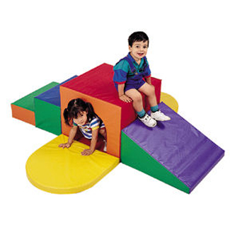 | 1 | ☐ Yes ☐ No
22. | CAROUSEL  R-160cm  H-2.4m  With 4 seats  Steel box 30x30x1.8mm  Steel rod f-20mm  Sponge minimum 3cm thick S20kg/m3  Sponge minimum 1cm thick S20kg/m3  Chipboard minimum 18mm thick  High density fibreboard minimum 3mm thick  Rope minimum f-6mm  Tarpaulin 580g/m2  Offered model should be similar to the picture below:  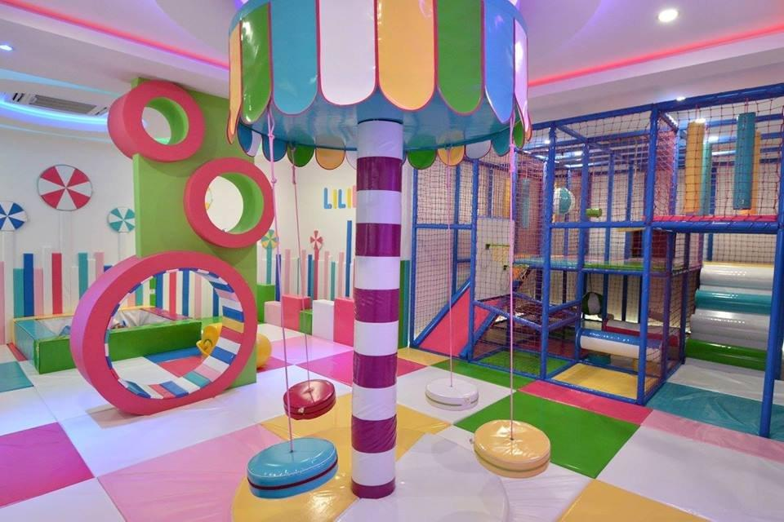 | 1 | ☐ Yes ☐ No

Delivery requirements –– Comparative Data Table

UNOPS Requirements |  | Is quotation compliant? Bidder to complete | Details  Bidder to complete  Insert details
Delivery time | Bidder shall deliver the goods 60 (Sixty Five) calendar days after the Contract signature. | ☐ Yes ☐ No
Delivery place and Incoterms rules | Net of any direct taxes, customs duties, indirect taxes and VAT.  DAP (Delivered at Place, as per Incoterms 2010):  Transportation, offload, assembly and installation of the equipment on the beneficiary’s premises are included in the price and should be according to attached delivery plan in attachment I. | ☐ Yes ☐ No
Consignee details | The exact address the goods shall be delivered and offloaded to, as well as all other relevant details, will be available upon contract signature. | ☐ Yes ☐ No
UNOPS Right to vary requirements | At the time the Contract is awarded, UNOPS reserves the right to vary the quantity of the goods and associated services specified above, provided this does not exceed +/- 20%, without any change in the unit prices or other terms and conditions of the RFQ. | ☐ Yes ☐ No

The offered goods and related services (if applicable) are in accordance with the required specifications and requirements specified in Section III: Schedule of Requirements.

☐ Yes ☐ No
ANY DEVIATION MUST BE LISTED BELOW:
___________________________________________________________________________________________________________________________________________________________________________________________________________________________________________________________________________________________________________________________________________________________________________________________________________________________________________________

Name : _____________________________________________________________

Title : _____________________________________________________________

Date : _____________________________________________________________

Signature : _____________________________________________________________

Form D: Previous experience form
RFQ reference no: [insert RFQ reference No.] ______________________________________
Name of Bidder: [insert name of Bidder] ______________________________________

Description of services/goods | Country | Total amount of Contract | Contract Identification and Title and  Contact details of Client:  (Name, Address, telephone, email, fax) | Year project was undertaken

Name : _____________________________________________________________

Title : _____________________________________________________________

Date : _____________________________________________________________

Signature : _____________________________________________________________75 00ax: +45 45 33 75 01

