Version: v2016.1
Returnable Bidding Forms Part I
Purchase of equipment for hairdresser and beauty salons in support of women entrepreneurship
RFQ Ref No: UNOPS-EP-2016-G-018

Section IV: Returnable Bidding Forms
Note to Bidders: Instructions to complete each Form are highlighted in blue in each Form. Please complete the Returnable Biding Forms as instructed and return them as part of your quotation.

The following returnable forms are part of this RFQ and must be completed and returned by bidders as part of their Quotation.

Form A: Quotation submission form
Bidders are requested to complete this form, sign it and return it as part of their bid submission. The bidder shall fill in this form in accordance with the instructions indicated. No alterations to its format shall be permitted and no substitutions shall be accepted.
Date: [Insert submission date]____________________________

Subject: Quotation for the supply of [Insert a brief description of goods/services] __________________________________in ________________________________[Name of country/city], RFQ Case No.[insert RFQ ref number]_______________________________, dated [insert date]_____________________.

We, the undersigned, declare that:
  - We offer to supply in conformity with the bidding documents, including the UNOPS General Conditions of Contract.
  - Our quotation shall be valid for the period of time of [insert number of days which shall not be less than the specified in Section I: Bid Particulars, Period of Validity of Bids] _________________from the date fixed for the bid submission deadline as set out in the RFQ, and it shall remain binding upon us and may be accepted at any time before the expiration of that period;
  - We have no conflict of interest in any activity that would put it, if selected for this assignment, in a conflict of interest with UNOPS;
  - Our firm confirms that the offeror and sub-contractors have not been associated, or had been involved in any way, directly or indirectly, with the preparation of the design, terms of references and/or other documents used as a part of this solicitation;
  - Our firm, its affiliates or subsidiaries—including any subcontractors or suppliers for any part of the Contract—has not been declared ineligible by UNOPS, nor is included in the suspended/ineligibility list of the UN/PD, other UN Agencies, the UN Security Council, and the World Bank, in accordance with Instructions to Bidders Article 3, Eligibility;
  - We embrace the UN Supplier Code of Conduct and adhere to the principles of the UN Global Compact
  - We have not declared bankruptcy, are not involved in bankruptcy or receivership proceedings, and there is no judgment or pending legal action against them that could impair their operations in the foreseeable future.
  - We have not offered and will not offer fees, gifts and/or favours of kind in exchange for this RFQ and will not engage in any such activity during the performance of any Contract awarded.
I, the undersigned, certify that I am duly authorized by [insert full name of bidder] ________________________________to sign this quotation and bind [insert full name of bidder] should UNOPS accept this quotation:
Name: [complete]_______________________________________________________
Title: [complete]_________________________________________________________
Signature: _____________________________________________________________

Provide the name and contact information for the primary contact from your company for this quotation:

Name: [complete]________________________________________________________
Title: [complete]__________________________________________________________
Email address: [complete]___________________________________________________
Telephone: [complete]______________________________________________________

Form B: Price Schedule Form
Bidders shall fill in this Price Schedule Form in accordance with the instructions indicated.

RFQ reference no: [insert RFQ reference No.]

LOT I – Equipment for hairdresser salons

Currency | RSD

Item No | Description | Qty | Unit price DAP  Tax free in RSD | Total price DAP  Tax free in RSD
1. | Ceramic Shampoo Chair I | 1
2. | Ceramic Shampoo Chair II | 3
3. | Footrest per one hairstyling place | 2
4. | Armchair | 2
5. | Hairdressers Hydraulic Chair I | 2
6. | Hairdressers Hydraulic Chair II | 2
7. | Hairdressing Trolley | 1
8. | Hairdressing Counter | 2
9. | Make-up Chair | 1
10. | Sofa I | 1
11. | Sofa II | 1
12. | Set of professional Hot Rollers I | 1
13 | Set of Professional Hot Rollers II | 1
14. | Hairdryer | 7
15 | Curling Iron 3 in 1 | 2
16. | Tourmaline Curler | 1
17. | Five Barrel Curler | 1
18. | Curling Iron with Motor | 1
19. | Hood dryer | 1
20 | Thinning Shears | 3
21. | Razor-Edge Scissors | 3
22. | Micro-Tech Scissors | 3
23. | Hair Clippers | 4
24. | Flat Iron 1 | 2
25. | Flat Iron 2 | 1
26. | Flat Iron 3 | 1
27. | Sterilizer | 1
28. | Practice Head | 1
TOTAL PRICE LOT I |  |  |  | (Insert)

LOT II – Equipment for beauty salons

Item No | Description | Qty | Unit price DAP  Tax free in RSD | Total price DAP  Tax free in RSD
1. | Electrically adjustable cosmetics bed | 3
2. | Cosmetics bed | 2
3. | Makeup Chair, High Chair | 4
4. | Auxiliary Cosmetics Trolley without Drawers | 3
5. | Auxilliary Cosmetics Trolley with Shelving and Drawers | 5
6. | Auxilliary Cosmetic Chair | 3
7. | Manicure Table | 2
8. | Pedicure Chair | 1
9. | Massage Oil Heating Device | 1
10. | Manicure Table Draft Fan | 1
11. | Manicure Extractor Fan (table mount) | 2
12. | Electric Nail File | 5
13. | Stone Heater | 1
14. | Pedicure Tub | 3
15. | Combined Wax Warmer | 3
16. | Professional Cosmetics Case | 1
17. | Nail Drying LED Lamp | 1
18. | Magnifying Glass With Light | 1
19. | Manicure - Handrest with Dust Collector | 1
20. | Nail Trainer | 1
21. | Hot/Cold Nail Polish Dryer | 1
22. | Dry-Heat Steriliser | 1
23. | Paraffin Melter, Aluminium | 2
24. | Double Hot Wax Warmer | 1
25. | Hot Wax Warmer | 1
26. | Trio Wax Cartridge Heater with Base | 1
27. | UV Lamp | 2
28. | UV lamp with Fan | 1
29. | UV LED Nail Lamp | 2
30. | Volcanic stone set | 2
31. | Multifunctional Device I | 1
32. | Multifunctional Device II | 1
33. | Interference Current Device | 1
34. | Magnetic Therapy Device | 1
35. | Mesotherapy Device | 1
36. | Diamond Tip Microdermoabrasion Device | 1
37. | Ultrasound cavitation device | 1
38. | Aqua detox | 1
39. | Electro stimulator | 1
40. | Multifunctional Beauty Instrument | 1
41. | Cosmetics Device | 1
42. | Multifunctional Beauty Device | 1
43. | Multifunctional Device | 1
44. | Tanning booth tower | 1
45. | Tanning booth vertical - tower | 1
46. | Tens stimulator | 1
47. | Physical Therapy Ultrasound | 1
TOTAL PRICE LOT II |  |  |  | (Insert)

Payment terms 30 days accepted: ☐ Yes

Bidder’s discount for accelerated payment: _____% of total firm price for each calendar day less than thirty (30) days

List of subcontractors or suppliers
Bidder must identify the names of all subcontractors/suppliers who will be providing good/services under this Contract and the type of work being subcontracted, if applicable.

[Full legal name and address of subcontractors]

- ____________________________________________

- ____________________________________________

- ____________________________________________

I, the undersigned, certify that I am duly authorized by [insert full name of Bidder]
______________________________________________________________ to sign this quotation and bind

____________________________________________________[insert full name of Bidder] should UNOPS accept this quotation:

Name : _____________________________________________________________

Title : _____________________________________________________________

Date : _____________________________________________________________

Signature : _____________________________________________________________

Form C: Technical Quotation Form

RFQ reference no: [insert RFQ reference No.]______________________________________

Name of Bidder: [insert name of Bidder]___________________________________________
Bidders are required to complete the Comparative Data Tables included in Section III: Schedule of Requirements to demonstrate compliance with UNOPS requirements and insert them below. Bidders are NOT allowed to make any change in the “UNOPS requirements” columns of the Comparative Data Tables. Such changes might disqualify your quotation.

Technical specifications for goods – Comparative Data Table

Item No | UNOPS minimum technical requirements | Qty | Is quotation compliant?  Bidder to complete | Details of goods offered. Bidder to complete  Insert details of goods offered, including specifications and brand/model offered if applicable
1. | Ceramic Shampoo Chair I  Height: 800 - 950 mm  Length: 900- 1500 mm  Width: 600-800 mm  Water supply: from the back and the floor  Water drainage: from the back and the floor  Adjustable ceramic slope  Stability: floor installation  Ceramic colour: white  Chair colour: white | 1 | ☐ Yes ☐ No
2. | Ceramic Shampoo Chair II  Height: minimum 1000 mm  Length: minimum 1000 mm  Width: minimum 500 mm  Water supply: floor and back  Water drainage: floor and back  Adjustable ceramic slope  Stability Floor installation  Chair colour: black | 3 | ☐ Yes ☐ No
3. | Footrest per one hairstyling place  Metal base  Placed under hairdressing counter (workplace), similar to the picture below:  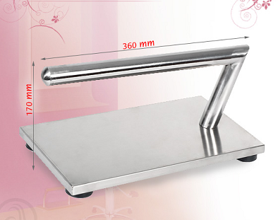 | 2 | ☐ Yes ☐ No
4. | Armchair  Colour: black  Material: synthetic leather, similar to the picture below:  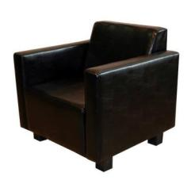 | 2 | ☐ Yes ☐ No
5. | Hairdressers Hydraulic Chair I  Seat colour: white  Material: synthetic leather  Base colour: chrome  Max. seat height:730 mm  Min. seat height: 500 mm  Seat width: 500-700 mm  Hydraulic capacity: 120 kg minimum, similar to the picture below  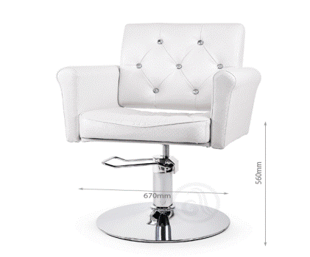 | 2 | ☐ Yes ☐ No
6. | Hairdressers Hydraulic Chair II  Universal (unisex) chair  Seat colour: black  Material: synthetic leather  Base colour: chrome  Max. seat height: 730 mm  Min. seat height: 500 mm  Seat width: 500-700 mm  Hydraulic capacity: 120 kg minimum  Foot rest, similar to the picture below:  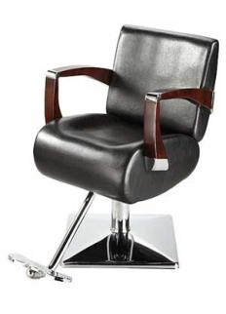 | 2 | ☐ Yes ☐ No
7. | Hairdressing Trolley  Colour: white  5 - 10 shelves  Metal frame  Metal hairdryer holder, similar to the picture below:  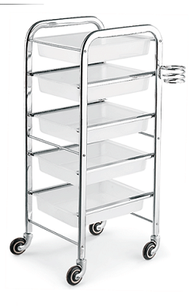 | 1 | ☐ Yes ☐ No
8. | Hairdressing Counter  Mirror with a shelf and light per one hairstyling place  Colour: MDF colour or burgundy, or black or yellow-black  Power: 80W minimum, similar to the picture below:  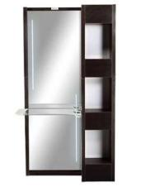 | 2 | ☐ Yes ☐ No
9. | Make-up Chair  Foldable, similar to the picture below:  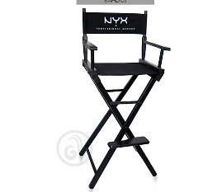 | 1 | ☐ Yes ☐ No
10. | Sofa I  Colour: white  Material: synthetic leather  Sofa height: 600-800 mm  Seat height: 300-400 mm  Backrest height: 300-400 mm  Sofa width: 1200- 1600 mm, similar to the picture below:  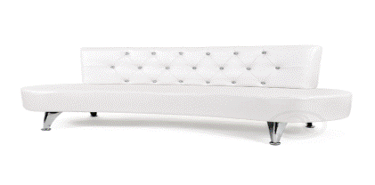 | 1 | ☐ Yes ☐ No
11. | Sofa II  Colour: black  Material: synthetic leather  Sofa height: maximum 800 mm  Seat height: minimum 300 mm  Backrest height: minimum 300 mm  Sofa width: minimum 1200 mm  Armrests and backrests | 1 | ☐ Yes ☐ No
12. | Set of Professional Hot Rollers I  9 different size rollers  Ion technology, fast heating  2 extra large rollers (50mm)  7 large rollers (38mm)  13 fixing needles + 4 spare  9 clips" | 1 | ☐ Yes ☐ No
13. | Set of Professional Hot Rollers II  20 different size rollers  Ion technology, fast heating  8 large rollers (28mm)  6 medium rollers (25mm)  6 small rollers (22mm)  20 fixing needles + 6 spare  10 clips | 1 | ☐ Yes ☐ No
14. | Hairdryer  Air speed: minimum 75km/h  Ion technology: minimum 70,000,000 ions/cm3  AC motor  Power 2000-2200W  Maximum temperature 110°C  Air speed: maximum 110m3/h  4 temperature settings  2 speed settings  Ceramic - tourmaline grid  Two air deflectors  Conical grid for hair styling  Cord length: minimum 2m | 7 | ☐ Yes ☐ No
15. | 3-in-1 Curling Iron  3 appliances in one  Styling iron for curls  Styling iron for waves  Styling iron for spiral curls  Magnetic accessories  Minimum temperature range between 160-200°C, Smooth ceramic Argan oil coated barrels, Auto shut-off, Cable length minimum 3m, Heat resistant storing pouch  Heat resistant glove | 2 | ☐ Yes ☐ No
16. | Tourmaline Curler  Ceramic, 25 -18 mm, similar to the picture below: 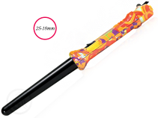 | 1 | ☐ Yes ☐ No
17. | Five Barrel Curler  5 interchangeable barrels different in size and an extension for lifting hair roots  Infrared technology from 60°C to 220°C  Ion technology  Material: titanium  Similar to the picture below  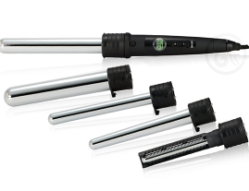 | 1 | ☐ Yes ☐ No
18. | Curling Iron with Motor  10-15 possible temperature settings ranging from minimum 70 to maximum 220°C  Automatic shut-off  Cable length minimum 3m  Heat resistant storing pouch  Heat resistant gloves | 1 | ☐ Yes ☐ No
19. | Hood Dryer  Two speed  Minimum power :1100 W  Work mode: 230V, 50Hz  Preferred color: black  Similar to the picture below  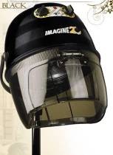 | 1 | ☐ Yes ☐ No
20. | Thinning Shears  Diamond sharpened blade  Stainless steel  Size 5.5" (14cm)  38 teeth blade | 3 | ☐ Yes ☐ No
21. | Razor-Edge Scissors  Self-sharpening blade  Material: carbon reinforced 440C steel  Size: 5.5" (14cm)  Blade: convex razor sharp blade  Finger rest | 3 | ☐ Yes ☐ No
22. | Micro-Tech Scissors  Diamond sharpened blade  Stainless steel  Size: 5.5" (14 cm)  Blade: micro-tech (for straight hair cutting) | 3 | ☐ Yes ☐ No
23. | Hair Clippers  Manual adjustment from 0.1 mm to 3 mm.  Set includes: hair clippers, blade protector, 4-6 additional combs, lubricating oil, cleaning brush  Mode: 230 V, 50 Hz, minimum 9 W  Similar to the picture below  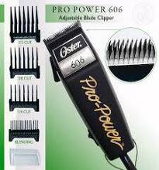 | 4 | ☐ Yes ☐ No
24. | Flat Iron 1  Thermal technology  Macadamia oil, Argan oil and keratin coated ceramic plates  Heats up to 110°C in 7-10 sec  Heats up to 180°C in 15-20 sec  Digital temperature setting range between 110-230°C  Similar to the picture below  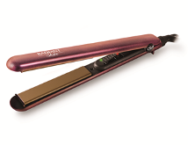 | 2 | ☐ Yes ☐ No
25. | Flat Iron 2  Ceramic tourmaline plates generate infrared rays and ions  Heats up in 30 sec | 1 | ☐ Yes ☐ No
26. | Flat Iron 3  Argan oil coated ceramic floating plates  Heats up to 110°C in 10 seconds  Heats up to 180°C in 30 seconds | 1 | ☐ Yes ☐ No
27. | Sterilizer  Lamp power minimum 8 W  Sterilization time 30-45 min  Can sterilize hair accessories and pedicure-manicure accessories  Similar to the picture below  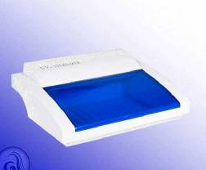 | 1 | ☐ Yes ☐ No
28. | Practice Head (with Natural Hair)  Hair length 50 - 60 cm  Each strand of hair stitched by hand | 1 | ☐ Yes ☐ No

