Version: v2016.1
Request for Quotation (RFQ) for Goods
Purchase of Dental Equipment in Support of Women Entrepreneurship
RFQ Ref No: UNOPS-EP-2016-G-001

Section IV: Returnable Bidding Forms
Note to Bidders: Instructions to complete each Form are highlighted in blue in each Form. Please complete the Returnable Biding Forms as instructed and return them as part of your quotation.

The following returnable forms are part of this RFQ and must be completed and returned by bidders as part of their Quotation.

Form A: Quotation submission form
Bidders are requested to complete this form, sign it and return it as part of their bid submission. The bidder shall fill in this form in accordance with the instructions indicated. No alterations to its format shall be permitted and no substitutions shall be accepted.
Date: [Insert submission date]____________________________

Subject: Quotation for the supply of [Insert a brief description of goods/services] __________________________________in ________________________________[Name of country/city], RFQ Case No.[insert RFQ ref number]_______________________________, dated [insert date]_____________________.

We, the undersigned, declare that:
  - We offer to supply in conformity with the bidding documents, including the UNOPS General Conditions of Contract.
  - Our quotation shall be valid for the period of time of [insert number of days which shall not be less than the specified in Section I: Bid Particulars, Period of Validity of Bids] _________________from the date fixed for the bid submission deadline as set out in the RFQ, and it shall remain binding upon us and may be accepted at any time before the expiration of that period;
  - We have no conflict of interest in any activity that would put it, if selected for this assignment, in a conflict of interest with UNOPS;
  - Our firm confirms that the offeror and sub-contractors have not been associated, or had been involved in any way, directly or indirectly, with the preparation of the design, terms of references and/or other documents used as a part of this solicitation;
  - Our firm, its affiliates or subsidiaries—including any subcontractors or suppliers for any part of the Contract—has not been declared ineligible by UNOPS, nor is included in the suspended/ineligibility list of the UN/PD, other UN Agencies, the UN Security Council, and the World Bank, in accordance with Instructions to Bidders Article 3, Eligibility;
  - We embrace the UN Supplier Code of Conduct and adhere to the principles of the UN Global Compact
  - We have not declared bankruptcy, are not involved in bankruptcy or receivership proceedings, and there is no judgment or pending legal action against them that could impair their operations in the foreseeable future.
  - We have not offered and will not offer fees, gifts and/or favours of kind in exchange for this RFQ and will not engage in any such activity during the performance of any Contract awarded.
I, the undersigned, certify that I am duly authorized by [insert full name of bidder] ________________________________to sign this quotation and bind [insert full name of bidder] should UNOPS accept this quotation:
Name: [complete]_______________________________________________________
Title: [complete]_________________________________________________________
Signature: _____________________________________________________________

Provide the name and contact information for the primary contact from your company for this quotation:

Name: [complete]________________________________________________________
Title: [complete]__________________________________________________________
Email address: [complete]___________________________________________________
Telephone: [complete]______________________________________________________

Form B: Price Schedule Form
Bidders shall fill in this Price Schedule Form in accordance with the instructions indicated.

RFQ reference no: [insert RFQ reference No.]

Currency | RSD

Item No | Description | Qty | Unit price DAP  (Insert) | Total price DAP  (Insert)
LOT 1
1. | Dental Chair equipped with Instrument Table, Water Block and Fountain | 4
2. | Dentist Stool | 4
3. | Oilless Dental Compressor Minimum 40lit | 4
TOTAL LOT 1

Item No | Description | Qty | Unit price DAP  (Insert) | Total price DAP  (Insert)
LOT 2
1. | Autoclave for Steam Sterilisation | 4
2. | Dry-Heat Steriliser | 3
3. | Ultrasonic Bath | 1
TOTAL LOT 2

Item No | Description | Qty | Unit price DAP  (Insert) | Total price DAP  (Insert)
LOT 3
1. | Bicarbonate jets | 4
2. | LED Curing Light | 3
3. | Ultrasonic Scaler – Built in | 2
4. | Portable Scaler | 1
5. | Pulp Vitality Tester | 2
6. | Thermocauter | 2
7. | Portable Surgical Vacuum Pump (sauger) | 1
8. | Digital Amalgam Mixer, i.e. Amalgamator, for Capsule Amalgam. | 2
9. | Endodontic Instrument with Apex Locator | 2
TOTAL LOT 3

Item No | Description | Qty | Unit price DAP  (Insert) | Total price DAP  (Insert)
LOT 4
1. | Turbine with Light w/o clutch | 2
2. | Clutch for Turbine with Light | 2
3. | Module for the Turbine with Light | 2
TOTAL LOT 4
Item No | Description | Qty | Unit price DAP  (Insert) | Total price DAP  (Insert)
LOT 5
1. | Intraoral Camera | 1
2. | Monitor Holder for the Reflector Post with a TFT Monitor | 1
TOTAL LOT 5

Payment terms 30 days accepted: ☐ Yes

Bidder’s discount for accelerated payment: _____% of total firm price for each calendar day less than thirty (30) days

List of subcontractors or suppliers

Bidder must identify the names of all subcontractors/suppliers who will be providing good/services under this Contract and the type of work being subcontracted, if applicable.

[Full legal name and address of subcontractors]

- _________________________________________________

- _________________________________________________

- _________________________________________________

I, the undersigned, certify that I am duly authorized by [insert full name of Bidder]
_______________________________________________ to sign this quotation and bind
__________________________________________________[insert full name of Bidder] should UNOPS accept this quotation:

Name : _____________________________________________________________

Title : _____________________________________________________________

Date : _____________________________________________________________

Signature : _____________________________________________________________

Form C: Technical Quotation Form

RFQ reference no: [insert RFQ reference No.]______________________________________
Name of Bidder: [insert name of Bidder]___________________________________________

Bidders are required to complete the Comparative Data Tables included in Section III: Schedule of Requirements to demonstrate compliance with UNOPS requirements and insert them below. Bidders are NOT allowed to make any change in the “UNOPS requirements” columns of the Comparative Data Tables. Such changes might disqualify your quotation.

Technical specifications for goods – Comparative Data Table

Item No | UNOPS minimum technical requirements | Qty | Is quotation compliant?  Bidder to complete | Details of goods offered. Bidder to complete  Insert details of goods offered, including specifications and brand/model offered if applicable
LOT 1
1. | Dental Chair equipped with Instrument Table, Water Block and Fountain  Dental Chair  Chair Structure  made of solid steel with anti-corrosion treatment and coated in scratch- and shock-proof polystyrene.  Chair Base  ergonomic design, made of solid steel plate, coated with anti-slip material, no need to anchor into the floor.  Chair Upholstery  anatomically shaped backrest with pronounced lumbar support, mounted onto a firm structure, filled with polyurethane, upholstered with laminated materials, seamless  plastic protecting foil to protect the upholstery in the area around the patients’ feet.  Seat Lifting/Backrest Reclining System  Electro-mechanical and activated via low voltage 24V electric motors.  Patient Arm Rest  two rounded armrests for the patients, integrated into the chair  Electronic System  Integrated, low voltage, 24V  Power supply  220 V, AC, 50/60 Hz.  Chair Movement Control  via a fixed multi-functional foot pedal,  Multi-Functional Foot Pedal, as minimum requirements, shall contain the following chair movement control commands:  1 – programming presets 1, 2 and 3 / activating presets 1, 2 and 3,  2 – automatic return to parking position,  3 – backrest raising,  4 – backrest reclining,  5 – seat lifting,  6 – seat lowering,  7 – reflector activation and intensity setting  Instrument Table  As minimum requirements it shall include the following leads for the instrument table mounted instruments:  item 1 – 3-functional metal handpiece,  item 2. – turbine line, turbine, connector (4-hole) with spray regulation functionality,  item 3. – line for the air motor with micromotor and bend, connector (4-hole) with spray regulation functionality,  Fountain water activating button,  autoclavable safeguard rubber for mountable instruments.  Hoses with retractors  - leads for the mountable instrument hoses fitted with retractors to reduce the tension on the hose and provide for easier handling of the mountable instrument,  - individual instrument pneumatic activation by pulling.  Instrument Table Arm  - made of steel with anti-corrosion treatment polymerized at 250°C,  - double articulated: horizontal – up to 1800, vertical - ±300,  - pneumatic brake to fix the table to a desired vertical position, positioned under the instrument table body.  Mountable Instrument Activating Foot Pedal  - mobile, progressive.  Tray Under the Instrument Table  - minimum 200x200mm tray, 360 degree rotation.  Junction Box  - made of polyethylene, shock proof, with rounded edges.  Mountable Instruments Water Supply System  - transparent tank, easy access, integrated with the dental device.  Reflector  - reflector with LED lights – over 50,000 working hours, colour temperature (white) 5,500 – 6.300 K  - robust, easy maintenance,  - ergonomic reflector handles are removable and autoclavable,  - chair foot pedal activated (possibility to change light intensity using foot commands),  - contactless reflector activation/deactivation via optical sensor,  - double articulated reflector arm, movable in all directions,  - reflector head with orbital movement and rotation of up to 620 degrees,  - reflector head movement up to ±350,  - reflector power: adjustable, 10 – 35kLUX.  Water block  Integrated with chair,  Integrated air suction,  Buttons for: fountain water activation/deactivation and activation/deactivation of cup water,  Faucets to adjust water flow in the fountain and to the cup.  Fountain  - min. 3 cm frame depth, possibility of removal for easier cleaning and disinfection.  Equal or similar to model SYNCRUS GL, and to the below illustration:  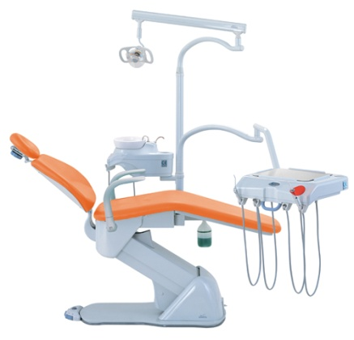 | 4 | ☐ Yes ☐ No
2. | Dentist Stool  Dentist’s working stool.  Stool base made of metal with durable wheels.  Backrest with adjustable angle and height, which enables multi-positioning and comfort for the lumbar region.  Seat with a possibility of lifting and lowering during seating. Gas mechanism.  Mechanism to enable changing the height of the seat and changing the angle of the backrest.  Stool height range between 50-70cm.  The backrest and seat coated with durable upholstery, seamless and with material density not allowing deformations.  The upholstery shall be easy to clean and bio-safe.  Equal or similar to model Syncrus Top (Gnatus) and to the below illustration:  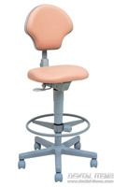 | 4 | ☐ Yes ☐ No
3. | Oilless Dental Compressor Minimum 40lit  Minimum technical requirements:  Fitted with a pressure measuring device (manometer) in a bottle, output pressure control manometer, output pressure regulator with a condensation vessel for filtration of water from air  Security system with a pressure release valve and thermal safeguard to protect the compressor against overheating.  Models with bottles of no less than 35 litres with interior anti-corrosion protection,  Grid power and frequency: 220 V~ ±10% 60Hz / 220 V~ ±10% 50Hz / 127 V~ ±10% 60Hz,  Electricity power: 127 V~ - 7,3 A / 220 V~ - 5 A  Nominal power and consumption: 127 V~ - 830 VA, 0,83 kW/h / 220 V~ - 1100 VA, 1,1 kW/h  Compressor power: 1 motor, not less than 1.12 HP  Bottle capacity: not less than 35 litres  Minimum pressure: 5.50 kgf/cm2  Air displacement: 212 l/min  Equal or similar to the below illustration:  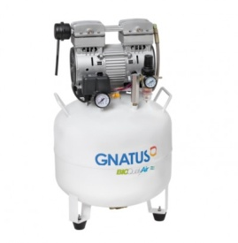 | 4 | ☐ Yes ☐ No

LOT 2
1. | Autoclave for Steam Sterilisation  Minimum technical requirements:  Micro-processor controlled electronic system.  Made of steel, coated with glossy epoxy paint, corrosion and detergent proof.  The chamber made of stainless material, with capacity of not less than 12 litres.  Coated with thermal insulating material; anti-vacuum valves, providing for a secure seal and preventing door jams.  Contains LED lights and functional buttons, manometer to measure pressure and temperature, providing for ergonomic handling with an automatic high pressure safeguard.  1 sterilisation cycle (12 - 20 minutes)  1 drying cycle, performed with the door slightly open.  Sterilisation type: steam sterilisation  Power supply: 220 V +20%, -10%, AC  Volume: not less than 12l  Power: 1600W  Operating temperature: 128 °C ± 2 °C  Pressure during sterilisation: 1,9 ± 0,2 kgf/cm2  Sterilisation time: 12-20min.  Required water: 150-200ml  Equal or similar to the below illustration:  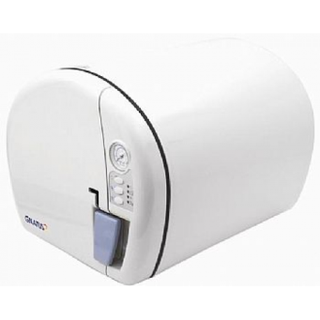 | 4 | ☐ Yes ☐ No
2. | Dry-Heat Steriliser  Minimum technical requirements:  Contains two perforated trays, to be insulated with mineral fibre and to possess digital temperature regulation.  Sterilisation type: dry  Power supply: 220 - 230 W  Volume: not less than 35l  Power: 1,000W  Operating temperature: 250°C  Water required: no  Equal or similar to the below illustration:  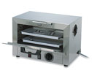 | 3 | ☐ Yes ☐ No
3. | Ultrasonic Bath  Minimum technical requirements:  Ceramic heaters (2 pcs):  Ultrasonic hot water cleaning: min. 4 heating options  Water discharge: valve for discharging water from the bath  Ultrasonic vibration generator (2 pcs): independent control units for each one, even wave distribution for a more thorough cleaning  Transparent cover  Mesh basket: made of durable thermoplastic, used for containment of cleaned objects  Lighting: inside light  Control panel: minimum 2-color LED digital display, with an overview of the cleaning cycle time; minimum 4 degrees of temperature setting, operating mode indicator  Cooling fan  Equal or similar to the below illustration:  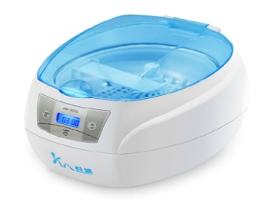 | 1 | ☐ Yes ☐ No

LOT 3
1. | Bicarbonate jet device  Multiflex connection.  Handle rotation for easier access during operation.  The cannula is removable and disinfectable.  Possibility of sterilization in the autoclave.  Compatible with the rest of the dental set in terms of use and connectors.  Equal or similar to the model Jet-Hand Gnatus and to the below illustration:  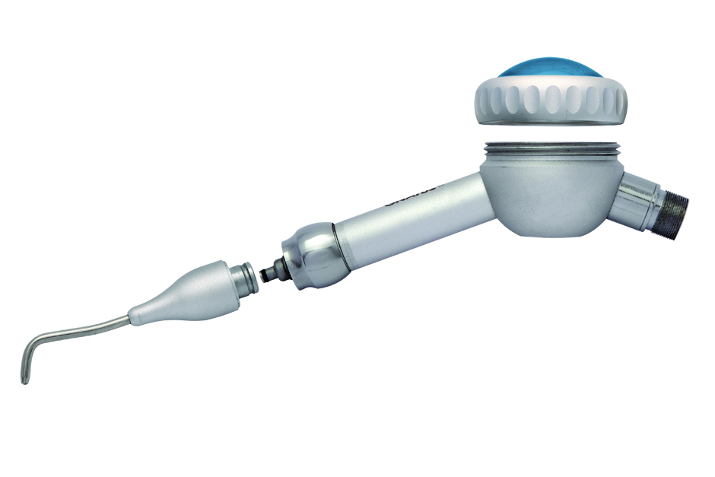 | 4
2. | LED Curing Light  Minimum technical requirements:  Wireless, made of injection moulded thermo-plastic  Control: commands on the lamp body  programs: 3 types - continuous, soft-start (gradual increase of) intensity, pulsating (alternating in 1x1s/ cycles);  Exposition time: 5, 10, 15 and 20 s  Sound signalling: every 5s,  Light source and conductor: light emitting diode (LED), fibre optic thread 100% coherent, autoclavable  Base unit: LED battery charging indicator,  Stand-by system: automatic shutdown  Intelligent Battery System: the battery shuts off automatically, no need for complete discharge to start a new charging cycle.  Base power source: 240 V AC, 50/60 Hz  Lamp/battery power source:  Battery capacity: min. 2000  Light intensity:  From 1,000 to 1,500 mW/cm²  Light wavelength: 420 - 480 nm  Equal or similar the below illustration:  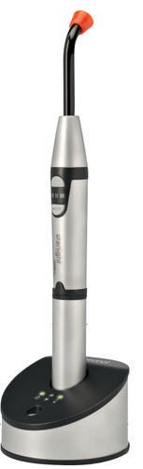 | 3 | ☐ Yes ☐ No
3. | Ultrasonic Scaler - Built in  Automatic frequency adjustment.  Automatic water supply system.  The hand piece is detachable and autoclavable.  The set must include not less than 5 inserts for scale removal, an adequate hose, potentiometer for power adjustments, faucet for spray adjustments and motor electronics.  Power: 3 - 20 W  Voltage on the instrument: 24 V AC, 50/60 Hz, 1,3 A  Water pressure: 0,01 - 0,5 MPa  Sterilisation / disinfection: autoclaving at min. 135°C  Equal or similar the below illustration:  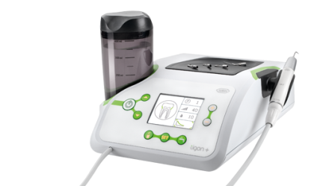 | 2 | ☐ Yes ☐ No
4. | Portable Scaler  Automatic frequency adjustment.  The hand piece is detachable and autoclavable up until 135°C and at the pressure of 0.22MMPa.  hand piece digital control.  The set shall include 5 inserts for scale removal.  Additional Information  Power: 3 - 20 W  Input Voltage: 220 - 230 V AC, 50/60 Hz, 150 mA  Voltage on the Instrument: 24 V AC, 50/60 Hz, 1,3 A  Water Pressure: 0,01 - 0,5 MPa  Central Unit Weight: 0,5 – 1,2 kg  Electricity Adapter Weight: 10,5 – 1,5 kg  Dimensions: min. 160 x 100 x 60  Max 200 x 1150 x 80 mm  Sterilisation / disinfection: autoclaving at min. 135°C  Equal or similar the below illustration:  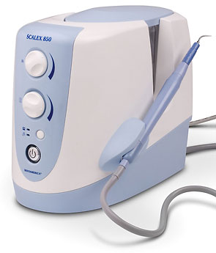 | 1 | ☐ Yes ☐ No
5. | Pulp Vitality Tester  Mildly pulsating handheld teeth vitality tester. Enables tooth reaction to mild electric stimulation.  Minimum two autoclavable tooth probes.  Battery-Saver system that turns off the device after a minimum of 6 minutes in case the user did not turn the device off.  Equal or similar to the model GentlePulse (Parkell) and to the below illustration:  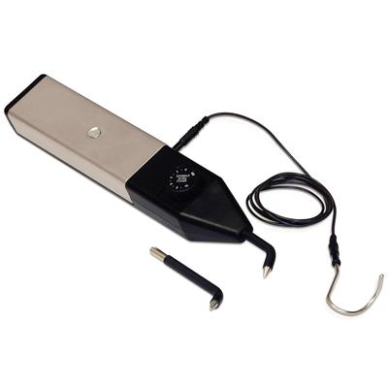 | 2 | ☐ Yes ☐ No
6. | Thermocauter  Battery powered portable thermocauter, applicable in various fields: it has an oral/dental/restorative application in orthodontics, in endodontics – cutting Gutta percha and in perio/oral surgery.  Set with not less than 3 easily interchangeable inserts.  Equal or similar to the model to the below illustration:  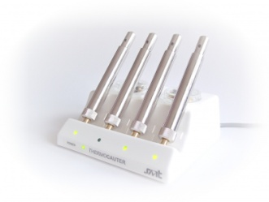 | 2 | ☐ Yes ☐ No
7. | Portable Surgical Vacuum Pump  Electrical portable surgical vacuum pump, designed for easy movement  Technical Properties  Power: 230 ± 10% V, AC, 50 Hz  Net Weight: max 5 kg  Width: 380 - 450 mm  Height: 230 – 300 mm  Depth: 170 – 240 mm  Equal or similar to the below illustration:  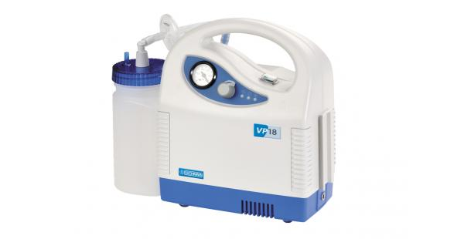 | 1 | ☐ Yes ☐ No
8. | Digital Amalgam Mixer, i.e. Amalgamator, for Capsule Amalgam  Rounded edges; Body covered in polystyrene compliant with electrical safety standards;  Contains a microprocessor ensuring precision and repetition in a selected time;  Elliptical movement with amplitudes of not less than 25mm and frequency of not less than 4,000 min.  In case of sudden opening the movement automatically stops;  Mixing time is adjustable in the range of 0-30s;  ISO 9001 quality assurance system;  Equal or similar to the below illustration:  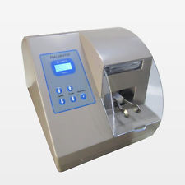 | 2 | ☐ Yes ☐ No
9. | Endodontic Instrument with Apex Locator  Minimum technical requirements:  - LCD display and user friendly keyboard,  - ergonomic design,  - alarm functions,  - 5 presets possible  - settings prior to device shut down memorised,  - Motor Properties: rpm 1,500 – 9,000; torque control; auto reverse function  Apex locator appropriate to this type of endodontic instrument. The device that isolates all distracting signals from the root canal in order to accurately establish the position of the apex – tip of the root. Automatic apex detection in wet and dry canals. Compact and small casing which can be placed on the working deck of the chair. LCD display providing the user with insight and control of the treatment.  Equal or similar to the model NSK Endo-Mate and to the below illustration:  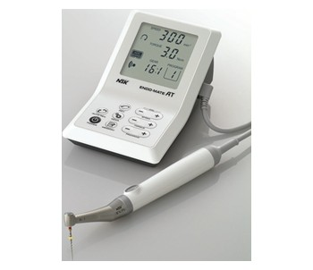 | 2 | ☐ Yes ☐ No
LOT 4
1. | Turbine with Light, without clutch  Minimum technical requirements  Balanced turbine cartridges, curve design. The turbine has the borer clamping force of minimum 30N;  Power / Operating Pressure: min. 15 W / 40 psi  Water Nozzle: min. 4  Connection Type: over the clutch  Head: standard size / height 14.5 mm, diameter 12.5 mm  Bearings: ceramic  Light: yes  Borer clamping system: button operated  Equal or similar to the model SMARTtorque (Kavo) and to the below illustration:  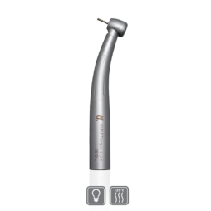 | 2 | ☐ Yes ☐ No
2. | Clutch for Turbine with Light  Minimum technical requirements:  Turbine clutch with 6-pin connection on the hose.  The light source is a halogen or LED light inside the clutch fitted with a valve to disable infection of turbine water lines with microorganisms.  Compatible with offered turbine with light.  Equal or similar to the below illustration:  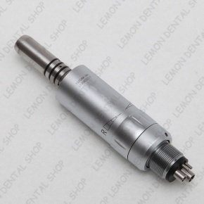 | 2 | ☐ Yes ☐ No
3. | Module for the Turbine with Light  compatible with offered turbine with light and clutch for said turbine  Equal or similar to the below illustration:  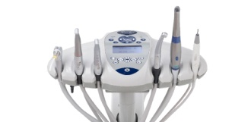 | 2 | ☐ Yes ☐ No

LOT 5
1. | Intraoral Camera  Minimum technical properties:  Option to memorize up to 60 individual full screen recordings or 240 recordings in "4 GRID" mode.  USB connection providing for a direct connection to a computer.  The camera shall be provided with an option for using protection, e.g. protective foil, to safeguard against transmitting infections.  Recording element: ¼” in colour CCD  Video output: 1.0 Vp-p composite/ 75 Ω  Resolution: minimum 480 TV lines  Electronic shutter: automatic,  Focal distance: 1 – 50 mm  Freeze: button on the handpiece – input/output: digital, 16 bit minimum  Digital resolution: minimum 8 bit 256 Grad, 512 x 1024 pix  Lighting: 3 – 6 LEDs  Equal or similar to the model In Cam LX and to the below illustration:  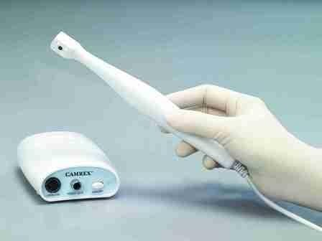 | 1 | ☐ Yes ☐ No
2. | TFT Monitor with the Monitor Mount (Holder) for the Reflector Post  The monitor must be adequate for an interoral camera. Monitor minimum performance: power 100-240 VAC (50/60 Hz), video signal RGB analogue/USB/VGA, contrast minimum 30.000 : 1 DFC, response time 8ms.  The monitor holder set shall be compatible with the dental chair and the interoral camera holder.  Equal or similar to the below illustration:  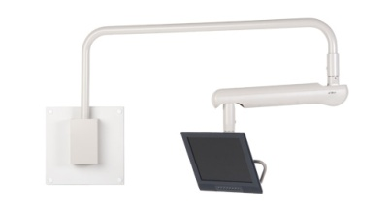 | 1 | ☐ Yes ☐ No
Delivery requirements –– Comparative Data Table

UNOPS Requirements |  | Is quotation compliant? Bidder to complete | Details  Bidder to complete  Insert details
Delivery time | Bidder shall deliver the goods 45 (Forty Five) calendar days after Contract signature. | ☐ Yes ☐ No
Delivery place and Incoterms rules | DAP (Delivered at Place) as per Incoterms 2010.  Offload, assembly and installation of the equipment on the beneficiaries’ premises are included in the price.  Four beneficiaries in the Municipalities of Aleksinac, Blace, Brus and Raska.  Net of any direct taxes, customs duties and indirect taxes and VAT. | ☐ Yes ☐ No
Consignee details | The exact address the goods should be delivered and offloaded to, as well as all other relevant details, will be available upon contract signature. | ☐ Yes ☐ No
UNOPS Right to vary requirements | At the time the Contract is awarded, UNOPS reserves the right to vary the quantity of the goods and associated services specified above, provided this does not exceed +/- 20%, without any change in the unit prices or other terms and conditions of the RFQ. | ☐ Yes ☐ No

The offered goods and related services (if applicable) are in accordance with the required specifications and requirements specified in Section III: Schedule of Requirements.

☐ Yes ☐ No

ANY DEVIATION MUST BE LISTED BELOW:
___________________________________________________________________________________________________________________________________________________________________________________________________________________________________________________________________________________________________________________________________________________________________________________________________________________________________________________
_______________________________________________________________________________________

Name : _____________________________________________________________

Title : _____________________________________________________________

Date : _____________________________________________________________

Signature : _____________________________________________________________

Form D: Previous experience form
RFQ reference no: [insert RFQ reference No.]_________________________________
Name of Bidder: [insert name of Bidder]______________________________________

Description of services/goods | Country | Total amount of Contract | Contract Identification and Title and  Contact details of Client:  (Name, Address, telephone, email, fax) | Year project was undertaken

Name : _____________________________________________________________

Title : _____________________________________________________________

Date : _____________________________________________________________

Signature : _____________________________________________________________75 00ax: +45 45 33 75 01

