Version: v2016.1
Request for Quotation (RFQ) for Goods
Purchase of jewellers and watchmakers equipment in support of women entrepreneurship
RFQ Ref No: UNOPS-EP-2016-G-004

Section IV: Returnable Bidding Forms
Note to Bidders: Instructions to complete each Form are highlighted in blue in each Form. Please complete the Returnable Biding Forms as instructed and return them as part of your quotation.

The following returnable forms are part of this RFQ and must be completed and returned by bidders as part of their Quotation.

Form A: Quotation submission form
Bidders are requested to complete this form, sign it and return it as part of their bid submission. The bidder shall fill in this form in accordance with the instructions indicated. No alterations to its format shall be permitted and no substitutions shall be accepted.
Date: [Insert submission date]____________________________

Subject: Quotation for the supply of [Insert a brief description of goods/services] __________________________________in ________________________________[Name of country/city], RFQ Case No.[insert RFQ ref number]_______________________________, dated [insert date]_____________________.

We, the undersigned, declare that:
  - We offer to supply in conformity with the bidding documents, including the UNOPS General Conditions of Contract.
  - Our quotation shall be valid for the period of time of [insert number of days which shall not be less than the specified in Section I: Bid Particulars, Period of Validity of Bids] _________________from the date fixed for the bid submission deadline as set out in the RFQ, and it shall remain binding upon us and may be accepted at any time before the expiration of that period;
  - We have no conflict of interest in any activity that would put it, if selected for this assignment, in a conflict of interest with UNOPS;
  - Our firm confirms that the offeror and sub-contractors have not been associated, or had been involved in any way, directly or indirectly, with the preparation of the design, terms of references and/or other documents used as a part of this solicitation;
  - Our firm, its affiliates or subsidiaries—including any subcontractors or suppliers for any part of the Contract—has not been declared ineligible by UNOPS, nor is included in the suspended/ineligibility list of the UN/PD, other UN Agencies, the UN Security Council, and the World Bank, in accordance with Instructions to Bidders Article 3, Eligibility;
  - We embrace the UN Supplier Code of Conduct and adhere to the principles of the UN Global Compact
  - We have not declared bankruptcy, are not involved in bankruptcy or receivership proceedings, and there is no judgment or pending legal action against them that could impair their operations in the foreseeable future.
  - We have not offered and will not offer fees, gifts and/or favours of kind in exchange for this RFQ and will not engage in any such activity during the performance of any Contract awarded.
I, the undersigned, certify that I am duly authorized by [insert full name of bidder] ________________________________to sign this quotation and bind [insert full name of bidder] should UNOPS accept this quotation:
Name: [complete]_______________________________________________________
Title: [complete]_________________________________________________________
Signature: _____________________________________________________________

Provide the name and contact information for the primary contact from your company for this quotation:

Name: [complete]________________________________________________________
Title: [complete]__________________________________________________________
Email address: [complete]___________________________________________________
Telephone: [complete]______________________________________________________

Form B: Price Schedule Form
Bidders shall fill in this Price Schedule Form in accordance with the instructions indicated.

RFQ reference no: [insert RFQ reference No.]

Currency | RSD

Item No | Description | Qty | Unit price DAP  (Insert) | Total price DAP  (Insert)
1. | Flexible shaft suitable for the use in watchmakers and jewellers workshops, with electronic foot pedal | 1
2. | High precision column bench drilling machine with compatible column drill adapter | 1
3. | UV light box | 1
4. | Professional LED task lamp for watchmakers and jewellers | 1
5. | TIG (argon) spot welding device including stereo microscope and accessory for goldsmiths, jewellers and watchmakers | 1
6. | Interval watch winder | 1
7. | Watch tester with stand microphone for mechanical watches | 1
8. | Double-sided polishing machine | 1
TOTAL PRICE

Payment terms 30 days accepted: ☐ Yes

Bidder’s discount for accelerated payment: _____% of total firm price for each calendar day less than thirty (30) days

List of subcontractors or suppliers

Bidder must identify the names of all subcontractors/suppliers who will be providing good/services under this Contract and the type of work being subcontracted, if applicable.

[Full legal name and address of subcontractors]

- _________________________________________________

- _________________________________________________

- _________________________________________________

I, the undersigned, certify that I am duly authorized by [insert full name of Bidder]
_______________________________________________ to sign this quotation and bind
__________________________________________________[insert full name of Bidder] should UNOPS accept this quotation:

Name : _____________________________________________________________

Title : _____________________________________________________________

Date : _____________________________________________________________

Signature : _____________________________________________________________

Form C: Technical Quotation Form

RFQ reference no: [insert RFQ reference No.]______________________________________
Name of Bidder: [insert name of Bidder]___________________________________________

Bidders are required to complete the Comparative Data Tables included in Section III: Schedule of Requirements to demonstrate compliance with UNOPS requirements and insert them below. Bidders are NOT allowed to make any change in the “UNOPS requirements” columns of the Comparative Data Tables. Such changes might disqualify your quotation.

Technical specifications for goods – Comparative Data Table

Item No | UNOPS minimum technical requirements | Quantity | Is quotation compliant?  Bidder to complete | Details of goods offered. Bidder to complete  Insert details of goods offered, including specifications and brand/model offered if applicable
1. | Flexible shaft suitable for the use in watchmakers and jewellers workshops, with electronic foot pedal  230 V / 240 W / 20000-25000 Rpm  motor with flexible shaft and electronic foot pedal with accessories.  Flexible shaft motor is designed for drilling, grinding, polishing, engraving and other processing of jewellery and watches in the most inaccessible places.  Equal or similar to the model “HM 2000” illustrated below  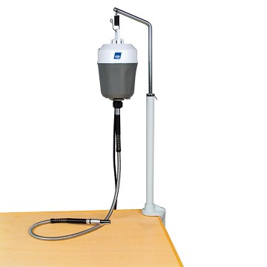 | 1 | ☐ Yes ☐ No
2. | High precision column bench drilling machine with compatible column drill adapter  - Machined work top to be made of high quality, ribbed die-cast aluminium  - Adjustable fence with scale.  - Solid, chromed steel column, 280 mm high, 20 mm diameter.  Stable die-cast head with built-in, VDE approved 220-240 Volt 85 W motor.  - Three step aluminium pulley with flat belts.  At least three different speeds: in the range between 1.800 and 8.500 rpm.  - Extremely high rotational accuracy, at least 30 mm feed.  - Adjustable depth gauge.  Throat depth (column to drill spindle) minimum 140 mm.  Included:  - Compatible column drill adapter  - Six triple slit precision collets for shaft sizes 1,0 - 1,5 - 2,0 - 2,4 - 3,0 - 3,2 mm  - 3/8" thread for drill chucks.  Equal or similar to the model “Xenox TBX”, illustrated below  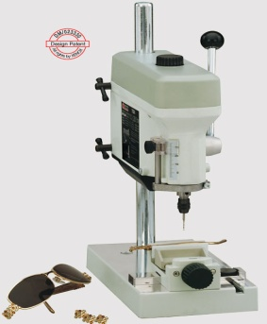 | 1 | ☐ Yes ☐ No
3. | UV light box for hardening the UV-adhesive when fitting mineral -/ sapphire glasses.  - 4 UV bulbs  - Wavelength: 350 - 400 nm  Equal or similar to the model illustrated below  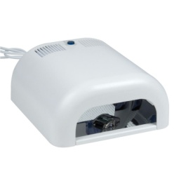 | 1 | ☐ Yes ☐ No
4. | Professional LED task lamp for watchmakers and jewellers  - LED Technology  - service life up to 50,000 hours  - energy savings features (minimum efficacy of at least 29 lm/W)  - Continuously dimmable down to 10%  - Glare Free, Flicker free and Shadow Free Light  - Contrast sensitivity and colour recognition.  spring balanced arm, at least 750 mm  - High performance plastic reinforced with robust aluminium and fibreglass  Equal or similar to the model “Taneo SZTL 24 R”, illustrated below  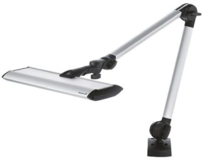 | 1 | ☐ Yes ☐ No
5. | TIG (argon) spot welding device including stereo microscope and accessory for goldsmiths, jewellers and watchmakers  - touch screen operation  - possibility to toggle between automatic operation and foot switch  - Pre-set programs for common welding situations and standard metals (gold, silver and platinum)  - Possibility of setting up of at least 30 programs  - Automatic gas flow control  - Gas consumption: approx 2 l/m  - Energy saving mode  - includes stereo microscope (10x) with eye protection filter  - 230 Volt / 6 Watt (standby)  - Minimum 3 years guarantee  Equal or similar to the model “Lampert PUK 4.1”, illustrated below  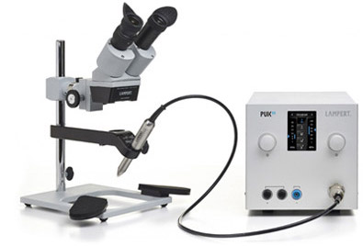 | 1 | ☐ Yes ☐ No
1. | Interval watch winder  Accommodation for up to 4 watches to be kept running at the same time.  - Rotating times and stops are controlled electronically.  - Rotation direction occurs randomly either clockwise or counter clockwise after each stop and break time (works 3 turns and sleep 110 sec.)  - Housing: zinc die-casting  - Springs: nickel chromium steel or polymer  - Springs covered with soft PVC pads  - Integrated safety clutch  - 230 / 110 V AC 4 Watt  - Weight 1-2 kg;  Equal or similar to the model “MTE WTS 4”, illustrated below  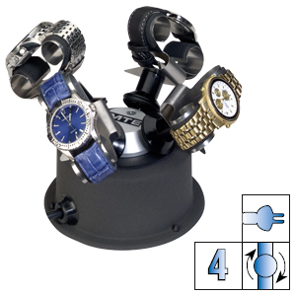 | 1 | ☐ Yes ☐ No
2. | Watch tester with stand microphone for mechanical watches  - High resolution touch screen colour display.  - Stand microphone for mechanical small and large watches and clocks up to Ø 55 mm, manually in all layers rotates  - Connections: Ethernet (LAN), DSUB 15, 2xUSB and Lemo connector for microphones. With the device following measurements can be taken  - Measuring the accuracy of mechanical watches Automatic determination of the most common beat numbers Numerical and visual indication of the rate and beat error  - Vibration amplitude: Numeric display of amplitude.  - Acoustic testing Built-in speaker for playback of impact sound.  - Oscillogram. Illustration of the impact sounds for fault analysis of inhibition in delivery  - Loudspeaker for listening to watch noise  Equal or similar to the model “Chrono Touch Vibrograf with MP12 microphone”, illustrated below  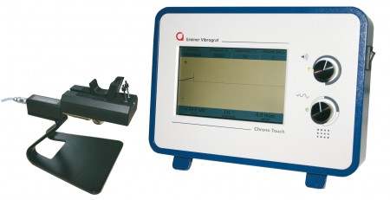 | 1 | ☐ Yes ☐ No
1. | Double-sided polishing machine  - two separately switchable extraction units each side  - two-speed motor, min. 300 W, 220 V, 1400 - 2800 rpm.  - large filter drawer for coarse dirt.  - switchable polishing lights for dazzle-free workplace illumination.  Equal or similar to the model “PA 210”, illustrated below  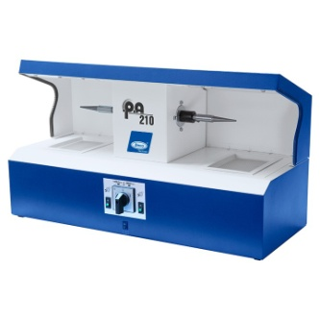 | 1 | ☐ Yes ☐ No

Delivery requirements –– Comparative Data Table

UNOPS Requirements |  | Is quotation compliant? Bidder to complete | Details  Bidder to complete  Insert details
Delivery time | Bidder shall deliver the goods 45 (Forty Five) calendar days after Contract signature. | ☐ Yes ☐ No
Delivery place and Incoterms rules | DAP (Delivery at Place) as per Incoterms 2010, net of any direct taxes, customs duties and indirect taxes and VAT:  Municipality of Nova Varos. | ☐ Yes ☐ No
Consignee details | The exact address the goods should be delivered and offloaded to, as well as all other relevant details, will be available upon contract signature. | ☐ Yes ☐ No
UNOPS Right to vary requirements | At the time the Contract is awarded, UNOPS reserves the right to vary the quantity of the goods and associated services specified above, provided this does not exceed +/- 20%, without any change in the unit prices or other terms and conditions of the RFQ. | ☐ Yes ☐ No

The offered goods and related services (if applicable) are in accordance with the required specifications and requirements specified in Section III: Schedule of Requirements.

☐ Yes ☐ No

ANY DEVIATION MUST BE LISTED BELOW:
___________________________________________________________________________________________________________________________________________________________________________________________________________________________________________________________________________________________________________________________________________________________________________________________________________________________________________________
_______________________________________________________________________________________

Name : _____________________________________________________________

Title : _____________________________________________________________

Date : _____________________________________________________________

Signature : _____________________________________________________________

Form D: Previous experience form
RFQ reference no: [insert RFQ reference No.]_________________________________
Name of Bidder: [insert name of Bidder]______________________________________

Description of services/goods | Country | Total amount of Contract | Contract Identification and Title and  Contact details of Client:  (Name, Address, telephone, email, fax) | Year project was undertaken

Name : _____________________________________________________________

Title : _____________________________________________________________

Date : _____________________________________________________________

Signature : _____________________________________________________________75 00ax: +45 45 33 75 01

